Zingst, Mecklenburg-Vorpommern, Germany
A gem of the German Baltic coast, Zingst blends powdery white beaches with untouched national park wilderness, ornate carved fisherman's doors, and an obsession with photography that spills outdoors onto the dunes.
⚓ Pier (Zingster Strom harbor) · 🚢 Small coastal & river cruise ships only · 🕒 Typical call: 5–8 hrs · 💶 Euro (€) · 🗣️ German
✍️ MY DAY IN PORT (FILL IN)
Ship / Date
In port | arrive ______ · all aboard ______
Booked excursion
Notes / meeting point
GETTING ASHORE
- Docking: Pier at Zingster Strom (Bodden/lagoon side of town)
- Walk to beach: 15–20 min on flat pedestrian street
- Best For: Beach walks, cycling the national park, wildlife (cranes in autumn)
- Don't Miss: Seebrücke pier's Tauchgondel diving gondola and a Fischbrötchen at the harbour
GETTING AROUND
- 🚕 Taxi: €10–€15 (short local trips) — Local taxis serve the Zingst area. Because the town is small, most rides are short. Pre-booking via local taxi companies
- 📱 Rideshare: ❌ not available
- 🚌 Hop-on hop-off: ✅ Darssbahn Erlebnistouren
TOP THINGS TO DO
- Cycle the Vorpommersche Boddenlandschaft National Park — Rent a bike and pedal into one of Germany's most scenic national parks.
- Seebrücke Pier & Tauchgondel — Walk 270 metres over the Baltic on Zingst's iconic wooden pier, then descend in the Tauchgondel — a steel gondola that lowers you…
- Crane Migration Spectacle (Autumn) — Each September–November, tens of thousands of migrating cranes rest on the Bodden wetlands around Zingst — one of Europe's great…
- Photography Art Trail — Zingst has branded itself Germany's photography town.
- Heimatmuseum Zingst — This captain's house from 1867 tells the story of Zingst's fishing and shipbuilding heritage, with traditional costumes…
BEST WALKS
- Harbour to Baltic Pier: 1.2 km | 15–20 min | Flat | Paved — The classic Zingst stroll: start at the harbour on the Bodden side, walk Strandstraße past thatched…
- Dune Promenade Walk: 2–3 km | 30–45 min | Easy | Sea views — From the base of the Seebrücke, follow the paved promenade along the top of the dunes east or west.
WEATHER · DAYLIGHT · MONEY
Month | High °F | Low °F | Rainy days
May | 61 | 48 | 10
Jul | 71 | 60 | 15
Sep | 66 | 55 | 11
Daylight: May 5:04AM–9:07PM · Jul 4:54AM–9:35PM · Sep 6:42AM–7:25PM
cruiseports.org/zingst · Confirm terminal & all-aboard time with your ship

Zingst, Mecklenburg-Vorpommern, Germany — Port Map
Red = walkable sights · Amber = excursions farther out · P = cruise terminal
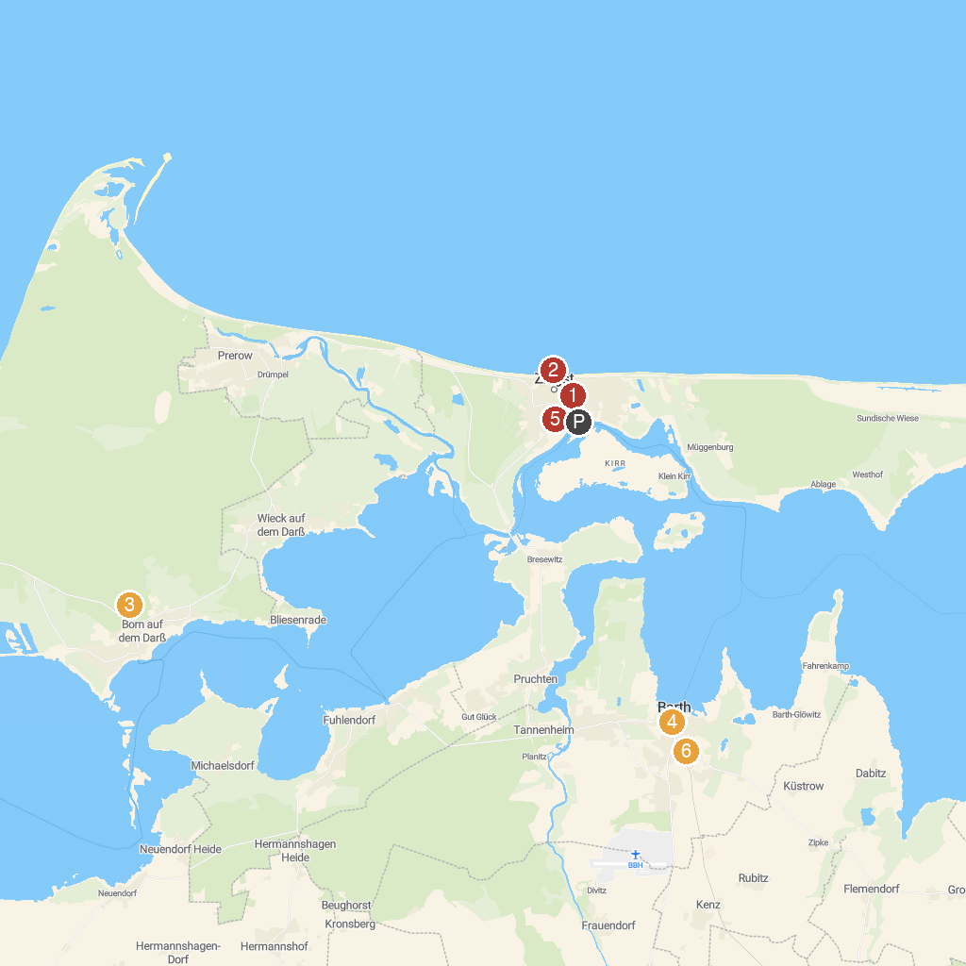
MAP KEY
1. Peter-Pauls-Kirche Zingst | 5. Vineta-Museum
2. Seebrücke Zingst | 6. Heimatmuseum mit Museumshof
3. Nationalpark Vorpommersche Boddenlandschaft | 7. Bibelzentrum Barth
4. Lighthouse Darßer place | 8. Hafen Zingst
P. Cruise port / terminal
Map © MapTiler © OpenStreetMap contributors · cruiseports.org

