Zanzibar, Tanzania
Zanzibar blends Arab, Swahili, and colonial influences into a UNESCO-listed Stone Town maze — coral-stone palaces, carved doors, spice-scented alleys, and warm Indian Ocean waters all within a short tender ride.
⚓ Tender port (anchor in harbor) · 🕒 Typical call: 8-10 hrs · 💵 Tanzanian Shilling / USD widely accepted · 🗣️ Swahili & English
✍️ MY DAY IN PORT (FILL IN)
Ship / Date
In port | arrive ______ · all aboard ______
Booked excursion
Notes / meeting point
GETTING ASHORE
- Docking: Ships anchor offshore; passengers tendered to Zanzibar Port quay at Stone Town's edge
- Walk to center: 5–10 min from tender dock into Stone Town UNESCO core
- Best For: History, spice culture, giant tortoises, Indian Ocean snorkeling
- Don't Miss: Old Slave Market & Christ Church Cathedral, Forodhani Gardens, Prison Island tortoises
GETTING AROUND
- 🚕 Taxi: $10–$20 USD — Taxis wait at the port and charge a flat negotiated rate per vehicle (not per person). Always agree on the fare before d
- 📱 Rideshare: ✅ Bolt
TOP THINGS TO DO
- Stone Town Walking Tour — Guided walk through the UNESCO-listed core: Old Slave Market, Christ Church Cathedral, House of Wonders (Beit-al-Ajaib), Old Fort…
- Prison Island & Giant Tortoises — A 20-minute dhow or speedboat ride to Changuu (Prison Island) brings you face-to-face with Aldabra giant tortoises — some over…
- Spice Farm Tour — Zanzibar earned its 'Spice Island' name from centuries of clove, cinnamon, cardamom, and vanilla cultivation.
- Jozani Forest & Red Colobus Monkeys — Tanzania's only national park on Zanzibar protects the rare endemic Zanzibar Red Colobus monkey.
- Sunset Dhow Cruise — Traditional wooden dhow sail along Stone Town's seafront as the sun drops over the Indian Ocean.
BEST WALKS
- Stone Town Heritage Loop: 2–3 km · 1.5–2 hrs · Easy · Paved alleys — Start at the Old Fort (Ngome Kongwe) on Mizingani Road, walk to the House of Wonders next door…
- Waterfront Stroll — Mizingani Road: 1 km · 20 min · Very easy · Flat seafront — A breezy flat walk along the harbor front from the tender quay north along Mizingani Road, passing…
WEATHER · DAYLIGHT · MONEY
Month | High °F | Low °F | Rainy days
May | 82 | 76 | 20
Jul | 81 | 73 | 15
Sep | 85 | 72 | 13
Daylight: May 6:24AM–6:14PM · Jul 6:35AM–6:22PM · Sep 6:16AM–6:20PM
cruiseports.org/zanzibar · Confirm terminal & all-aboard time with your ship

Zanzibar, Tanzania — Port Map
Red = walkable sights · Amber = excursions farther out · P = cruise terminal
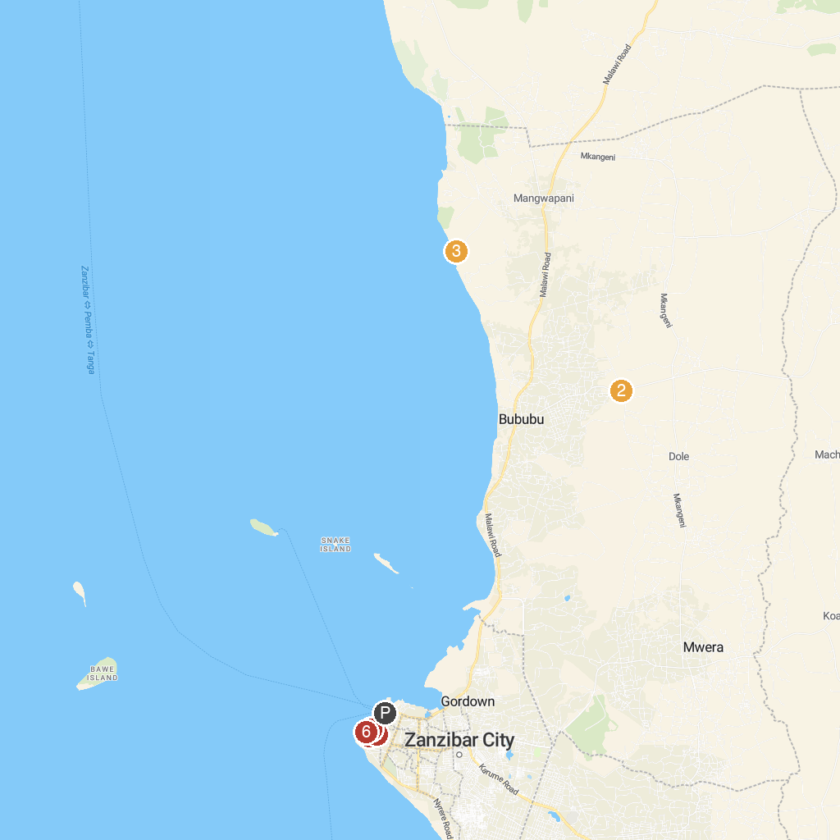
MAP KEY
1. Saint Joseph's Cathedral | 4. The Spice Route Museum
2. SISO SPICE FARM | 5. Old Fort
3. Cheetah's Rock | 6. Nakupenda Island Beach Tours
P. Cruise port / terminal
Map © MapTiler © OpenStreetMap contributors · cruiseports.org

