Zakynthos Island, Ionian Islands, Greece
The 'Flower of the East' delivers electric-blue seas, a rusting shipwreck framed by white cliffs, and endangered sea turtles nesting on its southern shores.
⚓ Tender port · 🕒 Typical call: 6-10 hrs · 💶 Currency: Euro (€) · 🗣️ Language: Greek · 🐢 Sea turtle nesting island
✍️ MY DAY IN PORT (FILL IN)
Ship / Date
In port | arrive ______ · all aboard ______
Booked excursion
Notes / meeting point
GETTING ASHORE
- Docking: Tender — ships anchor in the bay; boats transfer to the town harbor pier
- Walk to center: 1-2 min from tender pier to Solomos Square
- Best For: Boat excursions to Navagio & Blue Caves, sea-turtle spotting, Venetian architecture
- Don't Miss: Cliffside viewpoint over Shipwreck Beach (Navagio) — 50-60 min drive each way
GETTING AROUND
- 🚕 Taxi: €13–€25 — Taxis are available at the port and can take you to Zakynthos Town in about 5–10 minutes. Fixed-rate fares are common; a
TOP THINGS TO DO
- Navagio Shipwreck Bay & Blue Caves Boat Tour — The signature excursion: a boat trip to the stunning Navagio Bay to view the rusting MV Panagiotis shipwreck from the water…
- Sea Turtle Spotting — Marathonisi (Turtle Island) — Head to Laganas Bay in the south, the most important Loggerhead sea turtle nesting area in the Mediterranean.
- Zakynthos Town & Byzantine Museum — Explore the arcaded Venetian streets of Zakynthos Town, visit the ornate Church of Agios Dionysios (resting place of the island's…
- Navagio Cliffside Viewpoint Drive — Drive or taxi to the dramatic cliffs on the northwest tip of the island for the famous panoramic shot of Navagio Beach from above.
- Tsilivi Beach Day — A long sandy beach 10-15 minutes north of the port by taxi (about €12-15 each way).
BEST WALKS
- Zakynthos Town Harborfront & Solomos Square: 30-45 min · Easy · Free — From the tender pier, stroll along the harbor promenade to Solomos Square, browse Alexandrou Roma…
- Bochali Hill Viewpoint: 25-30 min uphill walk (or €7-10 taxi) · Moderate · Free — Climb (or taxi) to Bochali Hill above Zakynthos Town for sweeping views of the harbor, your cruise…
WEATHER · DAYLIGHT · MONEY
Month | High °F | Low °F | Rainy days
May | 74 | 62 | 5
Jul | 89 | 75 | 1
Sep | 82 | 71 | 6
Daylight: May 6:26AM–8:39PM · Jul 6:26AM–8:57PM · Sep 7:18AM–7:43PM
cruiseports.org/zakynthos-island · Confirm terminal & all-aboard time with your ship

Zakynthos Island, Ionian Islands, Greece — Port Map
Red = walkable sights · Amber = excursions farther out · P = cruise terminal
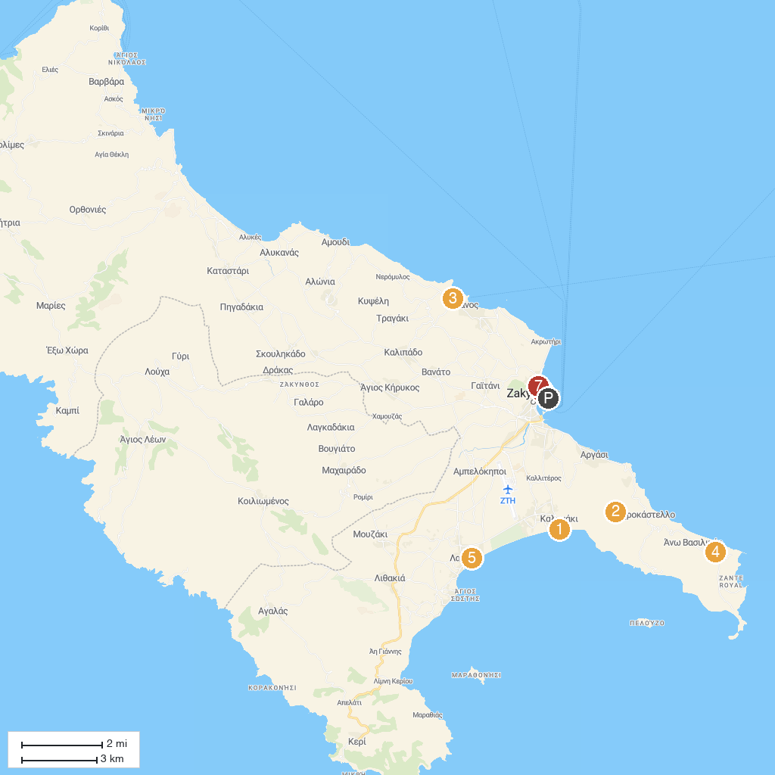
MAP KEY
1. National Marine Park of Zakynthos | 5. Pure Zante
2. Holy Church of Panagia Skopiotissa | 6. Solomos Square
3. Tsilivi Water Park | 7. Museum of D. Solomos and Other Eminent People of Zakynthos
4. Banana Beach
P. Cruise port / terminal
Map © MapTiler © OpenStreetMap contributors · cruiseports.org

