Zadar, Dalmatia, Croatia
An ancient walled city jutting into the Adriatic, Zadar layers Roman columns onto Venetian streets — then ends each day with a sunset that Alfred Hitchcock once called the world's most beautiful. The Sea Organ plays it out loud.
⚓ Docked (Gazenica terminal) · 🕒 Typical call: 8-10 hrs · 💵 Currency: Croatian Kuna / Euro (€) · 🗣️ Language: Croatian · 🏖️ Dalmatian coast gateway
✍️ MY DAY IN PORT (FILL IN)
Ship / Date
In port | arrive ______ · all aboard ______
Booked excursion
Notes / meeting point
GETTING ASHORE
- Docking: Gazenica cruise terminal, ~3 km from the old town; shuttle buses usually provided
- Walk to center: 15 min by shuttle or taxi; old town is compact and flat once you arrive
- Best For: Roman ruins, the Sea Organ, island day trips to Kornati and Dugi Otok
- Don't Miss: The Sea Organ and Greeting to the Sun on the Riva at sunset
GETTING AROUND
- 🚕 Taxi: €10–€25 — Taxis available at the Gaženica cruise terminal. Agree on fare before departing; metered rides to Old Town typically €15
- 📱 Rideshare: ✅ Uber, Bolt
TOP THINGS TO DO
- Kornati National Park Boat Trip — The Kornati archipelago — 89 mostly uninhabited islands — sits an hour by boat from Zadar.
- Roman Forum & Old Town Walk — Zadar's Roman Forum (Forum Zadar) is the largest on the eastern Adriatic coast — columns, paving stones, and a shaming post all…
- Krka National Park & Waterfalls — The cascading travertine waterfalls of Krka National Park (Skradinski Buk) are 75 km south of Zadar.
- Sea Organ & Greeting to the Sun — Alfred Hitchcock called Zadar's sunset the world's most beautiful — architect Nikola Bašić built two installations to honor it.
- Dugi Otok & Saharun Beach — Dugi Otok ('Long Island') is 45 minutes by fast catamaran from Zadar.
BEST WALKS
- Roman Forum to the Sea Organ: 1.5 km · 45–60 min · Easy — The essential Zadar loop.
- Kopnena Vrata to the Old Town Market: 0.8 km · 25 min · Easy — Enter through the Land Gate, pass the Five Wells Square (Trg pet bunara) — a 16th-century cistern…
WEATHER · DAYLIGHT · MONEY
Month | High °F | Low °F | Rainy days
May | 70 | 57 | 10
Jul | 85 | 69 | 5
Sep | 76 | 62 | 9
Daylight: May 5:32AM–8:18PM · Jul 5:30AM–8:39PM · Sep 6:38AM–7:09PM
cruiseports.org/zadar · Confirm terminal & all-aboard time with your ship

Zadar, Dalmatia, Croatia — Port Map
Red = walkable sights · Amber = excursions farther out · P = cruise terminal
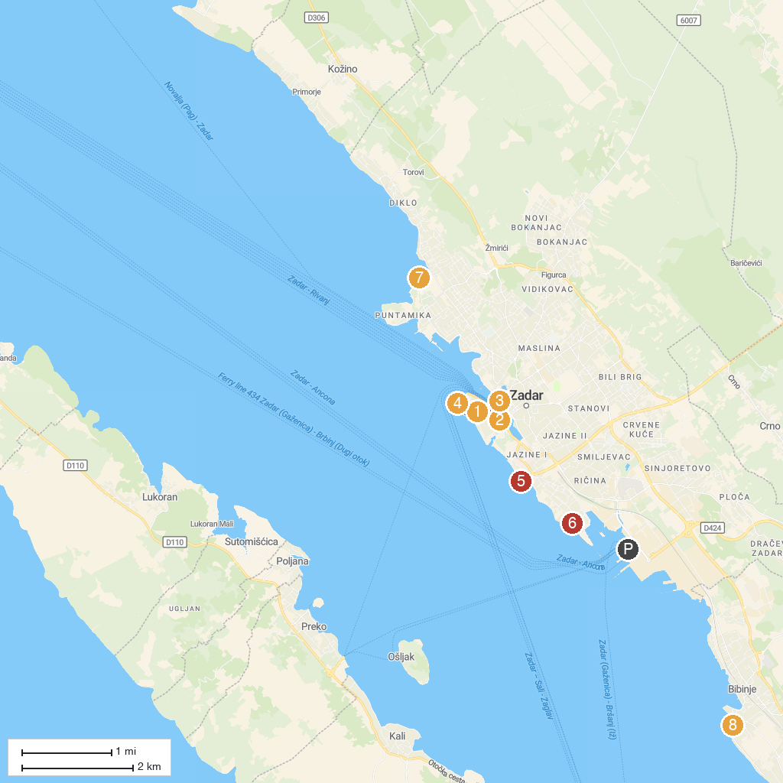
MAP KEY
1. Church of St. Donatus | 5. Kolovare Beach
2. Museum of Ancient Glass | 6. Plaža Podbrig
3. Church of the Sacred Heart of Jesus | 7. Borik Beach
4. Sea Organ | 8. Plaža Punta Rožica
P. Cruise port / terminal
Map © MapTiler © OpenStreetMap contributors · cruiseports.org

