Yorktown, Virginia, USA
Where the American Revolution ended — Yorktown's Riverwalk Landing puts you steps from a 1781 battlefield and 20 minutes from Colonial Williamsburg, the world's largest living history museum.
⚓ Pier (small ships) / Tender (large ships) · 🕒 Typical call: 8-10 hrs · 💵 USD · 🗣️ English · 🏛️ Historic Triangle
✍️ MY DAY IN PORT (FILL IN)
Ship / Date
In port | arrive ______ · all aboard ______
Booked excursion
Notes / meeting point
GETTING ASHORE
- Docking: Small ships dock at Riverwalk Landing Pier; larger vessels anchor ~1.75 miles offshore and tender in
- Walk to center: 0–5 min to Yorktown Riverwalk; 10 min (uphill) to historic Main Street
- Best For: American history buffs, living history, walking the battlefield
- Don't Miss: Colonial Williamsburg's trade shops and the Yorktown Battlefield Visitor Center
GETTING AROUND
- 🚕 Taxi: $30–$40 — Taxis are available at the pier and can take you to Colonial Williamsburg (~14 miles). Several local companies serve the
- 📱 Rideshare: ✅ Uber, Lyft
TOP THINGS TO DO
- Colonial Williamsburg — The world's largest living history museum spans 301 acres of restored 18th-century Virginia.
- Yorktown Battlefield & NPS Visitor Center — Walk the very ground where Cornwallis surrendered to Washington in 1781, ending the Revolutionary War.
- American Revolution Museum at Yorktown — State-of-the-art museum with immersive holographic theater, a re-created Continental Army encampment, and a Revolutionary-era…
- Jamestown Settlement — America's first permanent English settlement (1607) lies 15 miles from Yorktown.
- Yorktown Beach & Riverwalk — A calm, sandy beach on the York River is steps from the pier.
BEST WALKS
- Riverwalk to Historic Main Street: ~0.6 mi | 15 min | Moderate (uphill) — Stroll from the pier along the York River, then climb up to Main Street to see 18th-century homes…
- Colonial Williamsburg Duke of Gloucester Street: ~0.75 mi end-to-end | Easy | Flat brick/gravel — The main spine of Colonial Williamsburg runs from the Capitol building through the historic…
WEATHER · DAYLIGHT · MONEY
Month | High °F | Low °F | Rainy days
May | 74 | 61 | 12
Jul | 87 | 74 | 12
Sep | 80 | 68 | 12
Daylight: May 5:57AM–8:07PM · Jul 5:58AM–8:25PM · Sep 6:48AM–7:13PM
cruiseports.org/yorktown-williamsburg-va · Confirm terminal & all-aboard time with your ship

Yorktown, Virginia, USA — Port Map
Red = walkable sights · Amber = excursions farther out · P = cruise terminal
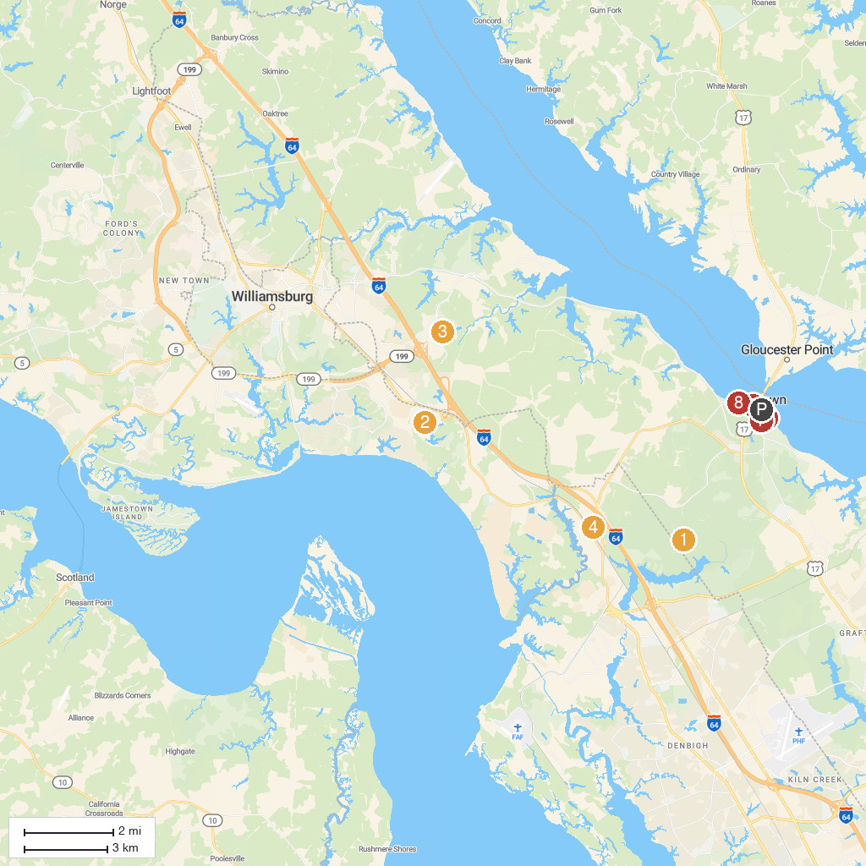
MAP KEY
1. Newport News Park | 5. Battle of Yorktown
2. Busch Gardens Williamsburg | 6. Cornwallis' Cave
3. Water Country USA | 7. Nelson House
4. Lee Hall Mansion | 8. Riverwalk
P. Cruise port / terminal
Map © MapTiler © OpenStreetMap contributors · cruiseports.org

