Yorkeys Knob, Queensland, Australia
Cairns' deep-water tender port, where Half Moon Bay marina drops you within striking distance of the world's largest coral reef and ancient rainforest — or just a cold beer on the biggest deck in Far North Queensland.
⚓ Tender port (no cruise pier) · 🕒 Typical call: 8-10 hrs · 💵 Australian Dollar (AUD) — tap-and-go everywhere · 🗣️ English
✍️ MY DAY IN PORT (FILL IN)
Ship / Date
In port | arrive ______ · all aboard ______
Booked excursion
Notes / meeting point
GETTING ASHORE
- Docking: Tender — ships anchor in Trinity Bay; 15-20 min ride to Yorkeys Knob Boating Club marina
- Walk to centre: Yorkeys Knob Beach: 15 min walk. Cairns city: 20 min drive — not walkable
- Best For: Great Barrier Reef dives, Kuranda rainforest, kitesurfing, fresh tropical seafood
- Don't Miss: Skyrail Rainforest Cableway + Kuranda Scenic Railway combo (book months ahead)
GETTING AROUND
- 🚕 Taxi: AUD $50-70 one-way — Taxis wait at the marina on ship days. The ~17 km ride to Cairns city center takes 15–20 minutes. Fares are metered; fla
- 📱 Rideshare: ✅ Uber
- 🚌 Hop-on hop-off: ✅
TOP THINGS TO DO
- Great Barrier Reef Snorkel & Dive — High-speed catamarans from Cairns Reef Fleet Terminal (20 min from the marina) ferry you to pontoons or reef platforms where you…
- Skyrail Cableway + Kuranda Scenic Railway — Glide over the World Heritage rainforest canopy on the Skyrail from Smithfield (10 min drive), explore the bohemian village of…
- Hartley's Crocodile Adventures — Twenty-five minutes north, Hartley's is the best place in Australia to see massive saltwater crocodiles in action, hold a koala…
- Kitesurfing Lesson at Yorkeys Knob Beach — Yorkeys Knob is world-renowned for consistent trade winds and wide flat-water bays — a premier kitesurfing destination.
- Daintree Rainforest & Mossman Gorge — The Daintree is the world's oldest tropical rainforest — older than the Amazon.
BEST WALKS
- Marina to Yorkeys Knob Beach: 1 km · 15 min · flat · free — Walk out from the boating club along the foreshore to Half Moon Bay Beach.
- Beach to Yorkeys Knob Lookout: 1.5 km · 25 min · moderate · free — Continue north along the beach and take the short rocky track up to the Yorkeys Knob headland for…
WEATHER · DAYLIGHT · MONEY
Month | High °F | Low °F | Rainy days
May | 78 | 70 | 9
Jul | 75 | 66 | 6
Sep | 78 | 68 | 6
Daylight: May 6:33AM–5:53PM · Jul 6:46AM–5:59PM · Sep 6:12AM–6:12PM
cruiseports.org/yorkeys-knob · Confirm terminal & all-aboard time with your ship

Yorkeys Knob, Queensland, Australia — Port Map
Red = walkable sights · Amber = excursions farther out · P = cruise terminal
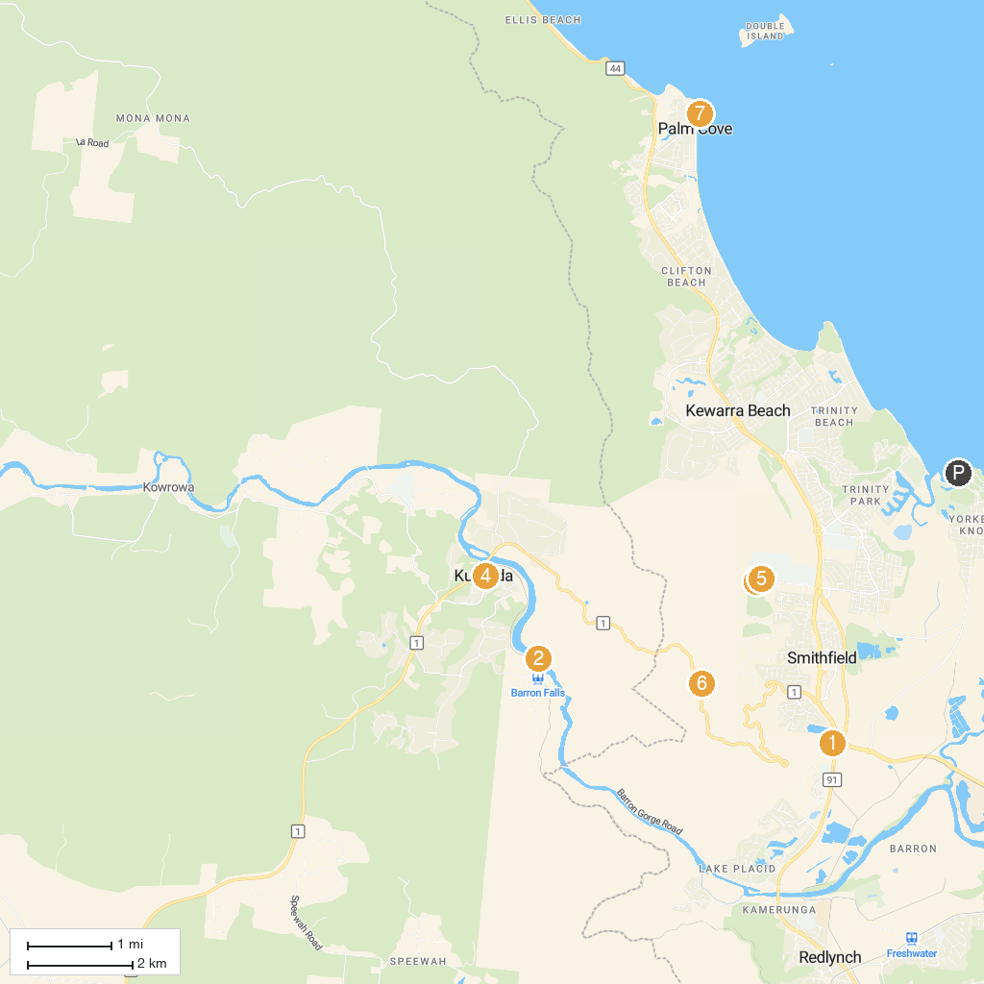
MAP KEY
1. Skyrail Rainforest Cableway | 5. Kuranda Original Rainforest Markets
2. Barron Falls | 6. Smithfield Mountain Bike Park Trail head
3. Skypark Cairns by AJ Hackett | 7. Henry Ross Lookout
4. Down Under Cruise & Dive - Evolution Outer Reef Cruise | 8. Palm Cove Jetty
P. Cruise port / terminal
Map © MapTiler © OpenStreetMap contributors · cruiseports.org

