Yokkaichi, Mie Prefecture, Japan
Yokkaichi surprises every visitor: by day it's a gateway to sacred Ise shrines and Wagyu feasts; by night its glittering petrochemical plants turn the bay into a Blade Runner dreamscape.
⚓ Pier (direct dock) · 🕒 Typical call: 8–10 hrs · 💴 Japanese Yen (JPY) · 🗣️ Japanese
✍️ MY DAY IN PORT (FILL IN)
Ship / Date
In port | arrive ______ · all aboard ______
Booked excursion
Notes / meeting point
GETTING ASHORE
- Docking: Direct pier — Kasumigaura South Pier (large ships) or Chitose-chō wharf
- Walk to center: ~20 min to Kintetsu-Yokkaichi Station; shuttle/taxi common
- Best For: Factory night views, Ise Grand Shrine day-trip, Banko pottery
- Don't Miss: Kojo-yakei (factory night cruise) if ship departs after dark
GETTING AROUND
- 🚕 Taxi: ¥1,500–¥3,500 — From No. 3 Pier, JR Yokkaichi Station is about a 5-minute cab ride; the city center is 15–25 minutes. Meters run at stan
- 📱 Rideshare: ✅ Uber Taxi, GO, DiDi
TOP THINGS TO DO
- Ise Grand Shrine Day Trip — Japan's most sacred Shinto complex, rebuilt every 20 years in ancient cypress.
- Banko Pottery Workshop — Yokkaichi produces roughly 80% of Japan's clay donabe pots.
- Mt. Gozaisho Ropeway — The ropeway near Yunoyama Onsen whisks you up to 1212 m with views across Ise Bay — on clear days you can see Mt.
- Iga Ninja Museum — In nearby Iga — birthplace of the ninja — tour a traditional ninja house with concealed doors and trick mechanisms, watch live…
- Factory Night View Cruise (Kojo-yakei) — Yokkaichi invented Japan's factory-night-view tourism.
BEST WALKS
- Kintetsu Station to Yokkaichi Port Building: 1.5 km · 20 min · Flat — From Kintetsu-Yokkaichi Station, walk south through the downtown shopping arcade to the Yokkaichi…
- Juushi River Sakura Avenue: 1 km loop · 15 min · Flat — A short riverside promenade lined with cherry trees — lovely in spring bloom, still a pleasant…
WEATHER · DAYLIGHT · MONEY
Month | High °F | Low °F | Rainy days
May | 72 | 58 | 11
Jul | 84 | 74 | 18
Sep | 80 | 70 | 16
Daylight: May 4:50AM–6:49PM · Jul 4:51AM–7:07PM · Sep 5:36AM–6:00PM
cruiseports.org/yokkaichi · Confirm terminal & all-aboard time with your ship

Yokkaichi, Mie Prefecture, Japan — Port Map
Red = walkable sights · Amber = excursions farther out · P = cruise terminal
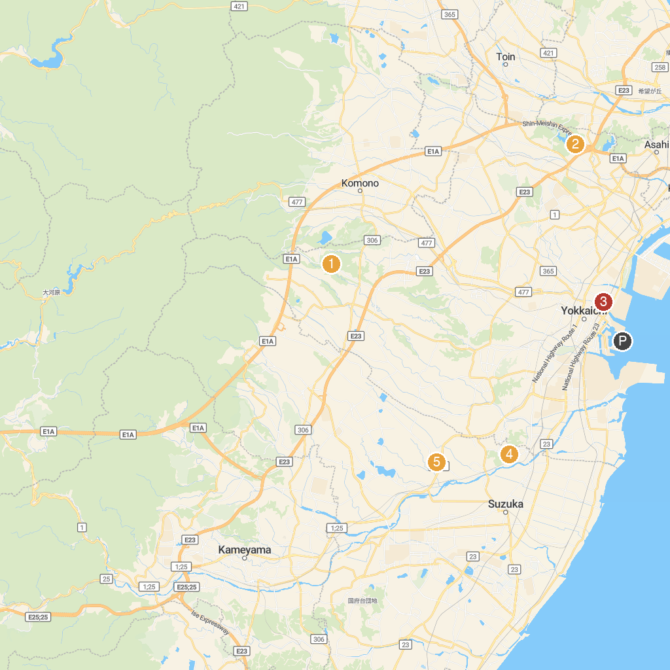
MAP KEY
1. Kuwana Castle Ruins | 5. Isaka Dam Cycle Park
2. Paramita Museum | 6. Mitaki Park
3. Suzuka Circuit Park | 7. Takaokayama Central Park
4. Yokkaichi Sports Land | 8. Nobutsuna Sasaki Memorial Museum
P. Cruise port / terminal
Map © MapTiler © OpenStreetMap contributors · cruiseports.org

