Yeosu, Jeollanam-do, South Korea
Korea's "City of Beautiful Waters" — where the 2012 World Expo left behind a gleaming waterfront, Admiral Yi Sun-shin's Turtle Ships stand watch, and a sea-crossing cable car offers the finest panorama on the southern coast.
⚓ Pier (Yeosu Expo Cruise Terminal) · 🕒 Typical call: 7–10 hrs · 💵 South Korean Won (KRW) · 🗣️ Korean (English limited)
✍️ MY DAY IN PORT (FILL IN)
Ship / Date
In port | arrive ______ · all aboard ______
Booked excursion
Notes / meeting point
GETTING ASHORE
- Docking: Pier — Yeosu Expo Cruise Terminal; no tender required
- Walk to center: Yi Sun-shin Square ~3 km; taxi 7–10 min, ~₩5,000–7,000
- Best For: History, seafood, coastal scenery, digital art
- Don't Miss: Turtle Ship replica + Yeosu Maritime Cable Car
GETTING AROUND
- 🚕 Taxi: ₩4,000–₩8,000 — Taxis queue directly outside the Yeosu Cruise Terminal at Expo Ocean Park. The meter starts at ₩3,800 and most rides to
- 📱 Rideshare: ✅ Kakao T, k.ride
TOP THINGS TO DO
- Yeosu Maritime Cable Car — Korea's first sea-crossing cable car connects Jasan Park (near Odongdo) to Dolsan Park over open water.
- Turtle Ship & Yi Sun-shin Square — Yeosu was the headquarters of Admiral Yi Sun-shin, Korea's greatest naval hero.
- Odongdo Island Walk — Cross the scenic 768-meter breakwater causeway (or hop the Dongbaek Train for ₩1,000) to this forested island park.
- Arte Museum Yeosu — Immersive digital art meets the ocean in this large-format media installation museum inside Expo Park — an easy walk from the pier.
- Goso-dong Wall Painting Village — Yeosu's oldest hillside neighborhood is crisscrossed with steep alleys painted in vivid murals depicting the city's maritime…
BEST WALKS
- Expo Waterfront to Odongdo Island: 2 km | 25 min | Flat paved path — Follow the coastal promenade from the cruise terminal past the Sky Tower and Expo pavilions to the…
- Yi Sun-shin Square & Old Town: 3 km from port | Taxi recommended one-way — Taxi to Yi Sun-shin Square, explore the Turtle Ship replica, then walk north through the old market…
WEATHER · DAYLIGHT · MONEY
Month | High °F | Low °F | Rainy days
May | 71 | 58 | 8
Jul | 81 | 73 | 14
Sep | 77 | 68 | 12
Daylight: May 5:26AM–7:25PM · Jul 5:27AM–7:42PM · Sep 6:12AM–6:36PM
cruiseports.org/yeosu · Confirm terminal & all-aboard time with your ship

Yeosu, Jeollanam-do, South Korea — Port Map
Red = walkable sights · Amber = excursions farther out · P = cruise terminal
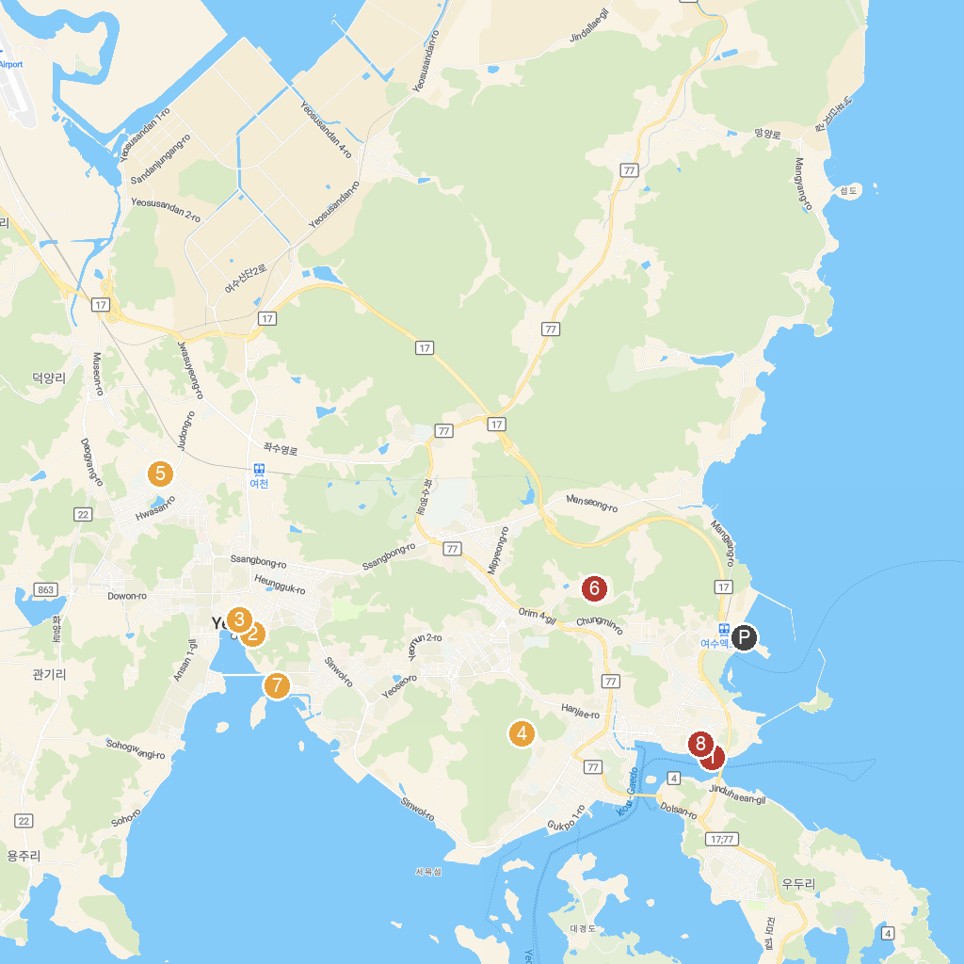
MAP KEY
1. Hamel Lighthouse | 5. 여수선사유적공원
2. Yeosu Seonso Historic Site | 6. 진남체육공원
3. 용기공원 | 7. Ungcheon Beach Park
4. 한산사 | 8. 여수해양공원
P. Cruise port / terminal
Map © MapTiler © OpenStreetMap contributors · cruiseports.org

