Yarmouth, Nova Scotia, Canada
Gateway to the Acadian Shore, where Bay of Fundy tides, world-famous lobster, and a one-of-a-kind applecore lighthouse define one of Atlantic Canada's most welcoming ports.
⚓ Pier (Lobster Rock Marine Terminal) · 🕒 Typical call: 7-9 hrs · 💵 Canadian Dollar (USD widely accepted) · 🗣️ English & French (Acadian) · 🦞 Lobster capital of Atlantic Canada
✍️ MY DAY IN PORT (FILL IN)
Ship / Date
In port | arrive ______ · all aboard ______
Booked excursion
Notes / meeting point
GETTING ASHORE
- Docking: Pier — Lobster Rock Marine Terminal or Old Government Wharf; anchorage/tender also used
- Walk to center: 5–10 min from pier to Main Street; flat to slight uphill
- Best For: Maritime history, Acadian culture, fresh lobster, lighthouse scenery
- Don't Miss: Cape Forchu Lighthouse (applecore shape) and Rudder's brew pub on the waterfront
GETTING AROUND
- 🚕 Taxi: CAD $11–14 — Several licensed taxis serve the port area, including Acadian Cab, Y-Town Cab, and Want More Taxi. Short rides within to
TOP THINGS TO DO
- Cape Forchu Lighthouse & Leif Erikson Park — One of the world's only 'applecore' lighthouses crowns a rugged headland 15 min from the pier.
- Yarmouth County Museum & Archives — Inside a striking Gothic Revival church, 20,000+ artifacts span Mi'kmaq heritage, the age of sail, and the Acadian expulsion.
- Fresh Lobster & Acadian Cuisine — Yarmouth sits at the heart of Canada's most productive lobster fishery.
- Working Lobster Boat Tour — Tusket Islands — Board a real working lobster boat and haul traps with local fishermen.
- Victorian Heritage Walking Tour — Yarmouth boasts the largest collection of standing Victorian homes in Atlantic Canada, built by wealthy 19th-century sea captains.
BEST WALKS
- Waterfront & Heritage Core: 1.5 km · 25-30 min · Easy — Stroll from the pier along Water Street past Rudder's Brew Pub and the W.
- Victorian Captains' District: 2 km · 35-40 min · Easy-moderate (slight hills) — From Main Street, head along Collins Street and Albert Street to admire the grand 19th-century sea…
WEATHER · DAYLIGHT · MONEY
Month | High °F | Low °F | Rainy days
May | 54 | 44 | 11
Jul | 67 | 59 | 11
Sep | 65 | 56 | 9
Daylight: May 5:58AM–8:43PM · Jul 5:56AM–9:03PM · Sep 7:04AM–7:34PM
cruiseports.org/yarmouth-ns · Confirm terminal & all-aboard time with your ship

Yarmouth, Nova Scotia, Canada — Port Map
Red = walkable sights · Amber = excursions farther out · P = cruise terminal
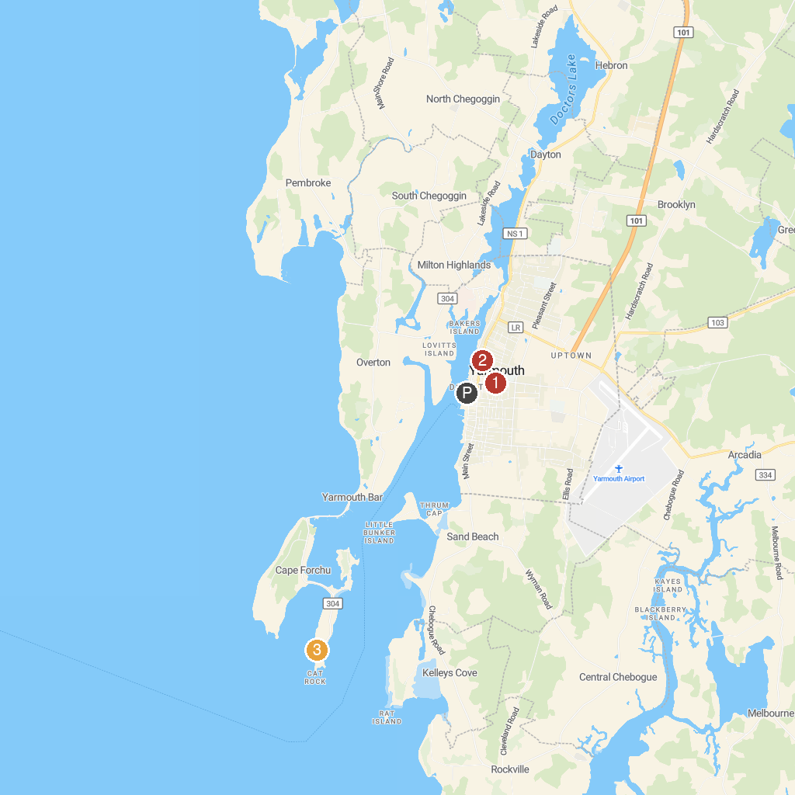
MAP KEY
1. Yarmouth County Museum and Archives | 3. Cape Forchu Lighthouse
2. Firefighters’ Museum of Nova Scotia
P. Cruise port / terminal
Map © MapTiler © OpenStreetMap contributors · cruiseports.org

