Yanbu Al-Bahr, Madinah Region, Saudi Arabia
Saudi Arabia's emerging Red Sea cruise port blends a 500-year-old coral-stone old town with some of the clearest, least-crowded dive sites on the planet. Tourism is new here — and locals are thrilled to welcome you.
⚓ Pier (docked) · 🕒 Typical call: 8-10 hrs · 💵 Saudi Riyal (SAR) · 🗣️ Arabic (English widely understood in tourist areas) · 🌡️ Best Nov–Apr
✍️ MY DAY IN PORT (FILL IN)
Ship / Date
In port | arrive ______ · all aboard ______
Booked excursion
Notes / meeting point
GETTING ASHORE
- Docking: Pier — Yanbu Commercial Port; large cruise ships dock directly, no tender
- Walk to center: ~2 km to Yanbu Corniche; ~4 km to Old Town (Yanbu Al-Balad); taxis/Uber recommended
- Best For: Red Sea diving & snorkeling, Old Town history, authentic Saudi culture
- Don't Miss: Lawrence of Arabia House, Souq Al Layl night market, coral reef snorkeling
GETTING AROUND
- 🚕 Taxi: SAR 30–50 — Metered taxis are available outside the cruise terminal. The ride to Yanbu Al-Balad (old town) or city center takes abou
- 📱 Rideshare: ✅ Uber, Careem
TOP THINGS TO DO
- Yanbu Old Town (Al-Balad) Walk — Wander lanes of 500-year-old coral-stone buildings, spot fossilized sea life embedded in the walls, browse Souq Al Layl, and…
- Lawrence of Arabia House — Visit the restored house where T.E.
- Red Sea Snorkeling & Diving — Yanbu's reefs are among the least-crowded on the Red Sea.
- Baridi Island Beach Escape — A short boat ride from port, Baridi Island has powdery sand, turquoise shallows, and good snorkeling reefs — perfect if you want…
- Yanbu Corniche & Waterfront Stroll — The modern corniche runs along the Red Sea with cafes, street food stalls, an outdoor amphitheater, and evening fountains.
BEST WALKS
- Old Town Heritage Loop: 1.5 km loop • ~45 min • Easy • Mostly flat — Start at the historic Souq Al Layl, wind through coral-stone alleyways past traditional merchant…
- Yanbu Corniche Promenade: 2 km one-way • ~30 min • Easy • Seafront — Walk north along the Corniche from Al-Salam Park to the Waterfront Theater.
WEATHER · DAYLIGHT · MONEY
Month | High °F | Low °F | Rainy days
May | 97 | 77 | 0
Jul | 101 | 82 | 0
Sep | 101 | 83 | 0
Daylight: May 5:45AM–7:03PM · Jul 5:49AM–7:17PM · Sep 6:14AM–6:31PM
cruiseports.org/yanbu-al-bahr · Confirm terminal & all-aboard time with your ship

Yanbu Al-Bahr, Madinah Region, Saudi Arabia — Port Map
Red = walkable sights · Amber = excursions farther out · P = cruise terminal
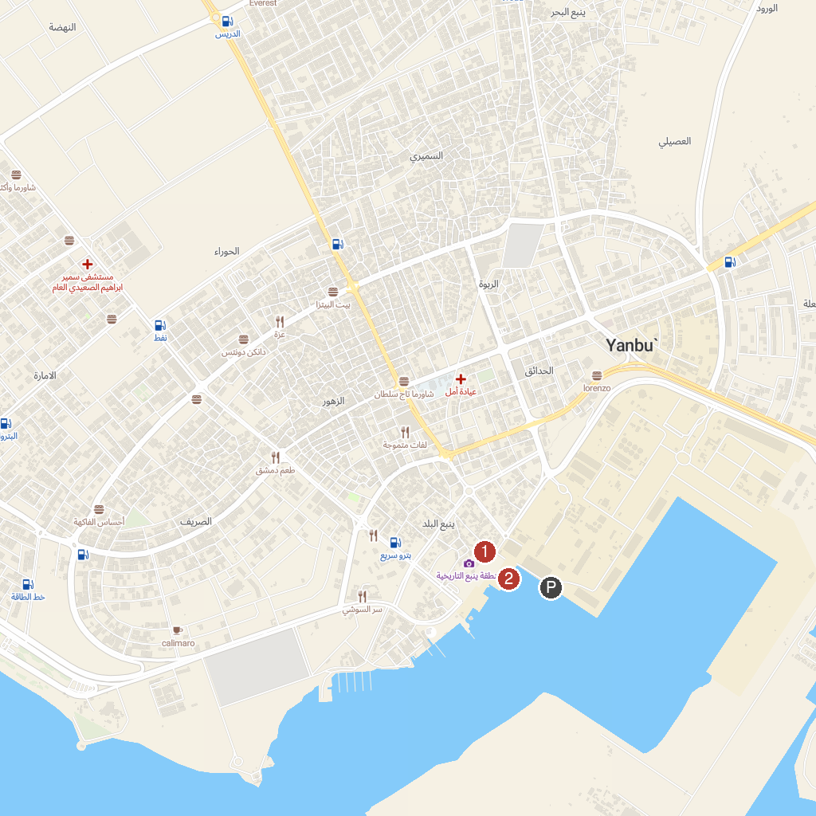
MAP KEY
1. Night market | 3. Yanbu Cruise Pirs
2. yanbu cruise parking
P. Cruise port / terminal
Map © MapTiler © OpenStreetMap contributors · cruiseports.org

