Yakushima Island, Kagoshima, Japan
A UNESCO World Natural Heritage island of ancient cedar giants and moss-draped forest. Yakushima inspired Studio Ghibli's Princess Mononoke — and stepping ashore, you'll understand why.
⚓ Pier (Miyanoura or Anbo Port) · 🕒 Typical call: 8-10 hrs · 💴 Currency: Japanese Yen (JPY) · 🗣️ Language: Japanese · 🌧️ Rainy year-round — pack waterproofs
✍️ MY DAY IN PORT (FILL IN)
Ship / Date
In port | arrive ______ · all aboard ______
Booked excursion
Notes / meeting point
GETTING ASHORE
- Docking: Pier — Miyanoura Port (main) or Anbo Port
- Walk to center: Miyanoura town is steps from the pier; forest trailheads need a bus or taxi (30–60 min)
- Best For: Hikers, nature lovers, wildlife spotting, ancient forests
- Don't Miss: Shiratani Unsuikyo Ravine (moss forest) or Yakusugi Land for shorter hikes
GETTING AROUND
- 🚕 Taxi: ¥2,500–¥5,000 — Three local taxi companies serve Miyanoura and Anbo ports: Anbo Taxi, Matsubanda Taxi, and Yakushima Kotsu Taxi. Advance
- 📱 Rideshare: ❌ not available
TOP THINGS TO DO
- Shiratani Unsuikyo Ravine — The moss-carpeted ravine that inspired Princess Mononoke.
- Yakusugi Land — A dedicated natural park showcasing cedars over 1,000 years old (yakusugi).
- Jomon Sugi Full-Day Hike — Japan's oldest living cedar — estimated at 2,000–7,200 years old.
- Wildlife Spotting Drive — Yakushima's roads are roamed by native Yakushima deer and Japanese macaque monkeys.
- Hirauchi Kaichu Onsen (Tidal Hot Spring) — A wild hot spring on the southern coast that appears only at low tide — the rocks form natural pools filled by geothermal heat.
BEST WALKS
- Miyanoura Waterfront & Town: 30–45 min | Flat | From pier — A short walk through Miyanoura town from the port: browse the market and visit the Yakushima…
- Shiratani Unsuikyo — Yayoisugi Cedar Trail: 1 hr | Easy | ¥500 entry — The shortest loop inside Shiratani Unsuikyo Ravine, passing the ancient Yayoisugi cedar and through…
WEATHER · DAYLIGHT · MONEY
Month | High °F | Low °F | Rainy days
May | 75 | 66 | 16
Jul | 85 | 79 | 21
Sep | 83 | 76 | 23
Daylight: May 5:23AM–7:04PM · Jul 5:26AM–7:21PM · Sep 6:02AM–6:23PM
cruiseports.org/yakushima-island-japan · Confirm terminal & all-aboard time with your ship

Yakushima Island, Kagoshima, Japan — Port Map
Red = walkable sights · Amber = excursions farther out · P = cruise terminal
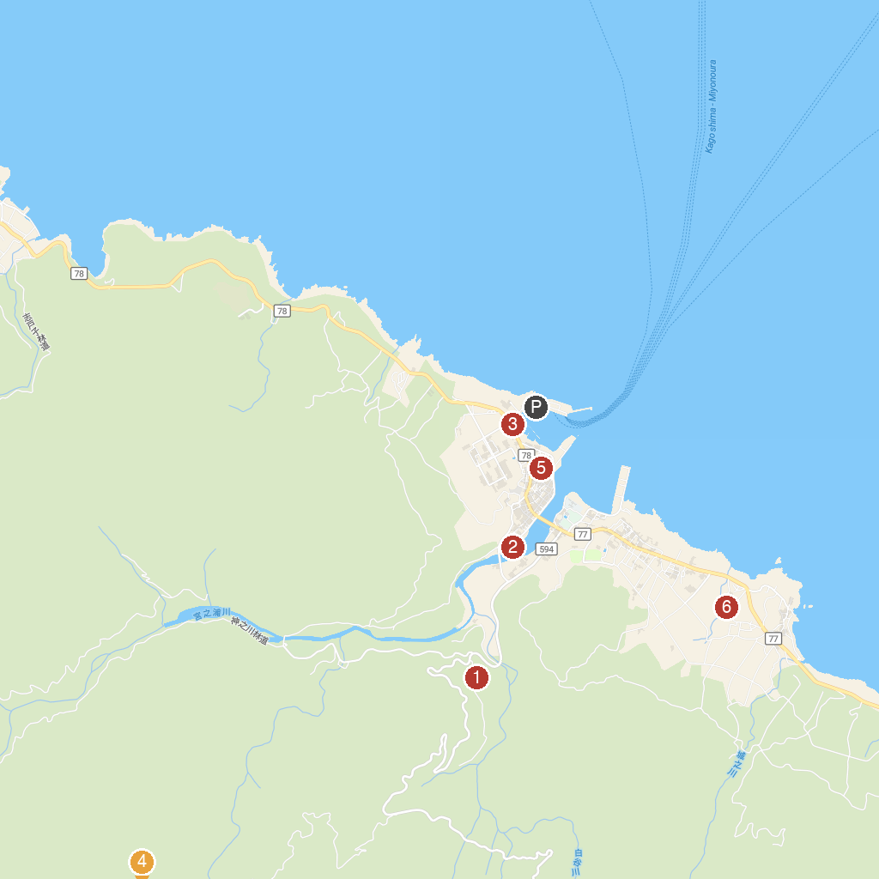
MAP KEY
1. Yakusugi Land | 5. Yakushima Environmental and Cultural Village Center
2. Yakusugi Museum | 6. Jōmon Sugi
3. Ushidokomoisho | 7. Yaku-jinja
4. Yakushima Museum of History and Folklore | 8. Yakushima Shrine
P. Cruise port / terminal
Map © MapTiler © OpenStreetMap contributors · cruiseports.org

