Xiamen, Fujian, China
One of China's most livable cities, Xiamen blends colonial-era European architecture on car-free Gulangyu Island with vibrant street food lanes, Buddhist temples, and sweeping views across the strait toward Taiwan.
⚓ Pier (Dongdu Terminal) · 🕒 Typical call: 8-10 hrs · 💵 Chinese Yuan (RMB) — cashless via Alipay/WeChat · 🗣️ Mandarin/Minnan dialect · 🇨🇳 Visa or 144-hr transit waiver
✍️ MY DAY IN PORT (FILL IN)
Ship / Date
In port | arrive ______ · all aboard ______
Booked excursion
Notes / meeting point
GETTING ASHORE
- Docking: Pier — Xiamen International Cruise Center (Dongdu Terminal), western Xiamen Island
- Walk to center: Not walkable — metro Line 2 from Cruise Center Station reaches downtown in 20 min
- Best For: UNESCO island day-trip, street food, Buddhist temples, Taiwan strait views
- Don't Miss: Gulangyu Island ferry (book early!), satay noodles on Zhongshan Road
GETTING AROUND
- 🚕 Taxi: CNY 10–15 (~USD 1.50–2) — Metered taxis are plentiful outside the terminal. The city center is only ~3 km away, keeping fares near the base rate;
- 📱 Rideshare: ✅ Didi
- 🚌 Hop-on hop-off: ✅
TOP THINGS TO DO
- Gulangyu Island Day-Trip — UNESCO World Heritage island just a short ferry hop from the cruise terminal.
- Hulishan Fortress & Krupp Cannon — Qing Dynasty coastal fort (1894) with thick granite battlements and the world's largest preserved 19th-century German Krupp cannon.
- Nanputuo Temple & Wulao Mountain Hike — Active Tang Dynasty Buddhist temple at the foot of Wulao Mountain — colorful roofs, lotus ponds, and resident monks.
- Zhongshan Road Street Food Walk — Xiamen's famous pedestrian boulevard lined with white colonial arcade buildings.
- Xiamen University & Baicheng Beach — China's most beautiful university campus mixes Western and Chinese architecture around a scenic lakeside.
BEST WALKS
- Zhongshan Road to the Waterfront: 1.5 km · 25 min · Easy · Metro start — Exit Metro Line 2 at Zhongshan Road Station and walk the full pedestrian boulevard of colonial…
- Nanputuo Temple to Baicheng Beach: 1.8 km · 30 min · Easy · Coastal — Start at Nanputuo Temple, walk through the temple grounds, then follow the path past Xiamen…
WEATHER · DAYLIGHT · MONEY
Month | High °F | Low °F | Rainy days
May | 82 | 71 | 17
Jul | 91 | 80 | 15
Sep | 89 | 77 | 13
Daylight: May 5:24AM–6:43PM · Jul 5:28AM–6:58PM · Sep 5:54AM–6:11PM
cruiseports.org/xiamen · Confirm terminal & all-aboard time with your ship

Xiamen, Fujian, China — Port Map
Red = walkable sights · Amber = excursions farther out · P = cruise terminal
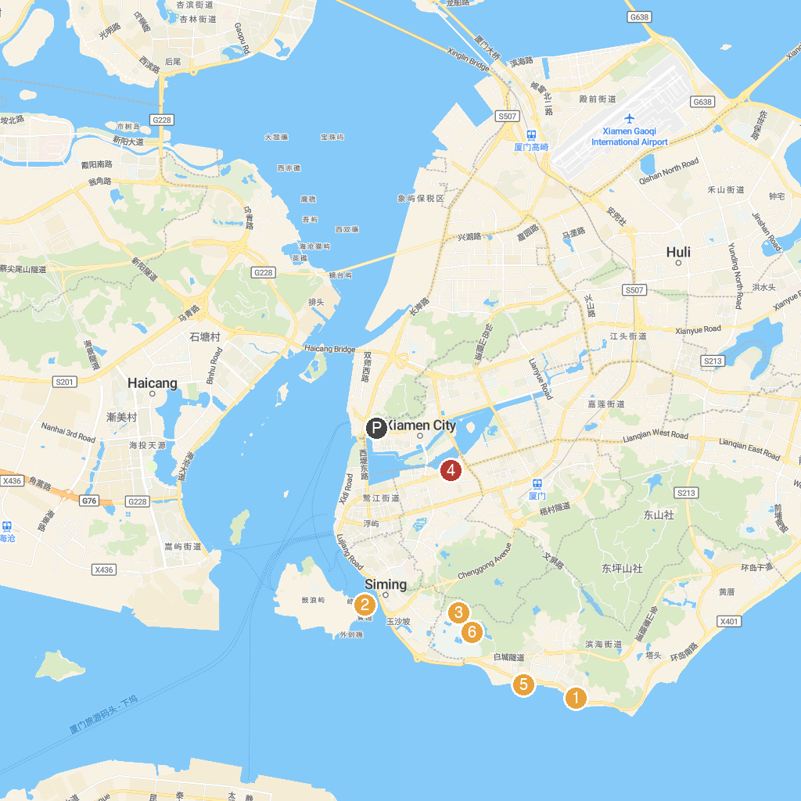
MAP KEY
1. Xiamen Calligraphy Square | 4. 白鹭洲公园
2. Gulangyu Wharf | 5. 环岛路
3. 万石山风景区 | 6. South Putuo Temple
P. Cruise port / terminal
Map © MapTiler © OpenStreetMap contributors · cruiseports.org

