Wyndham, Western Australia, Australia
Wyndham sits where five wild rivers pour into the Cambridge Gulf — a frontier port town of 800 souls, ancient red gorges, and some of Australia's largest saltwater crocodiles. This is the Kimberley at its most raw.
⚓ Pier (Anthon's Landing Jetty; tenders possible at low tide) · 🕒 Typical call: 6-8 hrs · 💵 Australian Dollar (AUD) · 🗣️ English · 🌡️ Extreme heat year-round — 35°C+ (95°F+)
✍️ MY DAY IN PORT (FILL IN)
Ship / Date
In port | arrive ______ · all aboard ______
Booked excursion
Notes / meeting point
GETTING ASHORE
- Docking: Anthon's Landing Jetty — most expedition ships berth directly; tenders used when tidal conditions or berth occupancy require
- Walk to Town: Wyndham Port (old town) is immediately off the pier; Three Mile (main town) is 5 km away — shuttle or tour bus required
- Best For: Scenic flights over the Bungle Bungles, Five Rivers Lookout, outback wildlife, authentic frontier Australia
- Don't Miss: Five Rivers Lookout at sunrise — one of the most spectacular panoramas in Australia
GETTING AROUND
- 🚕 Taxi: AUD $15–$30 — A small number of local taxis serve Wyndham but must be pre-arranged — there are no street-hail cabs. Ask your cruise li
TOP THINGS TO DO
- Five Rivers Lookout — Drive up the steep Bastion Range road to 360 m above town for a panoramic view of the Ord, Forrest, King, Pentecost, and Durack…
- Scenic Flight to the Bungle Bungles — Fly over Purnululu National Park's iconic orange-and-black striped beehive domes — a UNESCO World Heritage Site.
- Ord River Boat Cruise — High-speed cruise along the Ord River between Lake Argyle and Kununurra, spotting freshwater crocodiles, flying foxes, brolgas…
- El Questro Wilderness Park — Day tour to this legendary Kimberley cattle station with deep sandstone gorges, the thermal Zebedee Springs, dramatic Emma Gorge…
- Kununurra Day Trip — About 1.5 hours away, Kununurra offers the Hoochery Distillery (WA's oldest legal rum), the Sandalwood Factory, local Aboriginal…
BEST WALKS
- Wyndham Port Heritage Walk: 1.5 km loop · Flat · 30–45 min — From the jetty gate, walk to the historic Wyndham Port Cemetery, then past the Wyndham Town Club…
- Three Mile Town Stroll: 1 km loop · Flat · 20–30 min (via shuttle) — Take the ship shuttle to Three Mile.
WEATHER · DAYLIGHT · MONEY
Month | High °F | Low °F | Rainy days
May | 91 | 71 | 1
Jul | 87 | 65 | 0
Sep | 95 | 74 | 0
Daylight: May 5:42AM–5:05PM · Jul 5:55AM–5:12PM · Sep 5:22AM–5:22PM
cruiseports.org/wyndham-wa · Confirm terminal & all-aboard time with your ship

Wyndham, Western Australia, Australia — Port Map
Red = walkable sights · Amber = excursions farther out · P = cruise terminal
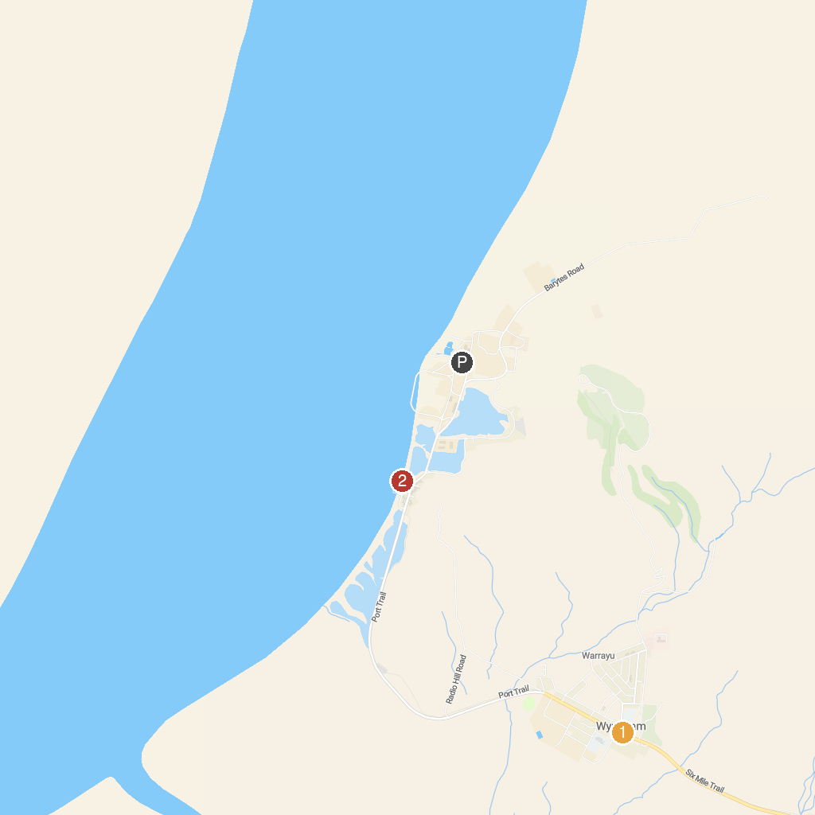
MAP KEY
1. The Big Crocodile | 2. Fishermans jetty
P. Cruise port / terminal
Map © MapTiler © OpenStreetMap contributors · cruiseports.org

