Wilmington, North Carolina, USA
Where the Cape Fear River meets a storied colonial port city — Wilmington rewards cruise visitors with a walkable Riverwalk, a legendary WWII battleship, and one of the South's most intact historic downtowns.
⚓ Docked (city docks / Riverwalk) · 🕒 Typical call: 8-10 hrs · 💵 US Dollar (USD) · 🗣️ English · 🚢 Small ships & expedition vessels
✍️ MY DAY IN PORT (FILL IN)
Ship / Date
In port | arrive ______ · all aboard ______
Booked excursion
Notes / meeting point
GETTING ASHORE
- Docking: Docked at city docks along the downtown Riverwalk; small/expedition ships only — bridge height limits large vessels
- Walk to center: Steps from the dock — the Riverwalk and Historic Downtown are immediately adjacent
- Best For: History lovers, WWII buffs, Southern dining, strolling a beautiful riverside downtown
- Don't Miss: Battleship North Carolina — the most battle-decorated US battleship of WWII, moored just across the river
GETTING AROUND
- 🚕 Taxi: ~$10-15 downtown — Local taxis (e.g. Angel's Taxi) are available at the port. Base fare around $4 plus ~$3–$5/mile; a short downtown ride r
- 📱 Rideshare: ✅ Uber, Lyft
TOP THINGS TO DO
- Battleship North Carolina — The most decorated US battleship of World War II is permanently moored just across the Cape Fear River.
- Historic Downtown Walking Tour — Wilmington's 230-block historic district is one of the largest in the South.
- Wrightsville Beach Day — One of the best beaches on the East Coast is just 15 minutes away.
- Cape Fear River Cruise — Board a narrated riverboat with Cape Fear Riverboats for an ecological and historical tour of the river, with views of the…
- Cape Fear Museum — A well-curated regional museum covering the natural and human history of the Cape Fear area — including a surprising Michael…
BEST WALKS
- Cape Fear Riverwalk Stroll: ~2 miles one-way | Easy | 45-60 min — Walk the full length of the Riverwalk from the northern docks (near the Isabel Holmes Bridge) south…
- Historic Downtown Loop: ~1.5 miles | Easy | 45-60 min — From the Riverwalk head east into the historic district.
WEATHER · DAYLIGHT · MONEY
Month | High °F | Low °F | Rainy days
May | 78 | 64 | 11
Jul | 86 | 75 | 18
Sep | 81 | 70 | 13
Daylight: May 6:09AM–8:06PM · Jul 6:11AM–8:23PM · Sep 6:55AM–7:17PM
cruiseports.org/wilmington-nc · Confirm terminal & all-aboard time with your ship

Wilmington, North Carolina, USA — Port Map
Red = walkable sights · Amber = excursions farther out · P = cruise terminal
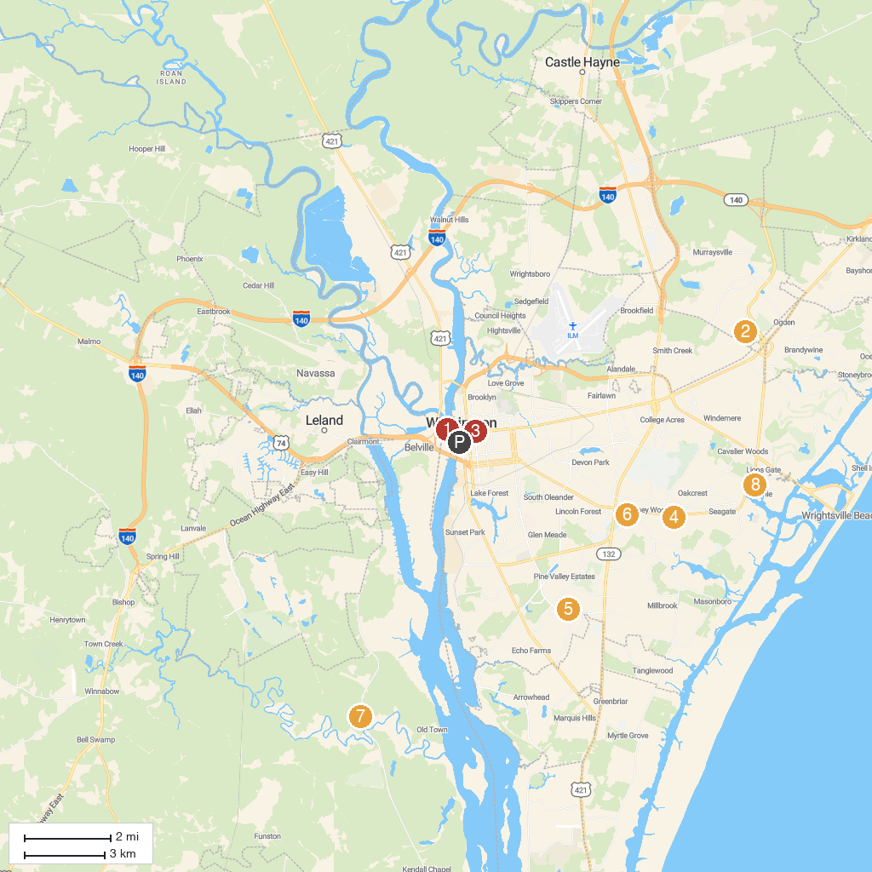
MAP KEY
1. Battleship North Carolina | 5. Halyburton Park
2. Ogden Park | 6. Long Leaf Park
3. Bellamy Mansion Museum | 7. Brunswick Nature Park
4. Jungle Rapids Family Fun Park | 8. Airlie Gardens
P. Cruise port / terminal
Map © MapTiler © OpenStreetMap contributors · cruiseports.org

