Willemstad, Curaçao, Kingdom of the Netherlands
Willemstad's electric-painted Dutch façades along the Handelskade waterfront make it one of the most photogenic ports in the Caribbean — and behind the Instagram backdrop lies a genuinely walkable, historic city with world-class diving and beaches a short drive away.
⚓ Docked — Mega Pier (Sint Annabaai) · 🕒 Typical call: 8-10 hrs · 💵 USD widely accepted (ANG local) · 🗣️ Papiamentu, Dutch, English
✍️ MY DAY IN PORT (FILL IN)
Ship / Date
In port | arrive ______ · all aboard ______
Booked excursion
Notes / meeting point
GETTING ASHORE
- Docking: Mega Pier, Sint Annabaai — a 10-min walk or free shuttle to downtown Punda
- Walk to center: ~10-15 min on foot to Queen Emma Bridge and Handelskade
- Best For: Colorful waterfront photography, Caribbean beaches, snorkeling, colonial history
- Don't Miss: Queen Emma Bridge swinging open to let tall ships pass — it happens throughout the day
GETTING AROUND
- 🚕 Taxi: ~$15-25 USD (up to 4 passengers) — Government-regulated fixed fares to Otrobanda or Punda city center. A 25% surcharge applies after 11 PM and for larger g
- 📱 Rideshare: ❌ not available
TOP THINGS TO DO
- Cas Abao Beach Day — One of the Caribbean's genuinely great beaches — white sand, calm turquoise water, and a laid-back beach bar.
- Willemstad City & Handelskade Walking Tour — A guided walk through the UNESCO World Heritage city center: the iconic yellow-and-orange Handelskade façades, the swinging Queen…
- Snorkeling or Diving at the Coral Reefs — Curaçao's leeward coast has healthy coral walls starting just meters from shore.
- Hato Caves — A well-preserved limestone cave system on the island's north coast, about 15 minutes from Willemstad.
- Curaçao Museum & Otrobanda District — Otrobanda ('the other side' of the pontoon bridge) is a quieter residential district with colorful colonial streets and the…
BEST WALKS
- Punda Heritage Loop: 2 hrs · ~2.5 km · Easy · Flat — The classic Willemstad walk.
- Otrobanda & Rif Fort Stroll: 1 hr · ~1.5 km · Easy — Cross to Otrobanda via the pedestrian ferry or Queen Wilhelmina Bridge, then walk west along the…
WEATHER · DAYLIGHT · MONEY
Month | High °F | Low °F | Rainy days
May | 85 | 79 | 8
Jul | 85 | 79 | 15
Sep | 87 | 81 | 10
Daylight: May 6:11AM–6:52PM · Jul 6:18AM–7:04PM · Sep 6:25AM–6:36PM
cruiseports.org/willemstad · Confirm terminal & all-aboard time with your ship

Willemstad, Curaçao, Kingdom of the Netherlands — Port Map
Red = walkable sights · Amber = excursions farther out · P = cruise terminal
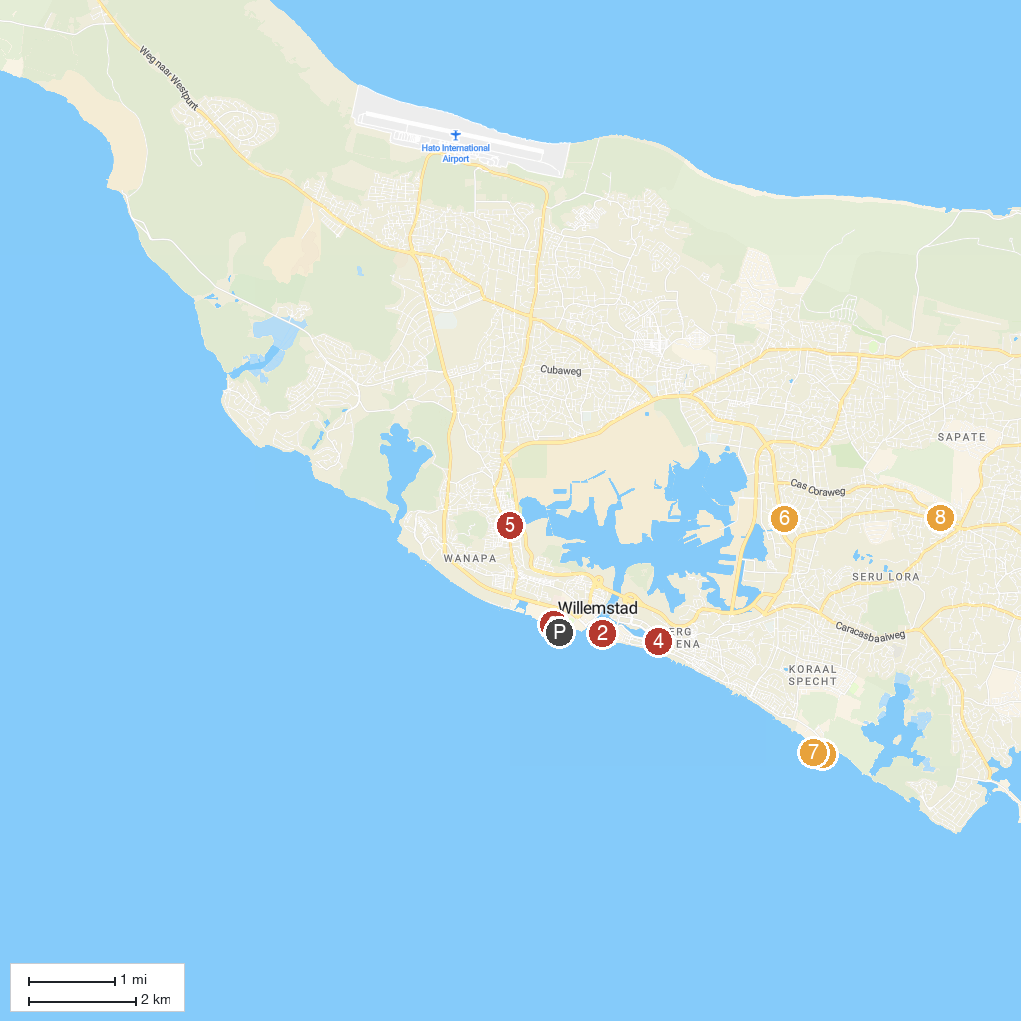
MAP KEY
1. Curaçao Sea Aquarium | 5. Gallery Alma Blou
2. Fort Church | 6. Mongui Maduro Historic House Museum
3. MV Superior Producer - Curaçao Iconic Shipwreck | 7. Substation Curacao
4. Queen of the Most Holy Rosary Cathedral | 8. Montaña Bierhuis Village
P. Cruise port / terminal
Map © MapTiler © OpenStreetMap contributors · cruiseports.org

