Willemstad, North Brabant, Netherlands
A near-perfect seven-pointed star fortress on the Hollands Diep — Willemstad rewards a slow stroll along its 16th-century ramparts, past a domed Protestant church, a working windmill, and a snug harbor of sailing yachts, all within a few minutes of the quay.
⚓ Docked (riverside quay) · 🕒 Typical call: a few hours · 💶 Euro (EUR); cards widely accepted · 🗣️ Dutch spoken; English widely understood · 🌡️ Temperate maritime climate
✍️ MY DAY IN PORT (FILL IN)
Ship / Date
In port | arrive ______ · all aboard ______
Booked excursion
Notes / meeting point
GETTING ASHORE
- Docking: River ships moor alongside the quay on the Hollands Diep / town harbor — docked, no tender
- Walk to center: A few minutes on foot; the entire fortified town is compact and walkable
- Best For: Star-fortress ramparts, Dutch history, the windmill, harbor strolls, small-town charm
- Don't Miss: The seven-bastion star walls, the octagonal Koepelkerk (Dome Church), and d'Orangemolen windmill
GETTING AROUND
- 🚕 Taxi: ~$14–20 USD — Government-regulated taxis queue at the terminal; the fixed rate to the city center is roughly $14–20 for up to 4 passen
- 📱 Rideshare: ❌ not available
TOP THINGS TO DO
- Star Fortress Ramparts Walk — Follow the grass-topped earthen ramparts that ring the town in a seven-pointed star, laid out for William the Silent in the 1580s.
- Koepelkerk (Dome Church) — Visit the octagonal, domed Protestant church built between 1597 and 1607 — the first church in the Netherlands purpose-built for…
- d'Orangemolen Windmill — See the town's tower windmill, d'Orangemolen, commissioned under the Prince of Orange in 1734 and a national monument.
- Prinsenhof / Mauritshuis (Gouvernementshuis) — The 17th-century Mauritshuis of Willemstad — also called the Prinsenhof or Gouvernementshuis, begun in 1623 — was a residence…
- Historic Harbor Stroll — Wander the snug town harbor lined with sailing yachts and historic façades, then settle on a waterside terrace for coffee, Dutch…
BEST WALKS
- Ramparts & Harbor Loop: 2-3 km · 45-60 min · Easy · Flat — Start at the quay, climb onto the earthen ramparts and follow the seven-bastion star around the…
- Old Town Lanes Stroll: 1-2 km · 30 min · Easy · Flat — Wander the cobbled inner lanes past historic Dutch façades, the Mauritshuis (Prinsenhof), and small…
WEATHER · DAYLIGHT · MONEY
Month | High °F | Low °F | Rainy days
May | 64 | 48 | 11
Jul | 73 | 58 | 14
Sep | 68 | 54 | 11
Daylight: May 6:11AM–6:52PM · Jul 6:18AM–7:04PM · Sep 6:25AM–6:36PM
cruiseports.org/willemstad-nl · Confirm terminal & all-aboard time with your ship

Willemstad, North Brabant, Netherlands — Port Map
Red = walkable sights · Amber = excursions farther out · P = cruise terminal
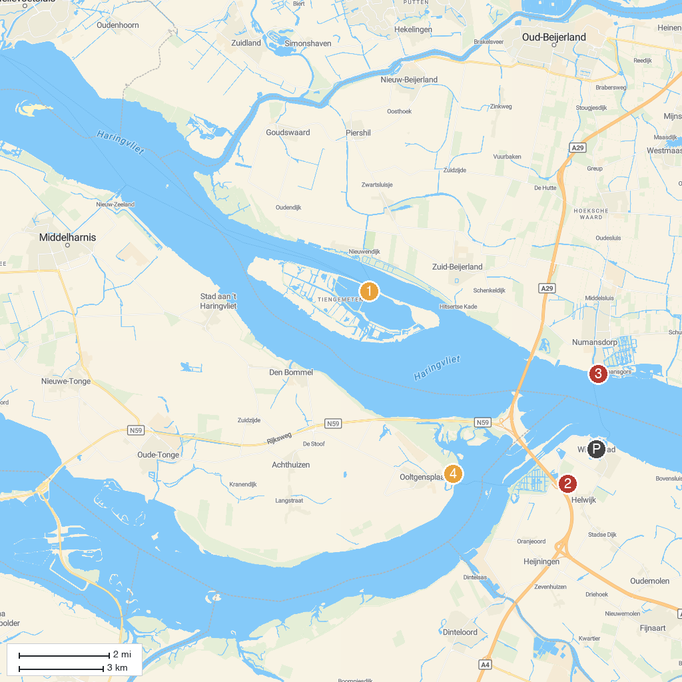
MAP KEY
1. Rien Poortvliet Museum | 4. Fort Buitensluis
2. Oudenbosch Basilica | 5. Watchtower Ooltgensplaat Hellegatsplaten
3. Escape Room Fort de Hel
P. Cruise port / terminal
Map © MapTiler © OpenStreetMap contributors · cruiseports.org

