Whittier, Alaska, USA
Tucked into the mountains at the head of Passage Canal, Whittier is Alaska's most singular port — a tiny Cold War town where most residents live in a single skyscraper, surrounded by waterfalls, glaciers, and the calm waters of Prince William Sound.
⚓ Pier (docked) · 🕒 Typical call: embark/debark day · 💵 USD · 🗣️ English · 🌧️ Very rainy — pack waterproofs
✍️ MY DAY IN PORT (FILL IN)
Ship / Date
In port | arrive ______ · all aboard ______
Booked excursion
Notes / meeting point
GETTING ASHORE
- Docking: Pier — all ships dock (no tender). New Chugach Glacier Gateway Terminal (NCLH brands) + Old Dock (Princess & Holland America).
- Walk to center: 5–10 min flat walk from pier to harbor/town center (~0.3 miles, wheelchair accessible).
- Best For: Glacier cruises on Prince William Sound, WWII history, kayaking, and dramatic Alaskan scenery.
- Don't Miss: The 26 Glacier Cruise with Phillips Cruises and the free Portage Pass Trail hike to Portage Glacier views.
GETTING AROUND
- 📱 Rideshare: ✅ Uber, Whittier Cruiser
TOP THINGS TO DO
- 26 Glacier Cruise — Prince William Sound — Phillips Cruises' signature 26 Glacier Cruise takes you deep into Prince William Sound to see 26 named glaciers, including…
- Sea Kayaking in Prince William Sound — Paddle the famously calm, protected waters of Prince William Sound past waterfalls, near glacier faces, and alongside harbor…
- Jet Ski Glacier Tour — One of the few places in Alaska where you can ride a guided jet ski to the face of a glacier — a thrilling way to experience…
- Whittier WWII Military History Tour — Whittier was built as a secret Army port in WWII.
- Spencer Glacier Float & Train — Take the Alaska Railroad Glacier Discovery train from Whittier to the Spencer Whistle Stop, then float the Placer River through…
BEST WALKS
- Harbor & Town Stroll: 0.5 miles | 20 min | Easy | Flat — Walk from your pier along the waterfront to the small boat harbor, past tour operator docks, shops…
- Portage Pass Trail: 4 miles round-trip | 2–3 hrs | Moderate | Views of Portage Glacier — Whittier's best free hike.
- Whittier Creek & Horsetail Falls: 0.75 miles | 20–30 min | Easy | Waterfall — A gentle stroll from town along Whittier Creek to Horsetail Falls, one of several dramatic…
cruiseports.org/whittier · Confirm terminal & all-aboard time with your ship

Whittier, Alaska, USA — Port Map
Red = walkable sights · Amber = excursions farther out · P = cruise terminal
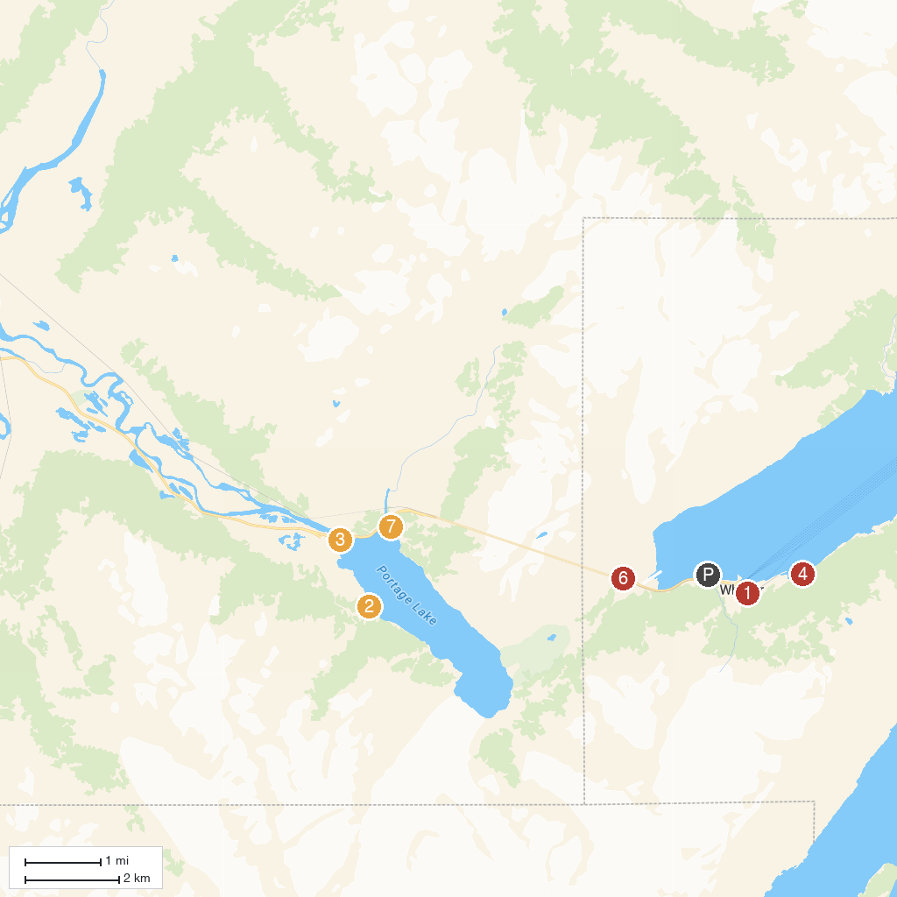
MAP KEY
1. Prince William Sound Museum | 5. Phillips Cruises & Tours, LLC
2. Portage Glacier Cruises | 6. Portage Road Pass
3. Begich, Boggs Visitor Center | 7. Portage Lake Overlook
4. Lu Young Public Beach
P. Cruise port / terminal
Map © MapTiler © OpenStreetMap contributors · cruiseports.org

