Whangarei, Northland, New Zealand
New Zealand's northernmost city serves up a Hundertwasser architectural masterpiece, a curtain waterfall draped in native bush, and ancient kauri forest — all within striking distance of Northport's deep-water berths.
⚓ Pier (Northport/Marsden Point) · 🕒 Typical call: 8-10 hrs · 💵 NZ Dollar (NZD) · 🗣️ English & Te Reo Māori · 🌿 Subtropical Northland
✍️ MY DAY IN PORT (FILL IN)
Ship / Date
In port | arrive ______ · all aboard ______
Booked excursion
Notes / meeting point
GETTING ASHORE
- Docking: Pier at Northport, Marsden Point — no tender required
- Port to Town Basin: 35 km / ~35-40 min by shuttle or taxi
- Best For: Art, waterfalls, Māori culture, nature walks
- Don't Miss: Hundertwasser Art Centre & Whangarei Falls
GETTING AROUND
- 🚕 Taxi: NZD – one way — Port access is restricted — taxis and private transfers must be pre-booked. Operators like Whangarei Passenger Services
- 📱 Rideshare: ✅ Uber
TOP THINGS TO DO
- Hundertwasser Art Centre — The last building completed to Hundertwasser's designs anywhere on earth, featuring an afforested living roof, undulating floors…
- Whangarei Falls (Otuihau) — A stunning 26-metre curtain waterfall wrapped in native bush, just 10 minutes by taxi from the Town Basin.
- Abbey Caves Glowworm Adventure — Three undeveloped limestone caverns 10 minutes from town.
- AH Reed Kauri Forest Canopy Walk — Elevated boardwalk threading through one of Northland's last stands of ancient kauri trees — some over 500 years old.
- Kiwi North Heritage Park — See a live kiwi bird in a state-of-the-art nocturnal house, plus tuatara (a living reptile unchanged for 220 million years) and a…
BEST WALKS
- Hatea Loop (Huarahi o te Whai): 4.2 km loop | ~1 hr | Easy | Fully accessible — Whangarei's signature waterfront circuit hugs the Hatea River through the Town Basin, crossing the…
- Town Basin Waterfront Stroll: 1-2 km | 30-45 mins | Easy | Flat — A relaxed wander along the marina taking in the Hundertwasser Art Centre, Clapham's Clock Museum…
WEATHER · DAYLIGHT · MONEY
Month | High °F | Low °F | Rainy days
May | 64 | 53 | 10
Jul | 58 | 48 | 14
Sep | 61 | 49 | 14
Daylight: May 7:11AM–5:26PM · Jul 7:30AM–5:27PM · Sep 6:23AM–6:13PM
cruiseports.org/whangarei · Confirm terminal & all-aboard time with your ship

Whangarei, Northland, New Zealand — Port Map
Red = walkable sights · Amber = excursions farther out · P = cruise terminal
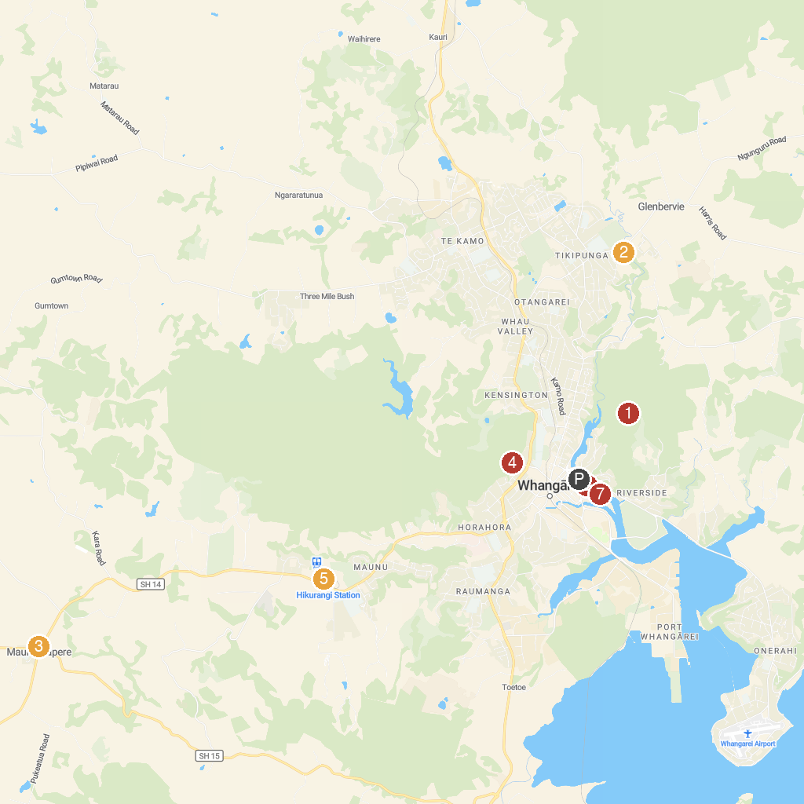
MAP KEY
1. Mount Parihaka Lookout and Memorial | 5. Kiwi North: Museum, Kiwi House and Heritage Park
2. Whangarei Falls | 6. Reyburn House Art Gallery
3. Packard Motor Museum | 7. Town Basin Loop Track Sculpture Trail
4. The Quarry Arts Centre
P. Cruise port / terminal
Map © MapTiler © OpenStreetMap contributors · cruiseports.org

