Westray Island, Orkney, Scotland
The 'Queen of the Isles' rewards those who make the journey — windswept clifftop puffin colonies, a 5,000-year-old carved figurine, and a ruined castle tied to Mary Queen of Scots await on this remote Orcadian gem.
⚓ Tender (no deep-water berth) · 🕒 Typical call: 6–8 hrs · 💷 Currency: British Pound (GBP) · 🗣️ Language: English · 🐦 Best May–Aug for puffins
✍️ MY DAY IN PORT (FILL IN)
Ship / Date
In port | arrive ______ · all aboard ______
Booked excursion
Notes / meeting point
GETTING ASHORE
- Docking: Tender — ships anchor in Pierowall Roadstead; tenders land at Gill Pier or Pierowall Harbour
- Walk to village: ~5 min from Gill Pier to Pierowall centre
- Best For: Birdwatching, archaeology, empty beaches, Scottish island life
- Don't Miss: Westray Heritage Centre (Orkney Venus figurine) & puffins at Castle o' Burrian
GETTING AROUND
- 🚕 Taxi: ~£4 first mile, £1.80/mile after — W. I. Rendall offers an informal taxi service bookable by phone. Orkney-regulated fares apply; pre-booking is strongly r
- 📱 Rideshare: ❌ not available
TOP THINGS TO DO
- Puffin Watch at Castle o' Burrian — A sea stack on the southeast coast hosts hundreds of puffins from May to August.
- Westray Heritage Centre & The Orkney Venus — This community museum in Pierowall houses the 5,000-year-old 'Westray Wife' — the earliest representation of a human face found…
- Noltland Castle — A striking 16th-century ruin built by Gilbert Balfour — a man linked to the murder of Lord Darnley, husband of Mary Queen of Scots.
- Noup Head RSPB Seabird Reserve — The island's northwest tip hosts over 40,000 nesting seabirds — gannets, kittiwakes, guillemots — along dramatic clay cliffs.
- Grobust Beach & Links of Noltland — White-sand dunes and turquoise water on the north coast, adjacent to an active Neolithic archaeological dig (Links of Noltland).
BEST WALKS
- Gill Pier to Pierowall Village & Heritage Centre: 1 mile round trip | 20 min | Flat & paved — Walk the coastal road from Gill Pier into Pierowall village.
- Pierowall to Noltland Castle: 2 miles round trip | 40 min | Gently rolling — From the village, follow the road southwest to the imposing ruin of Noltland Castle.
WEATHER · DAYLIGHT · MONEY
Month | High °F | Low °F | Rainy days
May | 49 | 46 | 14
Jul | 56 | 53 | 15
Sep | 56 | 53 | 18
Daylight: May 4:39AM–9:39PM · Jul 4:22AM–10:12PM · Sep 6:41AM–7:31PM
cruiseports.org/westray-island-scotland · Confirm terminal & all-aboard time with your ship

Westray Island, Orkney, Scotland — Port Map
Red = walkable sights · Amber = excursions farther out · P = cruise terminal
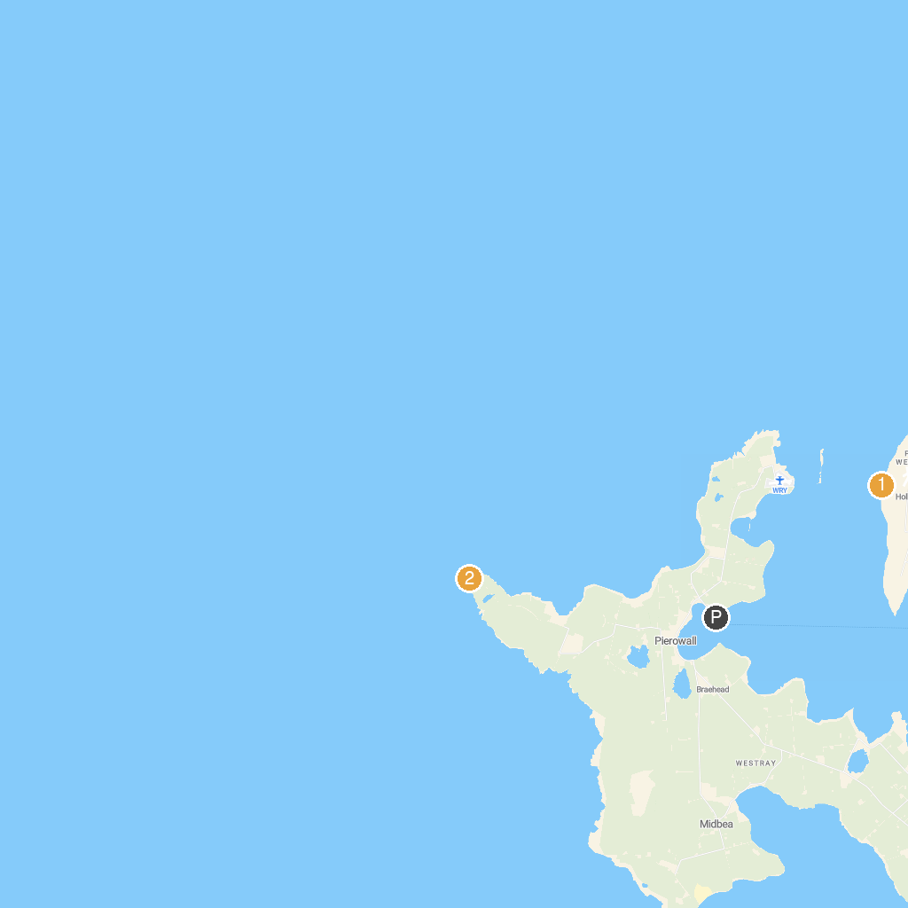
MAP KEY
1. Knap of Howar | 2. Noup Head Lighthouse
P. Cruise port / terminal
Map © MapTiler © OpenStreetMap contributors · cruiseports.org

