Wesel, North Rhine-Westphalia, Germany
Where the Rhine meets the Lippe, Wesel packs 300 years of Prussian history, a grand Gothic cathedral, and a charming rebuilt old town into an easy riverside stroll — hunt down the city's painted donkey sculptures and you won't miss a thing.
⚓ Docked (riverside berth) · 🕒 Typical call: 6–8 hrs · 💶 Currency: Euro (€) · 🗣️ Language: German
✍️ MY DAY IN PORT (FILL IN)
Ship / Date
In port | arrive ______ · all aboard ______
Booked excursion
Notes / meeting point
GETTING ASHORE
- Docking: Moored alongside central riverside quay; Viking has its own downtown dock
- Walk to center: 5–10 min to Willibrordi-Dom and Großer Markt
- Best For: History, cycling the Rheinaue, Prussian fortifications
- Don't Miss: Spotting Wesel's colourful donkey sculptures and the bronze 'Esel von Wesel' at Berliner-Tor-Platz
GETTING AROUND
- 🚕 Taxi: €5.50 base + €3.20/km — Metered taxis available; base fare is €5.50 with €3.20/km during the day. Given the compact city, most rides will cost o
- 📱 Rideshare: ✅ Uber
TOP THINGS TO DO
- Prussian Museum & Zitadelle — One of the largest preserved Prussian fortifications in the Rhineland, the Zitadelle now houses the Prussian Museum Wesel with…
- Willibrordi Cathedral & Old Town — The late Gothic Willibrordi-Dom dominates the Großer Markt.
- Rhine Promenade & Auesee Lake — Stroll the scenic Rhine Promenade from the quay, or head a short distance to Auesee — a large man-made lake with a sandy bathing…
- Cycling the Rheinaue — The flat Rhine meadowlands north and south of Wesel are perfect for cycling.
BEST WALKS
- Donkey-Spotting — Old Town Loop: 2.5 km · ~1 hr · Easy · Free — Stroll from the riverside quay through the historic centre, past the Willibrordi Cathedral, Großer…
- Zitadelle & Prussian Museum Walk: 1.5 km one-way · Easy · ~15 min — A short walk from the quay leads to the impressive Zitadelle fortress complex and the Prussian…
WEATHER · DAYLIGHT · MONEY
Month | High °F | Low °F | Rainy days
May | 65 | 49 | 11
Jul | 74 | 59 | 13
Sep | 68 | 54 | 10
Daylight: May 5:41AM–9:19PM · Jul 5:33AM–9:44PM · Sep 7:08AM–7:47PM
cruiseports.org/wesel · Confirm terminal & all-aboard time with your ship

Wesel, North Rhine-Westphalia, Germany — Port Map
Red = walkable sights · Amber = excursions farther out · P = cruise terminal
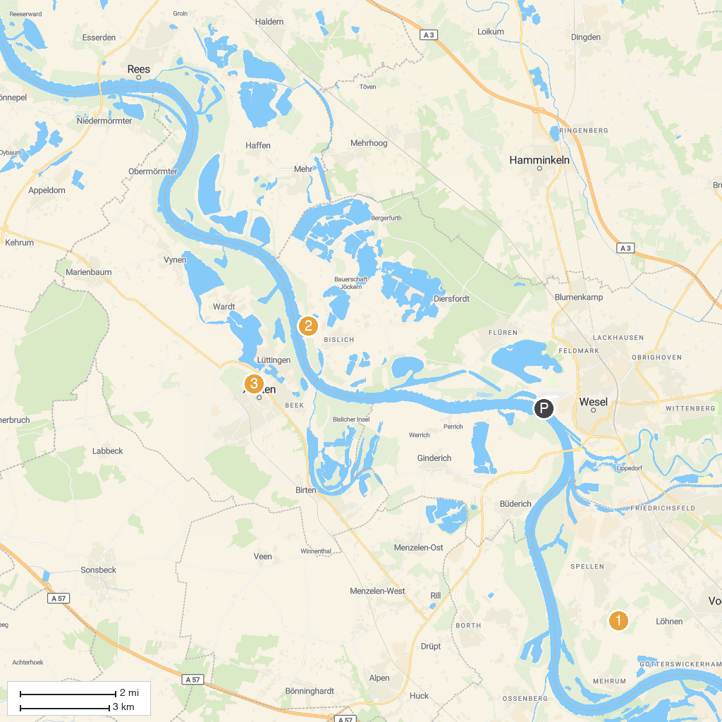
MAP KEY
1. Momm-Niederung | 5. Rundweg Dingdener Heide
2. Rheinaue Bislich-Vahnum | 6. St. Peter Kirche
3. Hafentempel im APX | 7. Museum rund ums Geld
4. LVR-Roman Museum | 8. Archaeological Park Xanten (APX)
P. Cruise port / terminal
Map © MapTiler © OpenStreetMap contributors · cruiseports.org

