Waterford, County Waterford, Ireland
Founded by Vikings in 914 AD, Waterford is Ireland's oldest city — a spirited mix of medieval towers, world-famous crystal, colourful street murals, and proper Irish pubs serving the unique local Blaa bread roll.
⚓ Docked at Belview (5 mi from city) or Tender at Dunmore East · 🕒 Typical call: 8–10 hrs · 💶 Euro (€) · 🗣️ English
✍️ MY DAY IN PORT (FILL IN)
Ship / Date
In port | arrive ______ · all aboard ______
Booked excursion
Notes / meeting point
GETTING ASHORE
- Docking: Belview Port (5 mi, shuttle provided) or tender at Dunmore East for large ships
- Walk to center: 5 min from city shuttle drop-off at Waterford Quay
- Best For: History, crystal shopping, Irish pub culture, street art
- Don't Miss: House of Waterford Crystal factory tour & the Viking Triangle museums
GETTING AROUND
- 🚕 Taxi: €20–€25 — Taxis meet ships at Belview. Pre-booking is wise; numbers can be limited when multiple ships are in port.
- 📱 Rideshare: ✅ Uber, Bolt
TOP THINGS TO DO
- Viking Triangle & Waterford Treasures — Five world-class museums packed into a short walk: Reginald's Tower (12th-century Viking fort), Medieval Museum (13th-century…
- House of Waterford Crystal Factory Tour — Watch master craftspeople blow, cut, and engrave the world-famous crystal in the original city-center factory.
- Mount Congreve Gardens — One of the great gardens of the world, with 70 acres of woodland walks, formal gardens, and one of the largest private…
- Tramore Beach Day — A 5 km sandy beach with a traditional seaside promenade, amusement arcades, surf, and dunes — 20 minutes by taxi from Waterford…
- Waterford Blaa & Pub Crawl — The Waterford Blaa is a soft, floury bread roll with EU protected status (like Champagne).
BEST WALKS
- Viking Triangle Loop: 1.5 km · 30–45 min · Easy — From the shuttle drop-off at Waterford Quay, walk to Reginald's Tower at the eastern edge of the…
- Waterford Street Art Walk: 2 km · 45 min · Easy — Waterford Walls is one of Ireland's best urban mural festivals — giant works by international…
cruiseports.org/waterford · Confirm terminal & all-aboard time with your ship

Waterford, County Waterford, Ireland — Port Map
Red = walkable sights · Amber = excursions farther out · P = cruise terminal
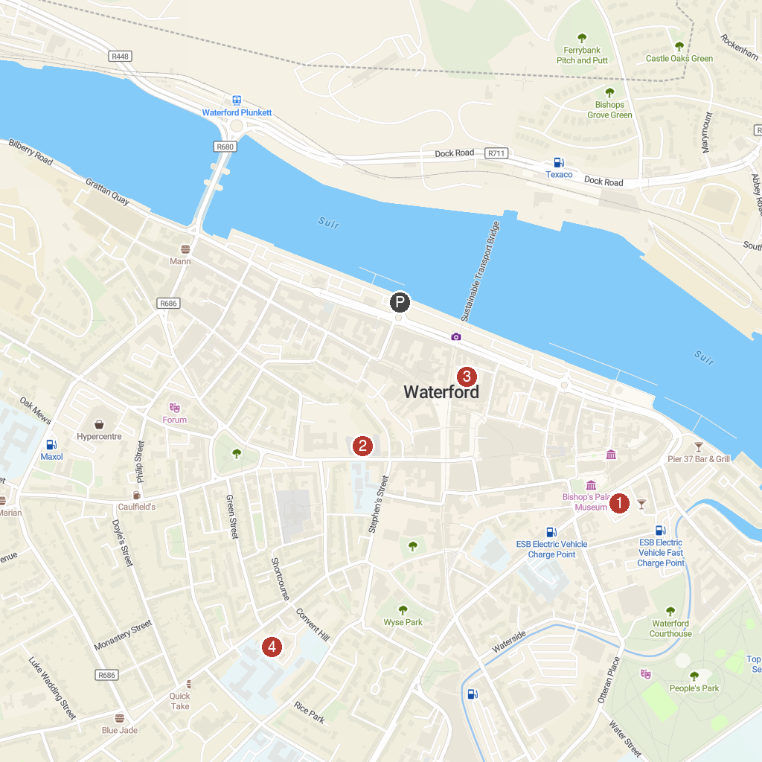
MAP KEY
1. House of Waterford | 5. John F Kennedy Arboretum
2. The Metal Man | 6. Cathedral of the Most Holy Trinity Within
3. St Patrick's Gateway Centre | 7. Edmund Rice Heritage Centre
4. Duncannon Fort
P. Cruise port / terminal
Map © MapTiler © OpenStreetMap contributors · cruiseports.org

