Wasserbillig, Grevenmacher, Luxembourg
Where the Sauer meets the Moselle at the Luxembourg-Germany border, Wasserbillig packs a surprising punch: free national train service puts Luxembourg City just 35 minutes away, while the riverside promenade and Moselle wine culture reward those who stay put.
⚓ Docked (riverside quay) · 🕒 Typical call: 6–8 hrs · 💶 Euro (€) · 🗣️ Luxembourgish / French / German · 🍷 Moselle wine country
✍️ MY DAY IN PORT (FILL IN)
Ship / Date
In port | arrive ______ · all aboard ______
Booked excursion
Notes / meeting point
GETTING ASHORE
- Docking: River cruise ships dock alongside the Moselle quay — no tendering, direct step-off onto the promenade
- Walk to center: 2–5 min to Grand-Rue; 8 min flat walk to train station
- Best For: Luxembourg City day-trippers, Moselle wine lovers, cycling along the river
- Don't Miss: Free train to Luxembourg City (UNESCO World Heritage) — no ticket needed anywhere in the country
GETTING AROUND
- 🚕 Taxi: €100–€115 — Fixed-rate private taxis from Wasserbillig to Luxembourg City Centre run approximately €100–115 per vehicle (not per per
- 📱 Rideshare: ✅ Uber
TOP THINGS TO DO
- Luxembourg City — UNESCO Fortified Capital — Hop the free train 35 minutes to one of Europe's most dramatic capitals.
- Trier, Germany — Rome's Oldest City North of the Alps — Cross the border by ferry or bus to Trier, home to the Porta Nigra, Imperial Baths, and a Roman amphitheater.
- Moselle Cycling — Vineyards & River Trails — Many river ships provide bikes.
- Moselle Wine Tasting — The Luxembourg Moselle produces excellent Riesling, Pinot Gris, and Crémant de Luxembourg sparkling wine at prices well below…
- Mullerthal Trail — Luxembourg's 'Little Switzerland' — A short drive or bus ride opens up the Mullerthal region: dramatic sandstone rock formations, mossy gorges, and marked hiking…
BEST WALKS
- Moselle Confluence Promenade: 1–2 km · 20–30 min · Flat · Free — Walk south along the Moselle esplanade from your ship to the Spatz confluence park, where the Sauer…
- Town to Train Station: 600 m · 8–10 min · Flat · Onward to Luxembourg City — A simple flat walk from the quay through the town center to Wasserbillig train station.
WEATHER · DAYLIGHT · MONEY
Month | High °F | Low °F | Rainy days
May | 65 | 48 | 11
Jul | 77 | 59 | 11
Sep | 69 | 53 | 10
Daylight: May 5:49AM–9:12PM · Jul 5:43AM–9:36PM · Sep 7:10AM–7:46PM
cruiseports.org/wasserbillig · Confirm terminal & all-aboard time with your ship

Wasserbillig, Grevenmacher, Luxembourg — Port Map
Red = walkable sights · Amber = excursions farther out · P = cruise terminal
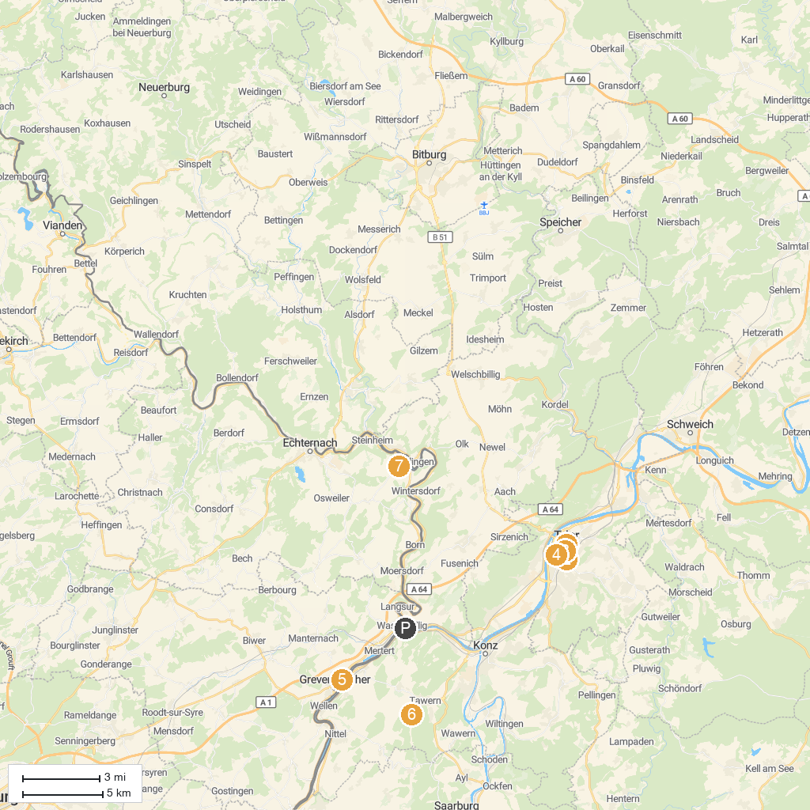
MAP KEY
1. Porta Nigra | 5. Place du marché
2. Rhineland State Museum Trier | 6. Butterfly Garden, Grevenmacher
3. Trier Cathedral | 7. Roman Temple of Tawern
4. Karl Marx House | 8. Tudor Museum
P. Cruise port / terminal
Map © MapTiler © OpenStreetMap contributors · cruiseports.org

