Warrenpoint, County Down, Northern Ireland
Tucked at the head of Carlingford Lough with the Mourne Mountains rising behind it, Warrenpoint is a boutique port that punches well above its size — C.S. Lewis country, an international border, and world-class oysters all within a short ride.
⚓ Tender (larger ships anchor; smaller ships may berth) · 🕒 Typical call: 7-9 hrs · 💷 Currency: GBP (€ across the border) · 🗣️ Language: English · 🏔️ Mourne Mountains gateway
✍️ MY DAY IN PORT (FILL IN)
Ship / Date
In port | arrive ______ · all aboard ______
Booked excursion
Notes / meeting point
GETTING ASHORE
- Docking: Tender — most cruise ships anchor in Carlingford Lough; smaller expedition vessels may berth at the harbour
- Walk to centre: 5 min from tender landing to Town Square
- Best For: Scenic drives, medieval Carlingford, Mourne Mountains hiking, Narnia connections
- Don't Miss: Carlingford oysters, Kilbroney Forest Park, Narrow Water Castle
GETTING AROUND
- 🚕 Taxi: £5–£10 — Taxis are available but limited — pre-booking recommended. AV Taxis (028 4177 3966) is the longest-serving firm in town.
- 📱 Rideshare: ✅ Uber
TOP THINGS TO DO
- Kilbroney Forest Park & Cloughmore Stone — Rostrevor's forest park, 3 miles from the port, holds the legendary 30-ton Cloughmore Stone and panoramic views over Carlingford…
- Medieval Carlingford (Republic of Ireland) — A 30-minute drive or ferry crossing away, Carlingford is one of Ireland's most intact medieval towns — cobblestone streets, King…
- Carlingford Lough Ferry Crossing — Hop the roll-on/roll-off ferry from Greencastle to Greenore in 15 minutes — crossing an international border on the water with…
- Newry City Day Out — Six miles away, Newry is one of Northern Ireland's oldest settlements.
- Warrenpoint Promenade & Town Walk — The town's Edwardian promenade runs along the lough shore with mountain views across the water.
BEST WALKS
- Promenade & Edwardian Town Square: 1.5 km · Flat · 20-25 min — From the tender landing, follow the seafront promenade past the Municipal Park bandstand, then cut…
- Narrow Water Castle Waterside Walk: 4 km return · Flat · 50-60 min — Head north along the Newry Road from the town centre to reach Narrow Water Castle, a photogenic…
WEATHER · DAYLIGHT · MONEY
Month | High °F | Low °F | Rainy days
May | 58 | 46 | 15
Jul | 66 | 54 | 16
Sep | 62 | 51 | 13
Daylight: May 5:21AM–9:22PM · Jul 5:12AM–9:48PM · Sep 6:58AM–7:40PM
cruiseports.org/warrenpoint · Confirm terminal & all-aboard time with your ship

Warrenpoint, County Down, Northern Ireland — Port Map
Red = walkable sights · Amber = excursions farther out · P = cruise terminal
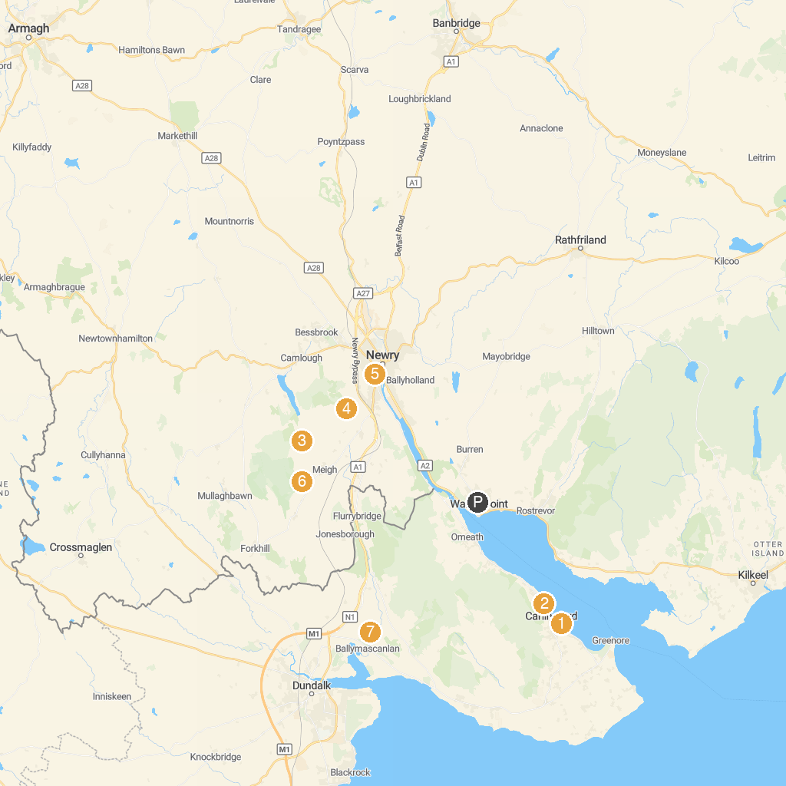
MAP KEY
1. Irish Folklore Park | 5. St Catherine's Dominican Church, Newry
2. Carlingford to Omeath Greenway | 6. Fionn's Giant Adventure
3. Killeavy Old Churches | 7. Proleek Dolmen
4. Ballymacdermott Court Tomb | 8. County Museum Dundalk
P. Cruise port / terminal
Map © MapTiler © OpenStreetMap contributors · cruiseports.org

