Warren, Rhode Island, USA
New England's best-kept waterfront secret — Warren pairs a beautifully preserved colonial working harbor with one of Rhode Island's top dining strips and the scenic East Bay Bike Path, all just steps from the dock.
⚓ Pier (Town Wharf, walk-off) · 🕒 Typical call: 6-8 hrs · 💵 USD · 🗣️ English · 🚶 Extremely walkable
✍️ MY DAY IN PORT (FILL IN)
Ship / Date
In port | arrive ______ · all aboard ______
Booked excursion
Notes / meeting point
GETTING ASHORE
- Docking: Pier — small ships dock at Town Wharf; walk off directly
- Walk to center: Immediate — Water St dining is 1 min from the gangway
- Best For: History walks, cycling the East Bay Bike Path, seafood, local art
- Don't Miss: A Rhode Island Coffee Cabinet at Delekta's Pharmacy on Main St
GETTING AROUND
- 🚕 Taxi: $10–$20 local; $30–$45 to Providence — Local taxi and car services are available. A ride to Providence (approx. 11 miles) typically costs $30–$45; most in-town
- 📱 Rideshare: ✅ Uber, Lyft
TOP THINGS TO DO
- East Bay Bike Path — One of New England's finest paved multi-use paths runs 14.5 miles from Providence to Bristol.
- Colonial Water Street Walk — Water Street is lined with 18th- and 19th-century buildings once home to sea captains and shipbuilders.
- Wampanoag Heritage at Burr's Hill — Burr's Hill Park sits on the ancestral Sowams land of the Wampanoag Nation — home of Massasoit Ousamequin, who met the Pilgrims…
- Warren Food Trail — For its size, Warren is a bona fide foodie destination.
- Warren Town Beach & Waterfront — A quiet sandy beach on the Warren River at Burr's Hill Park, perfect for a peaceful sit with harbor views.
BEST WALKS
- Water Street to Main Street Loop: 1.5 miles · 30-45 min · Easy — From Town Wharf, walk Water Street past the colonial captain's houses and the Blount Clam Shack…
- East Bay Bike Path to Bristol: 8 miles round-trip · 2-3 hrs · Easy (bike recommended) — Pick up the East Bay Bike Path near the waterfront and ride south through salt marshes and…
WEATHER · DAYLIGHT · MONEY
Month | High °F | Low °F | Rainy days
May | 66 | 51 | 11
Jul | 81 | 68 | 11
Sep | 73 | 61 | 10
Daylight: May 5:25AM–7:58PM · Jul 5:24AM–8:17PM · Sep 6:25AM–6:53PM
cruiseports.org/warren-ri · Confirm terminal & all-aboard time with your ship

Warren, Rhode Island, USA — Port Map
Red = walkable sights · Amber = excursions farther out · P = cruise terminal
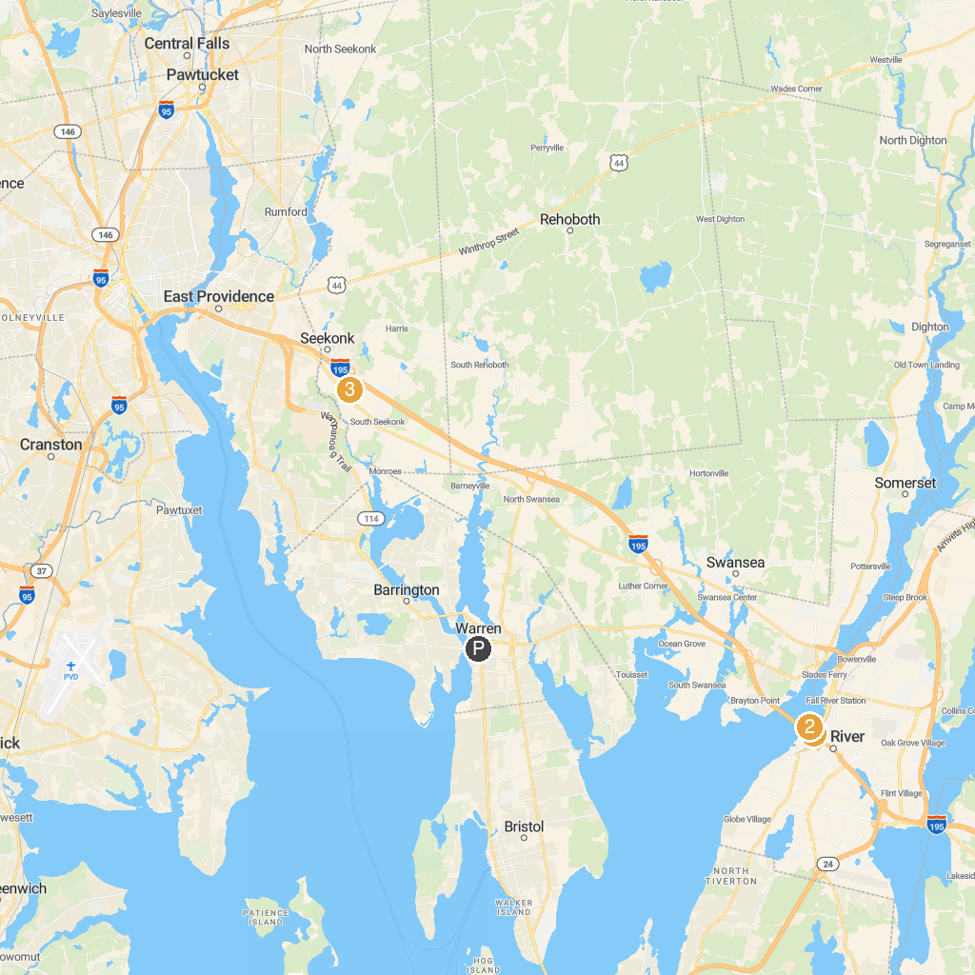
MAP KEY
1. Roger Williams Park Zoo | 5. Roger Williams Park Casino
2. Battleship Cove | 6. Seekonk Grand Prix
3. Providence Children's Museum | 7. Museum of Natural History and Planetarium
4. USS Massachusetts (BB-59) | 8. Cathedral of Saints Peter & Paul
P. Cruise port / terminal
Map © MapTiler © OpenStreetMap contributors · cruiseports.org

