Warnemünde, Mecklenburg-Vorpommern, Germany
Warnemünde puts you steps from a wide Baltic beach and a direct train line — to charming Rostock in 20 minutes or all the way to Berlin in under three hours.
⚓ Docked (cruise terminal) · 🕒 Typical call: 8–12 hrs · 💶 Euro (€) · 🗣️ German
✍️ MY DAY IN PORT (FILL IN)
Ship / Date
In port | arrive ______ · all aboard ______
Booked excursion
Notes / meeting point
GETTING ASHORE
- Docking: Warnemünde Cruise Center (berths P1–P8); pier is steps from town
- Walk to Center: 10–15 min to Alter Strom canal & lighthouse on foot
- Best For: Beach strolls, Rostock day trip, or ambitious Berlin excursion
- Don't Miss: Alter Strom canal, Warnemünde Lighthouse, St. Mary's Church in Rostock
GETTING AROUND
- 🚕 Taxi: €40–55 — Taxis queue at the port and reach Rostock city center in roughly 15–17 minutes. Fixed-rate apps like SIXT ride are also
- 📱 Rideshare: ✅ Uber
TOP THINGS TO DO
- Berlin in a Day — The big ticket excursion: Brandenburg Gate, Reichstag, Checkpoint Charlie, Berlin Wall, and the Holocaust Memorial.
- Rostock Old Town & St. Mary's Church — A 20-minute S-Bahn ride brings you to Rostock's Hanseatic old town.
- Warnemünde Beach & Lighthouse Stroll — Walk straight off the ship to about 3 km of wide sandy Baltic beach.
- Schwerin Palace Day Trip — About an hour by train from Rostock (with a connection), Schwerin's fairy-tale castle sits on an island in a lake.
- Lübeck & the Holstentor — Lübeck's medieval old town is a UNESCO World Heritage Site.
BEST WALKS
- Alter Strom to the Lighthouse: 2 km · Easy · 45 min — From the cruise terminal, walk northwest along the Alter Strom canal past the colorful fishing…
- Rostock Old Town Loop: 3 km · Easy · 1–2 hrs in Rostock — Take the S-Bahn to Rostock Hauptbahnhof, then walk through Kröpeliner Strasse to Neuer Markt, St.
- Alter Strom & lighthouse loop: ~2.5 km · 1.5 hrs · easy — Along the picturesque Alter Strom canal of fishing boats and cafés, out to the lighthouse and…
WEATHER · DAYLIGHT · MONEY
Month | High °F | Low °F | Rainy days
May | 61 | 48 | 10
Jul | 71 | 59 | 15
Sep | 66 | 55 | 11
Daylight: May 5:08AM–9:09PM · Jul 4:58AM–9:36PM · Sep 6:45AM–7:27PM
cruiseports.org/warnemunde-rostock · Confirm terminal & all-aboard time with your ship

Warnemünde, Mecklenburg-Vorpommern, Germany — Port Map
Red = walkable sights · Amber = excursions farther out · P = cruise terminal
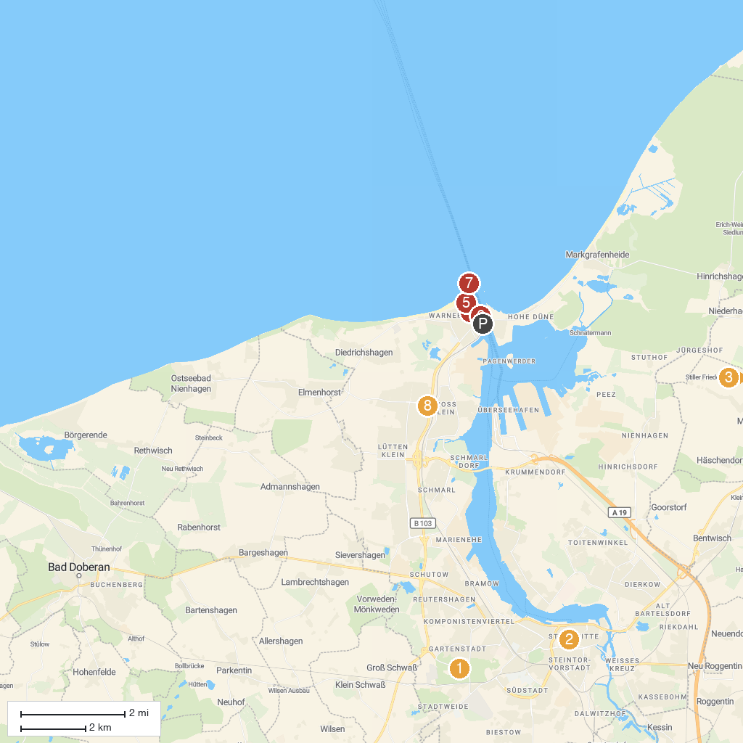
MAP KEY
1. Rostock Zoo | 5. Warnemünde lighthouse
2. Brunnen der Lebensfreude | 6. Hafenrundfahrt Warnemünde - Rostock - Fahrgastschifffahrt K. Schütt GmbH (Blaue Flotte)
3. Karl's Adventure Village Rövershagen | 7. Molenfeuer Westmole
4. Warnow-Personenschifffahrt OHG | 8. Sonnenblumenhaus
P. Cruise port / terminal
Map © MapTiler © OpenStreetMap contributors · cruiseports.org

