Walvis Bay, Namibia
Where the Namib Desert meets the Atlantic: pink flamingos wade in a Ramsar lagoon while towering red dunes rise just beyond the city limits. Walvis Bay is a working port with surprisingly rich wildlife and one of Africa's most dramatic desert coastlines on its doorstep.
⚓ Docked (cruise terminal) · 🕒 Typical call: 7-9 hrs · 💵 Namibian Dollar / South African Rand · 🗣️ English (official), Afrikaans · 🦩 Flamingo lagoon & Namib dunes
✍️ MY DAY IN PORT (FILL IN)
Ship / Date
In port | arrive ______ · all aboard ______
Booked excursion
Notes / meeting point
GETTING ASHORE
- Docking: Cruise ships berth at the commercial Port of Walvis Bay — no tendering. The town centre is roughly 3 km from the berth.
- Walk to Centre: It's a working industrial port, so a shuttle or taxi to the lagoon waterfront and town centre is the norm rather than walking out of the gate.
- Best For: Wildlife spotting (flamingos, pelicans, fur seals), desert dune drives, and a day in colonial Swakopmund.
- Don't Miss: Walvis Bay Lagoon flamingos and a quad-bike or 4WD excursion to Sandwich Harbour.
GETTING AROUND
- 🚕 Taxi: USD 5–7 — Local taxis are the primary transport from the port to city center (~3–4 km). Meters are rarely used — agree on the fare
- 📱 Rideshare: ✅ Yango, Bolt
TOP THINGS TO DO
- Walvis Bay Lagoon Flamingo & Pelican Tour — A motorboat glides through the Ramsar-listed lagoon toward Pelican Point, where curious Cape fur seals swim up to the boat and…
- Sandwich Harbour 4WD Dune Experience — A 4WD or quad-bike drive south through the Namib-Naukluft National Park to Sandwich Harbour, where colossal sand dunes spill…
- Swakopmund Town & Colonial Architecture — Drive 30 km north to Swakopmund, a well-preserved German colonial town with Bavarian-style buildings, a lively craft market…
- Dune 7 & Namib Desert Walk — Dune 7, just outside town, is Namibia's tallest dune at around 380 m.
- Cape Cross Seal Colony — About 120 km north, Cape Cross hosts one of the world's largest Cape fur seal colonies — up to 100,000 seals.
BEST WALKS
- Lagoon Esplanade Stroll: 1.5 km · Flat · 20-30 min — Walk the paved Esplanade along the southern edge of Walvis Bay Lagoon.
- Town Centre & Craft Market: 2 km loop · Easy · 45-60 min — Head into Walvis Bay town centre to browse the informal craft market near the town hall, pick up…
WEATHER · DAYLIGHT · MONEY
Month | High °F | Low °F | Rainy days
May | 75 | 57 | 0
Jul | 74 | 54 | 0
Sep | 68 | 51 | 0
Daylight: May 7:28AM–6:28PM · Jul 7:42AM–6:33PM · Sep 6:58AM–6:55PM
cruiseports.org/walvis-bay · Confirm terminal & all-aboard time with your ship

Walvis Bay, Namibia — Port Map
Red = walkable sights · Amber = excursions farther out · P = cruise terminal
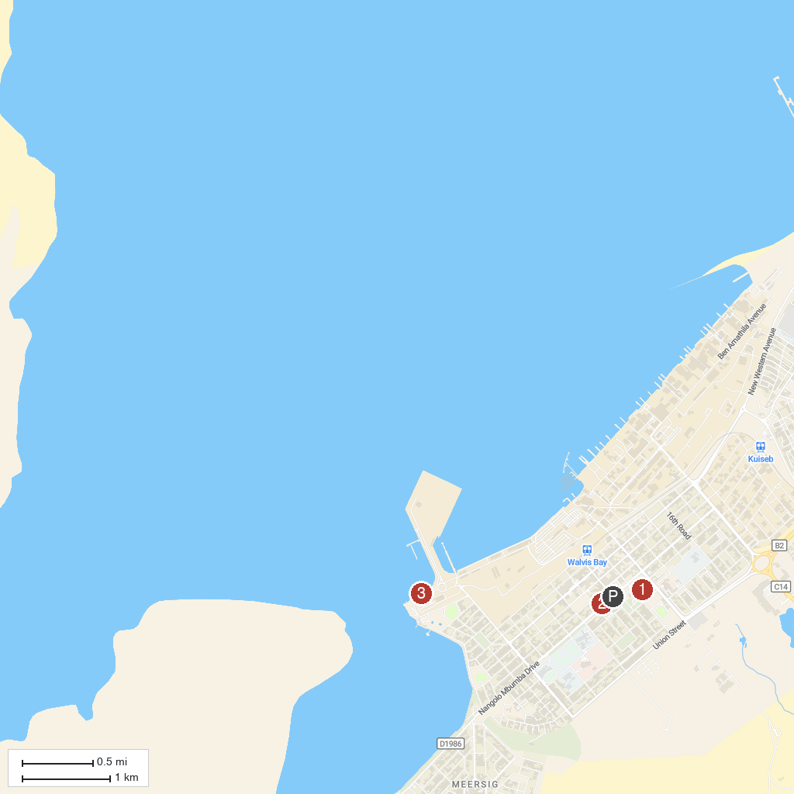
MAP KEY
1. Walvis Bay Museum | 3. Namibia Dolphin and Seal Catamaran Cruises
2. Walvis Bay Community Church
P. Cruise port / terminal
Map © MapTiler © OpenStreetMap contributors · cruiseports.org

