Waiheke Island, Auckland, New Zealand
New Zealand's celebrated island of wine drifts in the Hauraki Gulf just 40 minutes from Auckland — vineyards, white-sand beaches, and a bohemian creative soul packed into a single spectacular shore day.
⚓ Tender (boutique/expedition ships) or ferry from Auckland · 🕒 Typical call: 7-9 hrs · 💵 NZD (cards accepted everywhere) · 🗣️ English · 🍷 Wine island — book vineyard lunches in advance
✍️ MY DAY IN PORT (FILL IN)
Ship / Date
In port | arrive ______ · all aboard ______
Booked excursion
Notes / meeting point
GETTING ASHORE
- Docking: Expedition/luxury ships tender to Matiatia Wharf; most cruise lines dock in Auckland and ferry passengers over (40 min)
- Walk to center: Matiatia Wharf to Oneroa Village: 1.5 km, ~20-25 min (uphill) or 35 min via coastal track
- Best For: Wine touring, beaches, hiking, farm-to-table dining
- Don't Miss: A winery tasting with gulf views — book 2-3 months ahead in high season
GETTING AROUND
- 🚕 Taxi: NZD $10–$12 to Oneroa Village — Local operators Waiheke Five-O and Waiheke Easy Transport serve the terminal. The ride to Oneroa is about 3 minutes; far
- 📱 Rideshare: ✅ Uber
- 🚌 Hop-on hop-off: ✅ Fullers360
TOP THINGS TO DO
- Wine Country Tour — Waiheke has 30+ boutique wineries producing world-class Bordeaux-style reds and Syrahs in its warm, sheltered microclimate.
- Onetangi Beach Day — The island's crown-jewel beach — a 2 km sweep of white sand with calm, clear water.
- EcoZip Adventures — Three dual ziplines over working vineyards and native forest from one of the island's highest viewpoints.
- Matiatia to Oneroa Coastal Walk — Free and spectacular — this clifftop track starts right at the ferry wharf and winds along the Hauraki Gulf coast to Oneroa…
- Stony Batter Historic Reserve — Waiheke's hidden military secret — WWII gun emplacements and tunnels drilled into the island's eastern hills, now open for…
BEST WALKS
- Matiatia to Oneroa via Coastal Track: 1.5 km · 35 min · Moderate (clifftop, some steps) — Start at Matiatia Wharf and follow the coastal walkway signposts uphill toward the cliff edge.
- Oneroa Village Stroll: 0.5 km loop · 30 min · Easy — Wander Ocean View Road through Oneroa's galleries, cafes, and the Alison Park sculpture trail.
WEATHER · DAYLIGHT · MONEY
Month | High °F | Low °F | Rainy days
May | 63 | 57 | 12
Jul | 57 | 52 | 13
Sep | 59 | 53 | 16
Daylight: May 7:10AM–5:20PM · Jul 7:29AM–5:21PM · Sep 6:20AM–6:10PM
cruiseports.org/waiheke-island-nz · Confirm terminal & all-aboard time with your ship

Waiheke Island, Auckland, New Zealand — Port Map
Red = walkable sights · Amber = excursions farther out · P = cruise terminal
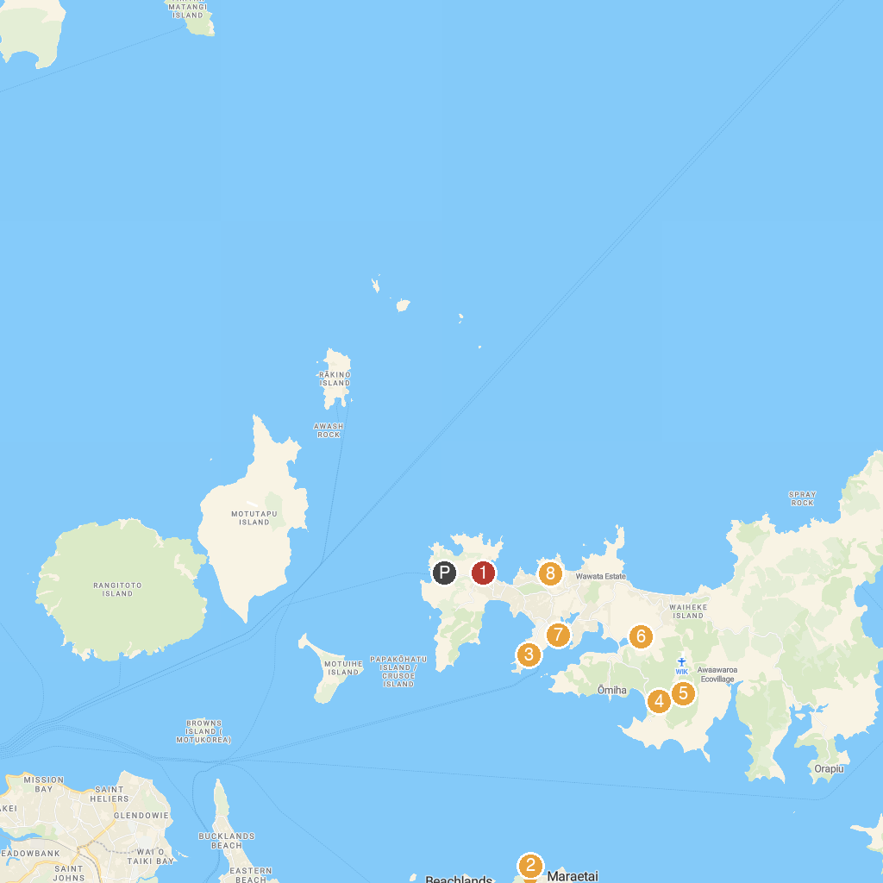
MAP KEY
1. Waiheke Art Gallery | 5. Cascades Waterfall - Waiheke
2. Omana Regional Park | 6. Museum of Waiheke
3. Kennedy Point Vineyard | 7. Shelley Beach Reserve
4. Whakanewha Regional Park | 8. Sacred Blessing Sanctuary Garden & Sculptures
P. Cruise port / terminal
Map © MapTiler © OpenStreetMap contributors · cruiseports.org

