Wachau Valley, Lower Austria, Austria
A 36-kilometre ribbon of terraced vineyards, castle ruins, and Baroque spires carved into the Danube — the Wachau Valley is one of Europe's most scenic river cruise passages and a UNESCO World Heritage Site.
⚓ River docking (no tender) · 🕒 Typical call: 6-8 hrs · 💶 Euro (€) · 🗣️ German · 🚲 Flat bike path along river
✍️ MY DAY IN PORT (FILL IN)
Ship / Date
In port | arrive ______ · all aboard ______
Booked excursion
Notes / meeting point
GETTING ASHORE
- Docking: River mooring at Melk, Dürnstein, or Krems — ships tie to floating pontoons on the bank
- Walk to Center: Melk: 5 min to village; Dürnstein: immediate; Krems: 10 min from dock
- Best For: Cycling, wine tasting, Melk Abbey, castle ruins, apricot products
- Don't Miss: Cycling the flat Danube Cycle Path between Melk and Dürnstein (~30 km)
GETTING AROUND
- 🚕 Taxi: €11–€20 — Local taxis are available; a short ride in Krems to town center runs about €11–€12. Uber is confirmed available in valle
- 📱 Rideshare: ✅ Uber
TOP THINGS TO DO
- Melk Abbey — One of Europe's finest Baroque monasteries, perched dramatically above the Danube.
- Dürnstein Castle Ruins — The ruined castle above Dürnstein held Richard the Lionheart captive in 1192-93.
- Danube Cycle Path Ride — Pedal the flat, paved Donauradweg between Melk and Dürnstein (~30 km).
- Heuriger Wine Tavern Experience — A Heuriger (traditional Austrian wine tavern) is where local winemakers serve their new Grüner Veltliner and Riesling with cold…
- Krems Altstadt Walk — Krems is the wine capital of the Wachau.
BEST WALKS
- Dürnstein Village & Blue Church: 30 min · Flat · Free — A complete loop of Dürnstein's main street takes under 30 minutes.
- Melk Abbey & Old Town: 1.5 hrs · Moderate uphill · ~€14 abbey entry — From the Melk dock follow signs uphill through the old town market square to the abbey entrance.
WEATHER · DAYLIGHT · MONEY
Month | High °F | Low °F | Rainy days
May | 66 | 51 | 15
Jul | 80 | 63 | 13
Sep | 70 | 55 | 10
Daylight: May 5:18AM–8:31PM · Jul 5:12AM–8:54PM · Sep 6:35AM–7:10PM
cruiseports.org/wachau-valley · Confirm terminal & all-aboard time with your ship

Wachau Valley, Lower Austria, Austria — Port Map
Red = walkable sights · Amber = excursions farther out · P = cruise terminal
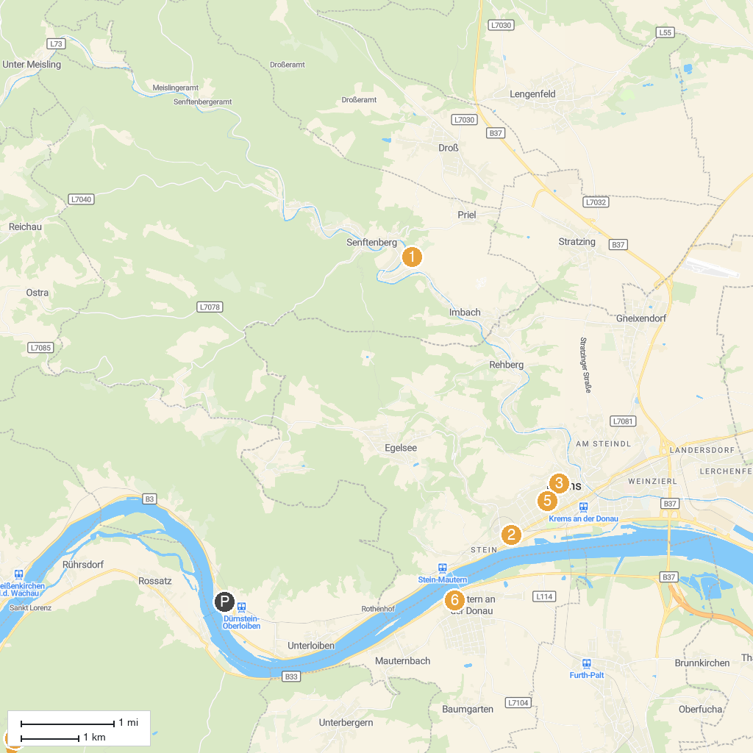
MAP KEY
1. Burgruine Senftenberg | 5. Steinertor
2. Karikaturmuseum Krems | 6. Römermuseum Mautern/Favianis
3. Piarist Church of Our Lady | 7. Urzeitmuseum Nussdorf-Traisental
4. Pfarr- und Wallfahrtskirche Mariae Geburt
P. Cruise port / terminal
Map © MapTiler © OpenStreetMap contributors · cruiseports.org

