Vukovar, Slavonia, Croatia
Croatia's 'Hero City' carries deep scars and deep pride. A Danube river stop where Bronze Age archaeology, Baroque streets, and war memorials occupy the same short walk from the dock.
⚓ River pier — direct docking, no tender · 🕒 Typical call: 6–8 hrs · 💶 Euro (€) · 🗣️ Croatian (English widely spoken in tourism)
✍️ MY DAY IN PORT (FILL IN)
Ship / Date
In port | arrive ______ · all aboard ______
Booked excursion
Notes / meeting point
GETTING ASHORE
- Docking: Floating pontoon pier, steps from the Baroque city center
- Walk to center: 2–5 min to pedestrian zone; 20 min to Water Tower
- Best For: Modern history, Vučedol archaeology, regional wine & food
- Don't Miss: Vukovar Water Tower — 600+ shell hits and still standing
GETTING AROUND
- 🚕 Taxi: €3–€6 — Short metered taxi rides from the dock to the Water Tower or Vučedol Museum. Base fare ~€2, plus ~€0.67/km — most in-tow
- 📱 Rideshare: ✅ Uber
TOP THINGS TO DO
- Vukovar Water Tower — The defining symbol of the 1991 siege: a 50-metre tower struck by 600+ shells that refused to fall.
- Eltz Manor & Municipal Museum — An 18th-century Baroque palace meticulously restored after war damage.
- Vučedol Culture Museum — A stunning modern museum ~5 km from the dock dedicated to a 5,000-year-old culture famous for the Vučedol Dove — the oldest…
- Slavonian Food & Wine Tasting — Try fiš paprikaš (spicy river-fish stew), kulen cured sausage, and local Graševina white wine.
- Memorial Cemetery of Homeland War Victims — The largest mass grave in Europe since WWII — 938 white marble crosses for victims exhumed here.
BEST WALKS
- Danube Promenade to Baroque City Center: 45 min · Flat · Free — Walk from the pontoon pier along the Danube Promenade, turn into the pedestrian main street (Ulica…
- Promenade to Water Tower: 40 min each way · Flat · ~€10–13 entry — A pleasant 2 km walk from the dock along the riverbank to the war-damaged water tower.
WEATHER · DAYLIGHT · MONEY
Month | High °F | Low °F | Rainy days
May | 71 | 54 | 12
Jul | 84 | 65 | 8
Sep | 75 | 58 | 8
Daylight: May 5:14AM–8:07PM · Jul 5:10AM–8:28PM · Sep 6:22AM–6:54PM
cruiseports.org/vukovar · Confirm terminal & all-aboard time with your ship

Vukovar, Slavonia, Croatia — Port Map
Red = walkable sights · Amber = excursions farther out · P = cruise terminal
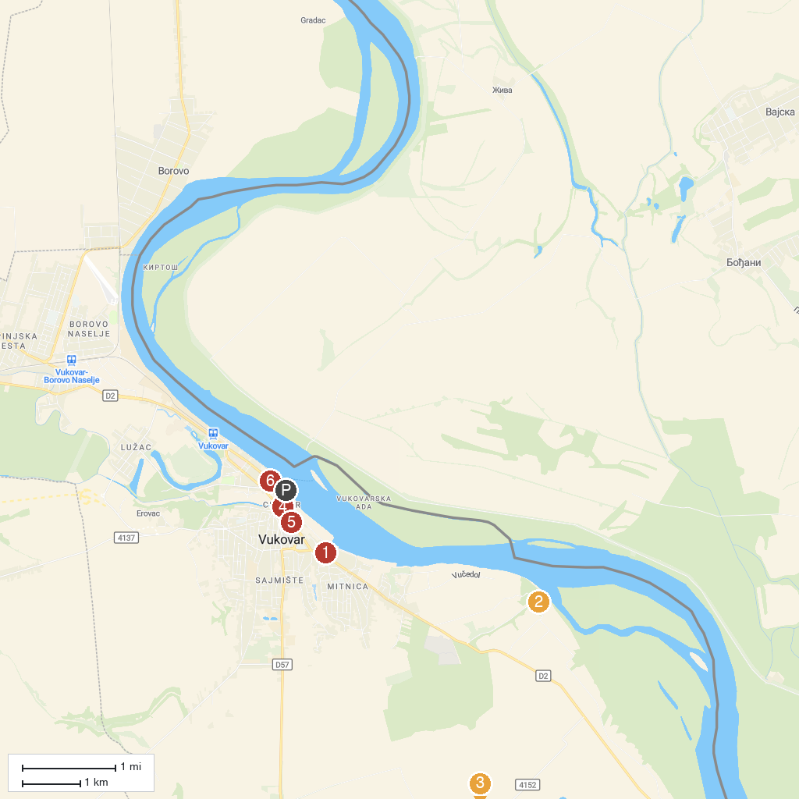
MAP KEY
1. Vukovar Water Tower | 4. Radnički dom / Grand hotel
2. Vučedol Culture Museum and Archaeological Site | 5. Crucifix
3. Ovcara Memorial Center | 6. Vukovar Municipal Museum / Castle Eltz
P. Cruise port / terminal
Map © MapTiler © OpenStreetMap contributors · cruiseports.org

