Volos, Thessaly, Greece
Set where Jason and the Argonauts once set sail, Volos pairs mythical heritage with one of Greece's finest eating traditions — and serves as the launchpad for Meteora and Mount Pelion.
⚓ Docked (pier) · 🕒 Typical call: 8-10 hrs · 💶 Currency: Euro (€) · 🗣️ Language: Greek · 🏛️ UNESCO Meteora nearby
✍️ MY DAY IN PORT (FILL IN)
Ship / Date
In port | arrive ______ · all aboard ______
Booked excursion
Notes / meeting point
GETTING ASHORE
- Docking: Ships dock at Pier 2 — walk-off, no tender needed
- Walk to center: 5 min to promenade; 10-15 min to main squares
- Best for: Meteora day trips, Pelion villages, waterfront dining
- Don't miss: A tsipouradiko lunch with rounds of tsipouro and free meze
GETTING AROUND
- 🚕 Taxi: €5–€10 — Taxis wait at the port entrance. Base fare is ~€3.50 plus ~€1.50/km; a short city-center ride runs €5–€10. Ensure the me
- 📱 Rideshare: ✅ Bolt, FreeNow
TOP THINGS TO DO
- Meteora Monasteries Full Day — One of Greece's most awe-inspiring sights: ancient Orthodox monasteries perched atop soaring sandstone pillars.
- Mount Pelion Villages — The mythical home of the Centaurs is a lush, hilly peninsula dotted with stone-and-wood villages.
- Pelion Narrow-Gauge Railway (Moutzouris) — The historic steam train chugs through mountain gorges and forests from Ano Lechonia to Milies.
- Archaeological Museum of Volos — One of Greece's oldest and most respected regional museums.
- Tsipouradiko Lunch on the Promenade — Order a bottle of tsipouro (Greece's grape-based spirit) and watch the meze arrive — each round brings a more elaborate free…
BEST WALKS
- Argonafton Promenade Stroll: 1.5 km · 25 min · Flat · Free — Walk the full length of the promenade from the port gate eastward past cafes, yachts, and the…
- City Center & Museum Loop: 2.5 km · 40 min · Flat · €2-4 museum entry — Head inland from the promenade to Agios Nikolaos Cathedral, then continue to the Athanasakeion…
WEATHER · DAYLIGHT · MONEY
Month | High °F | Low °F | Rainy days
May | 75 | 61 | 6
Jul | 88 | 74 | 3
Sep | 80 | 68 | 6
Daylight: May 6:14AM–8:34PM · Jul 6:14AM–8:53PM · Sep 7:09AM–7:36PM
cruiseports.org/volos · Confirm terminal & all-aboard time with your ship

Volos, Thessaly, Greece — Port Map
Red = walkable sights · Amber = excursions farther out · P = cruise terminal
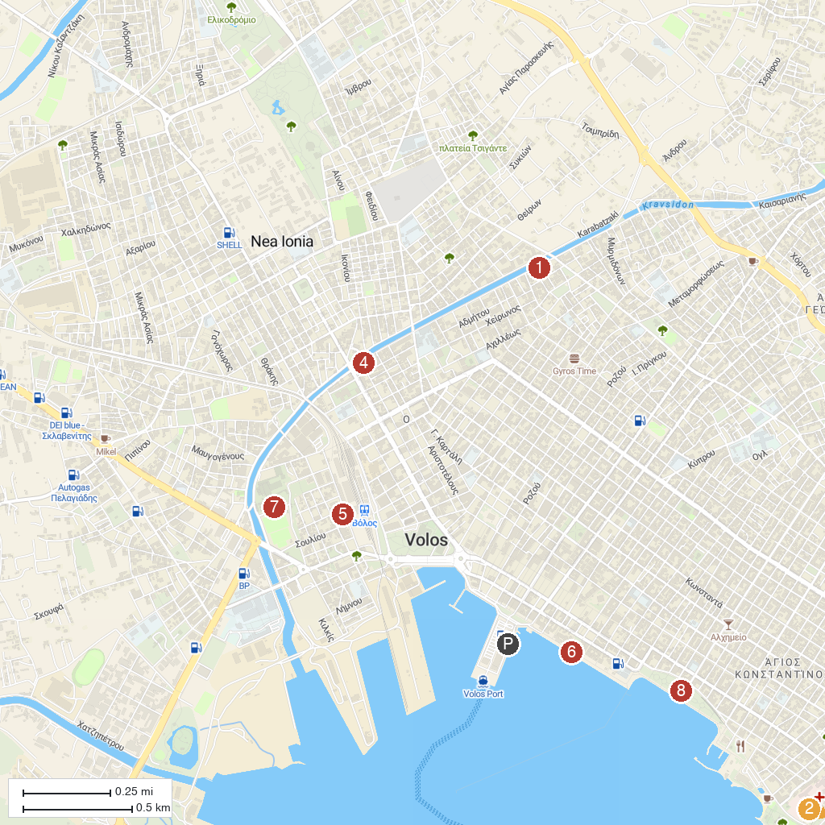
MAP KEY
1. Entomological Museum | 5. Volos City Museum
2. EPSA Agria Volos | 6. Volos Seaside
3. Volos Port | 7. Μουσείο Πλινθοκεραμοποιίας Ν. & Σ. Τσαλαπάτα
4. Natural History Museum of Volos | 8. Saint Konstantinos Park
P. Cruise port / terminal
Map © MapTiler © OpenStreetMap contributors · cruiseports.org

