Vlore, Albania
Where Albania declared independence in 1912, Vlore pairs a handsome Lungomare promenade with crystal-clear Ionian coves — all within easy reach of the passenger terminal.
⚓ Mostly tender; small ships may dock · 🕒 Typical call: 7-9 hrs · 💵 Albanian Lek (EUR widely accepted) · 🗣️ Albanian; Italian & English understood
✍️ MY DAY IN PORT (FILL IN)
Ship / Date
In port | arrive ______ · all aboard ______
Booked excursion
Notes / meeting point
GETTING ASHORE
- Docking: Tender for most cruise ships; smaller vessels can dock at the city passenger terminal
- Walk to center: Lungomare promenade 2-5 min; Historic Quarter ~25-30 min (2 km) or short taxi
- Best For: History lovers, beach seekers, budget-friendly independent exploration
- Don't Miss: Muradie Mosque, Karaburun-Sazan boat tour, byrek from a street bakery
GETTING AROUND
- 🚕 Taxi: €15–18 — The cruise port is 3–5 km from the city center. Metered taxis are readily available at the pier; negotiate or confirm th
- 📱 Rideshare: ❌ not available
TOP THINGS TO DO
- Karaburun-Sazan Island Boat Tour — Speedboat or 'pirate ship' tours leave from the port area for Sazan Island — a former secret military base with Cold War bunkers…
- Llogara Pass Scenic Drive — A taxi or excursion up to Llogara Pass (1,027 m) delivers jaw-dropping views of mountains plunging straight into the Ionian Sea.
- National Museum of Independence — The modest villa where Albanian independence was declared on 28 November 1912 now houses a compact museum tracing the country's…
- Muradie Mosque & Historic Quarter — Built in 1537 by Mimar Sinan (the great Ottoman architect behind Istanbul's Süleymaniye Mosque), the Muradie Mosque features…
- Ionian Beach Day at Radhime — Ten to fifteen minutes south of the city by taxi, Radhime marks the start of the true Ionian coast — turquoise water, pebbly…
BEST WALKS
- Lungomare Promenade Stroll: 2-3 km one way · Flat · 30-45 min — Turn right out of the terminal and follow the sweeping palm-lined waterfront south.
- City Center & Independence Square: ~2 km · Mostly flat · 25-30 min walk — Head north and inland along Rruga Sadik Zotaj toward the center.
WEATHER · DAYLIGHT · MONEY
Month | High °F | Low °F | Rainy days
May | 74 | 58 | 9
Jul | 88 | 70 | 4
Sep | 81 | 66 | 8
Daylight: May 5:25AM–7:51PM · Jul 5:24AM–8:10PM · Sep 6:23AM–6:50PM
cruiseports.org/vlore · Confirm terminal & all-aboard time with your ship

Vlore, Albania — Port Map
Red = walkable sights · Amber = excursions farther out · P = cruise terminal
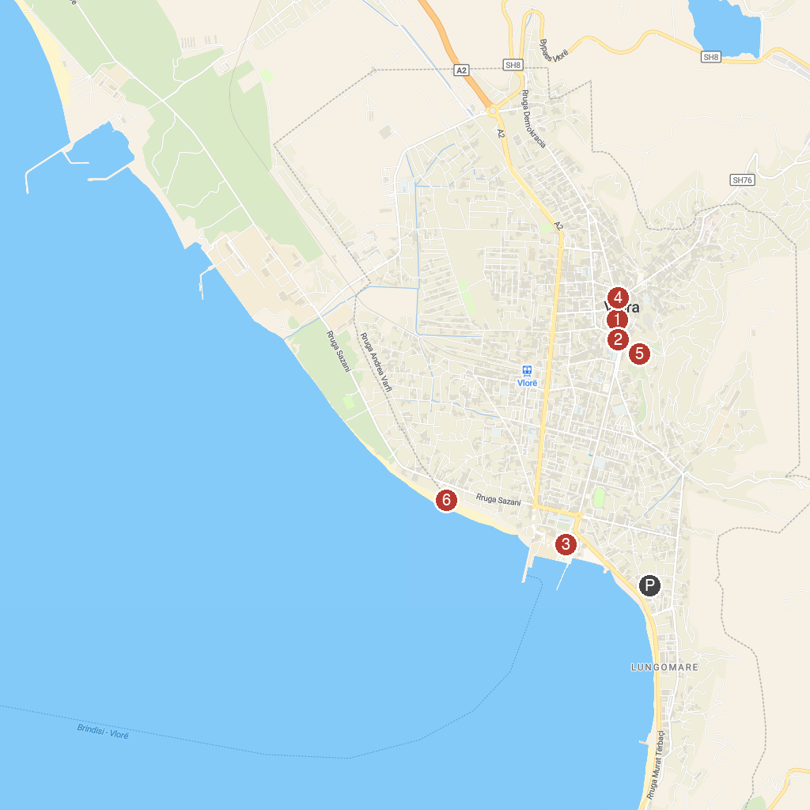
MAP KEY
1. Independence Monument | 4. Muzeu Historik
2. Muradie Mosque | 5. Kuzum Baba
3. National Museum of Independence | 6. Paradise Tropical
P. Cruise port / terminal
Map © MapTiler © OpenStreetMap contributors · cruiseports.org

