Vlissingen, Zeeland, Netherlands
Birthplace of Admiral Michiel de Ruyter and home to the Netherlands' longest sea boulevard, Vlissingen surprises with sandy beaches, world-class ship-watching, and a charming medieval neighbor just ten minutes by train.
⚓ Pier (docked) · 🕒 Typical call: 7–9 hrs · 💶 Euro (€) · 🗣️ Dutch (English widely spoken) · 🚂 Train to Middelburg: 10 min
✍️ MY DAY IN PORT (FILL IN)
Ship / Date
In port | arrive ______ · all aboard ______
Booked excursion
Notes / meeting point
GETTING ASHORE
- Docking: Pier at Westerkade (Buitenhaven); very large ships use industrial Sloehaven with a shuttle
- Walk to center: ~15 min (1 km) from Westerkade to Bellamypark; Sloehaven requires shuttle
- Best For: Ship-watching, beaches, maritime history, day trip to Middelburg
- Don't Miss: The boulevard at high tide when 400-metre cargo ships pass within metres of the shore
GETTING AROUND
- 🚕 Taxi: €12–€17 — Taxis are readily available at the terminal and station. Fare to the city center (approx. 3–5 km) runs €12–€17; base cha
- 📱 Rideshare: ✅ Uber
TOP THINGS TO DO
- Middelburg Day Trip — A 10-minute train ride takes you to the Zeeland capital: medieval canals, a 15th-century Gothic town hall, the soaring Lange Jan…
- muZEEum — Zeeland Maritime Museum — Set in historic 17th-century buildings including the Lampsins House, the muZEEum tells the story of Vlissingen's shipbuilding…
- Boulevard Walk & Ship-Watching — The longest sea promenade in the Netherlands runs along the Westerschelde estuary.
- Badstrand & Nollestrand Beaches — Vlissingen is the only Zeeland city with a beach directly against its center.
- Ferry to Breskens & Bike Loop — A ~20-minute foot-and-bike ferry across the Westerschelde drops you in Breskens, in Zeelandic Flanders (the Dutch mainland south…
BEST WALKS
- Boulevard & Old Town Loop: 2–3 km · 45–60 min · Easy, flat — From the pier walk to Bellamypark (the central square), then follow the boulevard west past the…
- Windorgel at Nolledijk: 3 km one-way · 40 min · Easy — Walk the full length of Boulevard de Ruyter to the tip of the Nolledijk headland.
WEATHER · DAYLIGHT · MONEY
Month | High °F | Low °F | Rainy days
May | 61 | 50 | 12
Jul | 70 | 60 | 13
Sep | 67 | 56 | 11
Daylight: May 5:54AM–9:30PM · Jul 5:47AM–9:55PM · Sep 7:21AM–7:59PM
cruiseports.org/vlissingen · Confirm terminal & all-aboard time with your ship

Vlissingen, Zeeland, Netherlands — Port Map
Red = walkable sights · Amber = excursions farther out · P = cruise terminal
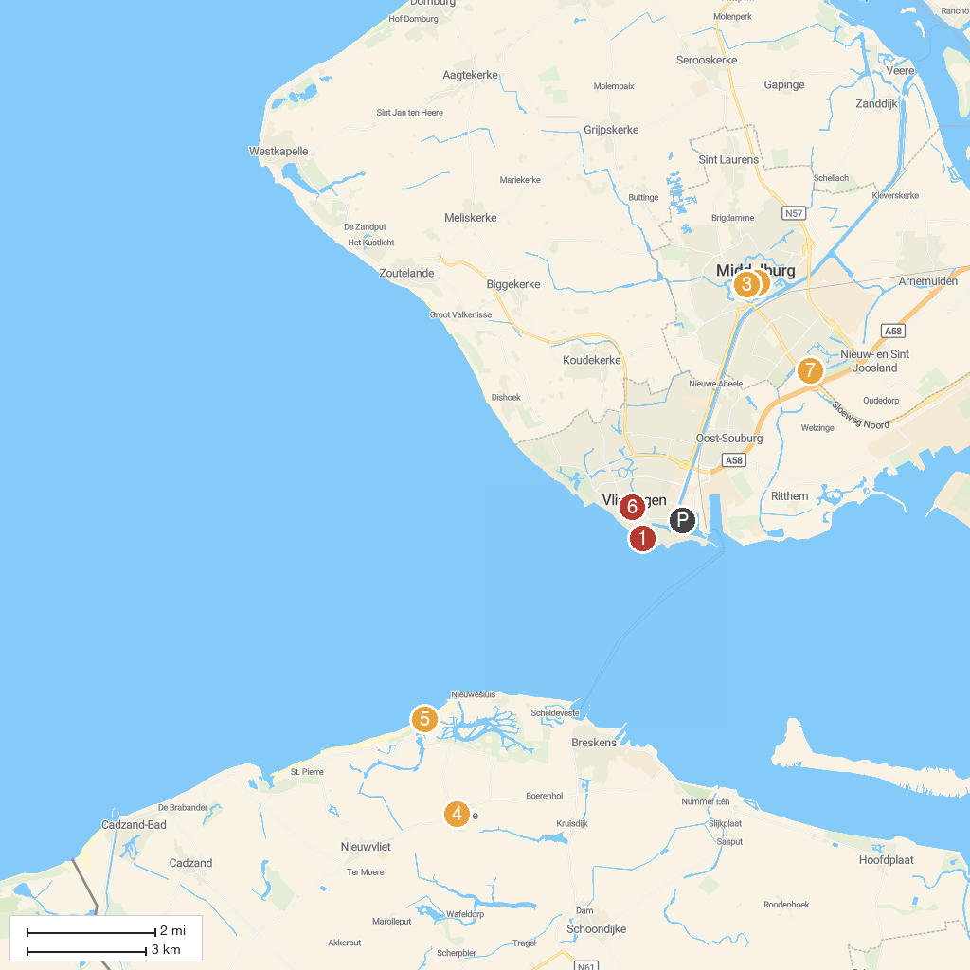
MAP KEY
1. Iguana reptile Zoo | 5. Beach House 25
2. New Church Middelburg | 6. Museum Panorama Walcheren
3. Foundation Public Observatory Philippus Lansbergen | 7. ZEP
4. Het Vlaemsche Erfgoed
P. Cruise port / terminal
Map © MapTiler © OpenStreetMap contributors · cruiseports.org

