Vitória, Espírito Santo, Brazil
One of Brazil's three island capitals, Vitória rewards curious cruisers with a 16th-century convent perched on a granite cliff, centuries-old clay-pot pottery still made by hand, and a lighter, more elegant seafood stew than you'll find anywhere else in the country.
⚓ Pier (docked) · 🕒 Typical call: 8-10 hrs · 💵 Brazilian Real (BRL) — cards accepted widely · 🗣️ Portuguese (little English spoken) · 🦺 Uber strongly recommended
✍️ MY DAY IN PORT (FILL IN)
Ship / Date
In port | arrive ______ · all aboard ______
Booked excursion
Notes / meeting point
GETTING ASHORE
- Docking: Pier — Cais Comercial, historic downtown Vitória
- Walk to center: 2-10 min on foot to historic Centro; beaches need Uber/taxi
- Best For: History, seafood, beaches, local crafts, scenic viewpoints
- Don't Miss: Convento da Penha (Vila Velha) and Moqueca Capixaba lunch
GETTING AROUND
- 🚕 Taxi: R$30–60 (USD $6–12) — Metered taxis available at the port. Base fare R$6.20 plus ~R$4.00/km; an 8km ride to city center runs approximately R$4
- 📱 Rideshare: ✅ Uber
TOP THINGS TO DO
- Convento da Penha & Vila Velha — The crown jewel of the region: a Franciscan convent founded in 1558 atop a 154m granite hill with sweeping views over the bay…
- Paneleiras de Goiabeiras — Clay Pot Workshop — Watch local women hand-craft the iconic black clay pots used to cook Moqueca Capixaba using Tupi-Guarani techniques over 400…
- Moqueca Capixaba Lunch at Ilha das Caieiras — Vitória's historic fishing quarter serves the authentic local seafood stew — lighter than Bahia-style, cooked in a handmade clay…
- Praia da Costa (Vila Velha) Beach Day — The best beach close to the port: clean golden sand, calm waters at Praia da Sereia, and a boardwalk full of kiosks serving cold…
- Historic Centro Walking Tour — Stroll from the pier to the Palácio Anchieta (1551, with Saint Anchieta's tomb and free guided tours), the neo-Gothic…
BEST WALKS
- Historic Centro Stroll: 1-2 hrs · Mostly flat · Free — Walk from the pier gate along Avenida Getúlio Vargas to Palácio Anchieta, then up to the…
- Praça do Papa & Project Tamar: 30 min · Easy · ~$5 entry — A short Uber ride to Praça do Papa brings you to the Project Tamar sea turtle conservation center…
WEATHER · DAYLIGHT · MONEY
Month | High °F | Low °F | Rainy days
May | 79 | 69 | 11
Jul | 77 | 65 | 10
Sep | 80 | 69 | 10
Daylight: May 6:03AM–5:11PM · Jul 6:17AM–5:17PM · Sep 5:37AM–5:35PM
cruiseports.org/vitoria · Confirm terminal & all-aboard time with your ship

Vitória, Espírito Santo, Brazil — Port Map
Red = walkable sights · Amber = excursions farther out · P = cruise terminal
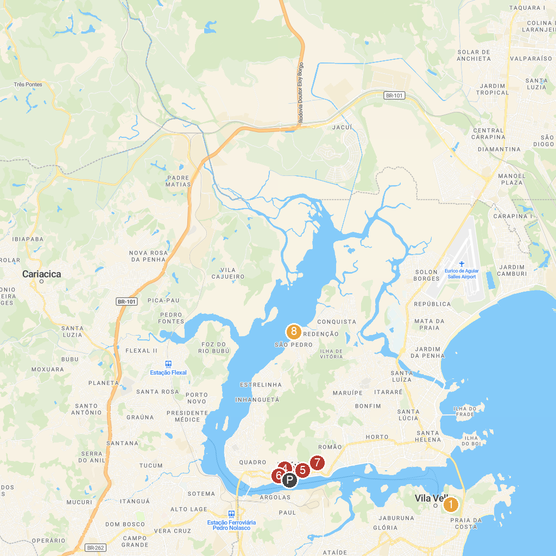
MAP KEY
1. Convento da Penha | 5. Igreja do Rosário
2. Palácio Anchieta | 6. MUCANE - Museu Capixaba do Negro
3. Chapel of Santa Luzia | 7. Parque Natural Municipal Gruta da Onça
4. Convento de São Francisco | 8. Museu Histórico da Ilha das Caieiras "Manoel Passos Lyrio" - Lime Kiln Island History Museum
P. Cruise port / terminal
Map © MapTiler © OpenStreetMap contributors · cruiseports.org

