Visegrád, Pest County, Hungary
Where the Danube makes its most dramatic turn, a medieval citadel crowns the forested hilltop above one of Hungary's most historic royal towns. Visegrád punches well above its size.
⚓ Docked at pier · 🕒 Typical call: 6–8 hrs · 💵 Hungarian Forint (HUF); cards widely accepted · 🗣️ Hungarian; English spoken in tourist areas · 🏰 Medieval history & scenic views
✍️ MY DAY IN PORT (FILL IN)
Ship / Date
In port | arrive ______ · all aboard ______
Booked excursion
Notes / meeting point
GETTING ASHORE
- Docking: Ships dock directly at Visegrád Ship Station on the river — no tender required
- Walk to center: 10–15 min flat walk south along the riverfront to the Royal Palace area
- Best For: Medieval history, panoramic Danube views, and easy walkable sightseeing
- Don't Miss: The Citadel's hilltop view of the Danube Bend — the most iconic viewpoint on the entire river
GETTING AROUND
- 🚕 Taxi: ~1,400–1,800 HUF (~$4–5 USD) — Local taxis cover the short distance from the pier to the town center quickly. Given the walkable distance, taxis are ma
TOP THINGS TO DO
- Visegrád Citadel — The 13th-century fortress crowning the hilltop delivers 360° views over the Danube Bend — the most famous river panorama in…
- Royal Palace of Matthias Corvinus — Buried by a landslide in the 1700s and excavated in the 20th century, this reconstructed Renaissance palace features the red…
- Alpine Bobsled Track — A summer alpine coaster near the Citadel — unexpected fun for families and active cruisers.
- Solomon's Tower & Medieval Knights — A massive hexagonal 13th-century tower north of the pier, once used to imprison Vlad the Impaler.
- Danube Bend Panorama Walk — The flat riverfront promenade from the pier offers scenic views across the Danube to the Börzsöny Hills and the twin town of…
BEST WALKS
- River Town Stroll: 1.5 km · Flat · 20 min · Free — Walk south along the Danube promenade from the ship station past Solomon's Tower, through the town…
- Calvary Trail to the Citadel: 3 km · Steep · 50–60 min up · Hiking boots required — For fit hikers only — the Calvary Trail climbs 330 m through forested Pilis hillside to the Citadel.
WEATHER · DAYLIGHT · MONEY
Month | High °F | Low °F | Rainy days
May | 68 | 51 | 13
Jul | 81 | 63 | 11
Sep | 71 | 55 | 9
Daylight: May 5:06AM–8:15PM · Jul 5:01AM–8:38PM · Sep 6:21AM–6:55PM
cruiseports.org/visegrad · Confirm terminal & all-aboard time with your ship

Visegrád, Pest County, Hungary — Port Map
Red = walkable sights · Amber = excursions farther out · P = cruise terminal
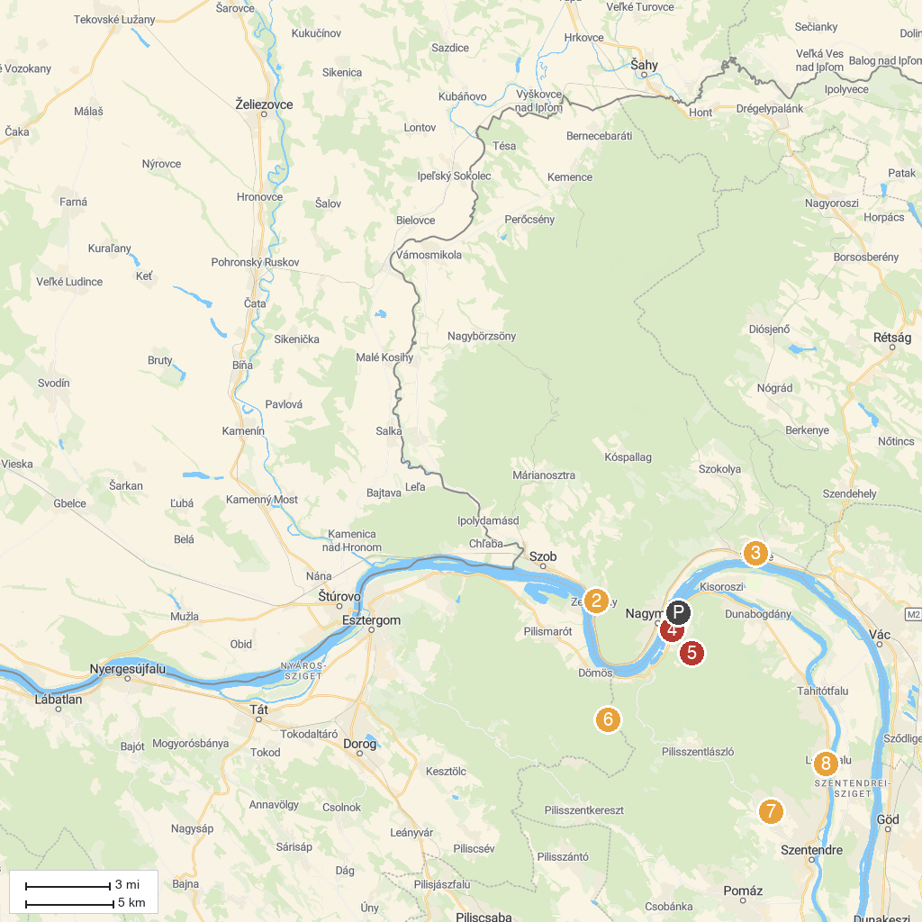
MAP KEY
1. Museum of Matthias Rex | 5. Devil's Mill Waterfall
2. Hajózástörténeti Múzeum | 6. Predikálószék lookout
3. Gorka Géza Kerámiamúzeum | 7. Szentendre Skanzen Village Museum
4. Zugfőzde Pálinkamúzeum | 8. Szent Anna's Church
P. Cruise port / terminal
Map © MapTiler © OpenStreetMap contributors · cruiseports.org

