Visby, Gotland, Sweden
The 'Town of Roses and Ruins' offers the best-preserved medieval city wall in Northern Europe — UNESCO-listed and entirely walkable from the cruise pier.
⚓ Pier (Kopparsvik terminal) · 🕒 Typical call: 8–10 hrs · 💵 Swedish Krona (SEK) · 🗣️ Swedish (English widely spoken) · 🏰 UNESCO World Heritage Site
✍️ MY DAY IN PORT (FILL IN)
Ship / Date
In port | arrive ______ · all aboard ______
Booked excursion
Notes / meeting point
GETTING ASHORE
- Docking: Pier at Kopparsvik, ~1.5 km south of the city walls
- Walk to center: 20–25 min walk or shuttle bus to the Old Town gates
- Best For: Medieval history, rose-lined streets, church ruins, coastal views
- Don't Miss: The 3.4 km Ringmur city wall and the Viking silver at Gotlands Museum
GETTING AROUND
- 🚕 Taxi: 80–95 SEK (~$8–10) — Taxis queue at the pier; the ride to the city center takes about 4–5 minutes. Local provider Visbytaxi also offers a boo
- 📱 Rideshare: ✅ Uber
- 🚌 Hop-on hop-off: ✅ City Sightseeing Visby
TOP THINGS TO DO
- Visby City Wall (Ringmur) Walk — The 3.4 km Ringmur is the best-preserved medieval city wall in Northern Europe.
- Gotlands Museum — Home to the world's largest cache of Viking silver treasure, plus picture stones, medieval weaponry, and Gotland's history from…
- Fårö Island Sea Stacks Day Trip — Drive or tour 45 km north to the island of Fårö, famous for its otherworldly raukar limestone sea stacks jutting from Baltic…
- Coastal Bike Tour — Rent bikes at the pier area or join a guided tour to cycle the scenic coastal path south toward Högklint cliffs, with sweeping…
- Church Ruins & Cathedral Walk — Visby has more medieval church ruins per square kilometer than almost anywhere in Europe.
BEST WALKS
- Medieval Wall Circuit: 3.4 km loop | 1.5–2 hrs | Easy–moderate — Start at Söderport gate and walk the full Ringmur circuit, passing towers and viewpoints.
- Old Town Lanes & Ruins Loop: 2 km | 1–1.5 hrs | Easy — From the cathedral, wander south through cobblestone lanes past the St.
WEATHER · DAYLIGHT · MONEY
Month | High °F | Low °F | Rainy days
May | 59 | 44 | 8
Jul | 71 | 58 | 11
Sep | 63 | 53 | 10
Daylight: May 4:24AM–9:02PM · Jul 4:10AM–9:33PM · Sep 6:17AM–7:05PM
cruiseports.org/visby · Confirm terminal & all-aboard time with your ship

Visby, Gotland, Sweden — Port Map
Red = walkable sights · Amber = excursions farther out · P = cruise terminal
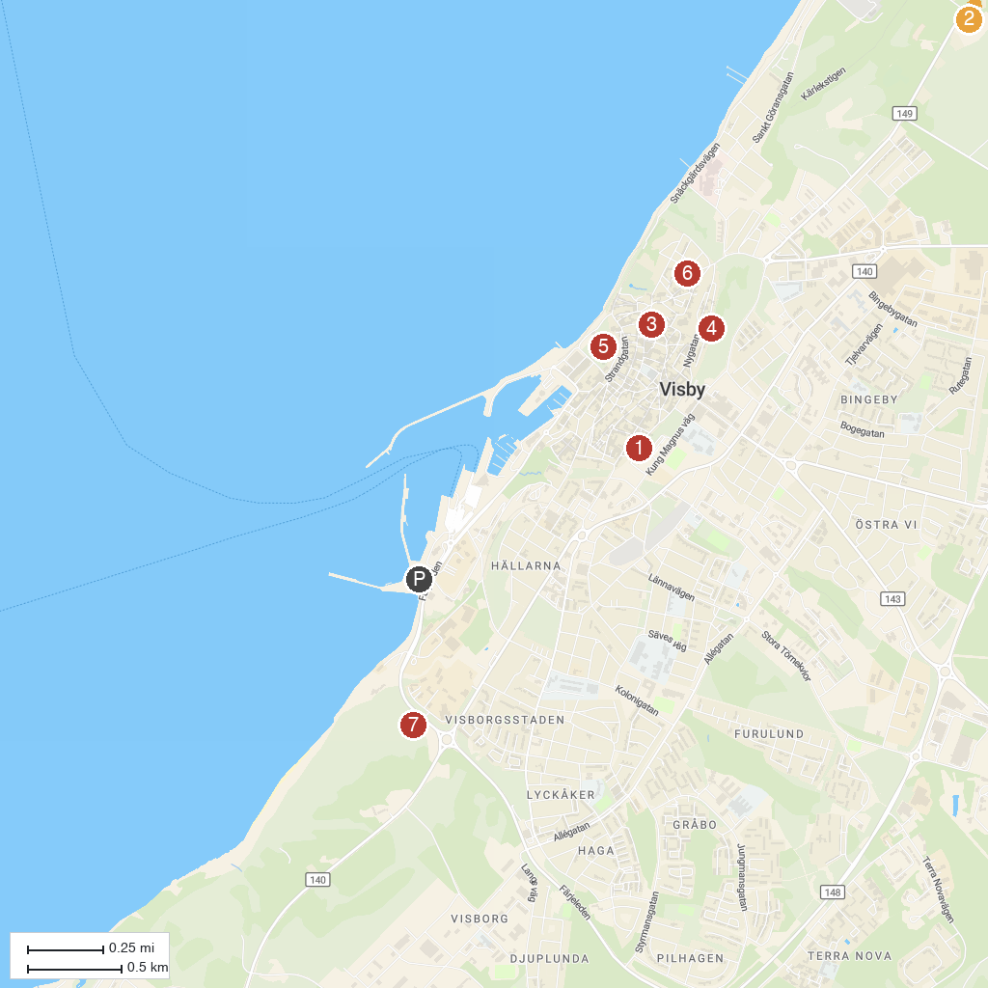
MAP KEY
1. Kajsar Tower | 5. Almedalen
2. Brucebo naturreservat | 6. St. Nicolai Ruin
3. Drottens ruin | 7. South Hällarna Nature Reserve
4. Dalmansporten
P. Cruise port / terminal
Map © MapTiler © OpenStreetMap contributors · cruiseports.org

