Vis Island, Dalmatia, Croatia
Once a sealed Yugoslav military base, Vis is now Croatia's most authentic island — stone alleys, secret cold-war tunnels, and a glowing sea cave that earns its hype.
⚓ Tender (most ships anchor offshore) · 🕒 Typical call: 6-8 hrs · 💶 Currency: Euro (€) · 🗣️ Language: Croatian (English widely spoken)
✍️ MY DAY IN PORT (FILL IN)
Ship / Date
In port | arrive ______ · all aboard ______
Booked excursion
Notes / meeting point
GETTING ASHORE
- Docking: Tender for mid/large ships; small yachts & coastal cruisers dock at Vis Town pier
- Walk to center: Immediate — you step ashore in Vis Town; Kut old quarter is 15-20 min walk
- Best For: Blue Cave excursion, WWII history, authentic Dalmatian food, unspoiled beaches
- Don't Miss: Blue Cave on Biševo Island, Kut old quarter, Tito's cave military tour
GETTING AROUND
- 🚕 Taxi: €5 start + €2.30/km (car); €3.10/km (van) — Local taxis (e.g. Taxi Đuli, Vis Taxi 24, Alpha Travel Vis) are available near the port. Prices can add up quickly for l
- 📱 Rideshare: ❌ not available
TOP THINGS TO DO
- Blue Cave (Biševo Island) — Sunlight enters an underwater opening and reflects off the white limestone floor, flooding the cave in electric blue light.
- WWII & Cold-War Military Tour — A 4x4 guide takes you into classified Yugoslav-era bunkers, underground rocket bases, and Tito's Cave — a clifftop hideout used…
- Stiniva Cove by Boat — Europe's best beach 2016 — a narrow cliff passage opens to a hidden white-pebble cove surrounded by towering rock walls.
- Vis Town & Kut Old Quarter Walk — Kut is one of Dalmatia's most atmospheric neighborhoods — Venetian Renaissance palaces, stone alleys, and hidden courtyards.
- Vis Wine & Seafood Lunch — Vis grows Vugava, a golden, full-bodied white wine cultivated since ancient Greek settlers arrived.
BEST WALKS
- Quay to Kut Old Quarter: 15-20 min one way | Flat | Free — From the tender quay at Luka, walk east along the seafront promenade past cafes and fishing boats…
- Quay to Prirovo Beach & Monastery: 10 min one way | Flat | Free — Walk west from the quay along the harbor road to the small Prirovo Peninsula.
- Fort George Hike: 30 min up | Moderate | Free — From Kut, follow the road uphill to the British-built Fort George (1813, Napoleonic era).
WEATHER · DAYLIGHT · MONEY
Month | High °F | Low °F | Rainy days
May | 65 | 62 | 8
Jul | 78 | 75 | 3
Sep | 74 | 70 | 6
Daylight: May 5:32AM–8:11PM · Jul 5:29AM–8:32PM · Sep 6:35AM–7:04PM
cruiseports.org/vis-island-croatia · Confirm terminal & all-aboard time with your ship

Vis Island, Dalmatia, Croatia — Port Map
Red = walkable sights · Amber = excursions farther out · P = cruise terminal
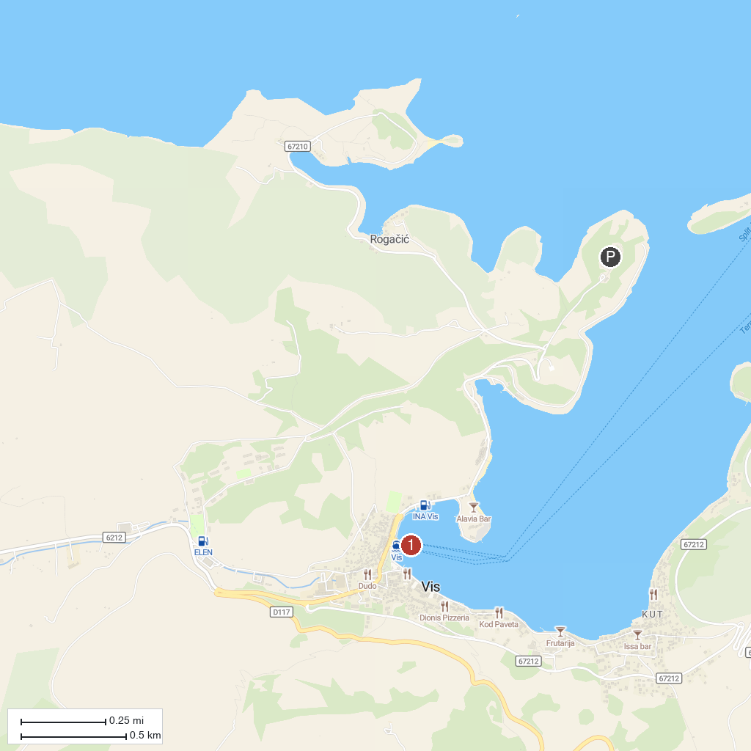
MAP KEY
1. Franciscan Monastery | 2. Vis Ferry Harbour
P. Cruise port / terminal
Map © MapTiler © OpenStreetMap contributors · cruiseports.org

