Virgin Gorda, British Virgin Islands
Giant granite boulders spill into turquoise coves at The Baths — Virgin Gorda's geological wonder. Add in empty crescent beaches and a yachting-village vibe, and you have the BVI's most rewarding shore day.
⚓ Tender port (no pier) · 🕒 Typical call: 6-8 hrs · 💵 US Dollar (USD) · 🗣️ English · 🏖️ Beach & nature focus
✍️ MY DAY IN PORT (FILL IN)
Ship / Date
In port | arrive ______ · all aboard ______
Booked excursion
Notes / meeting point
GETTING ASHORE
- Docking: Anchor & tender to Virgin Gorda Yacht Harbour, Spanish Town
- Walk to center: 2-5 min from tender dock to Spanish Town shops & restaurants
- Best For: The Baths, snorkeling, uncrowded beaches, yachting atmosphere
- Don't Miss: The Baths National Park boulder trail to Devil's Bay
GETTING AROUND
- 🚕 Taxi: $5–$10/person — Open-air safari buses and taxis meet ferries and tender tenders at the dock. Short hops around Spanish Town cost roughly
- 📱 Rideshare: ❌ not available
TOP THINGS TO DO
- The Baths National Park — Navigate a maze of house-sized granite boulders forming sea caves, tunnels, and tidal pools leading to the secluded Devil's Bay…
- Spring Bay & Devil's Bay — Just north of The Baths, Spring Bay has the same dramatic boulders with far fewer crowds.
- Savannah Bay — A long, sweeping crescent of white sand on the island's northern side — often virtually empty.
- Gorda Peak National Park Hike — Hike through semi-rainforest to the island's 1,370-ft summit observation tower for 360° views across the BVI, including Necker…
- Copper Mine Point Ruins — Walk the dramatic windswept southern tip to see ruins of a 19th-century Cornish copper mine — engine house, chimney, and clifftop…
BEST WALKS
- Spanish Town Stroll: 30-45 min · Easy · Flat — Wander the yacht harbor, browse boutique shops, and stop for conch fritters or a rum punch at The…
- The Baths Trail to Devil's Bay: 45-60 min · Moderate · Water shoes required — From the Baths entrance, follow marked trail signs through the granite boulder labyrinth — ducking…
cruiseports.org/virgin-gorda-island-bvi · Confirm terminal & all-aboard time with your ship

Virgin Gorda, British Virgin Islands — Port Map
Red = walkable sights · Amber = excursions farther out · P = cruise terminal
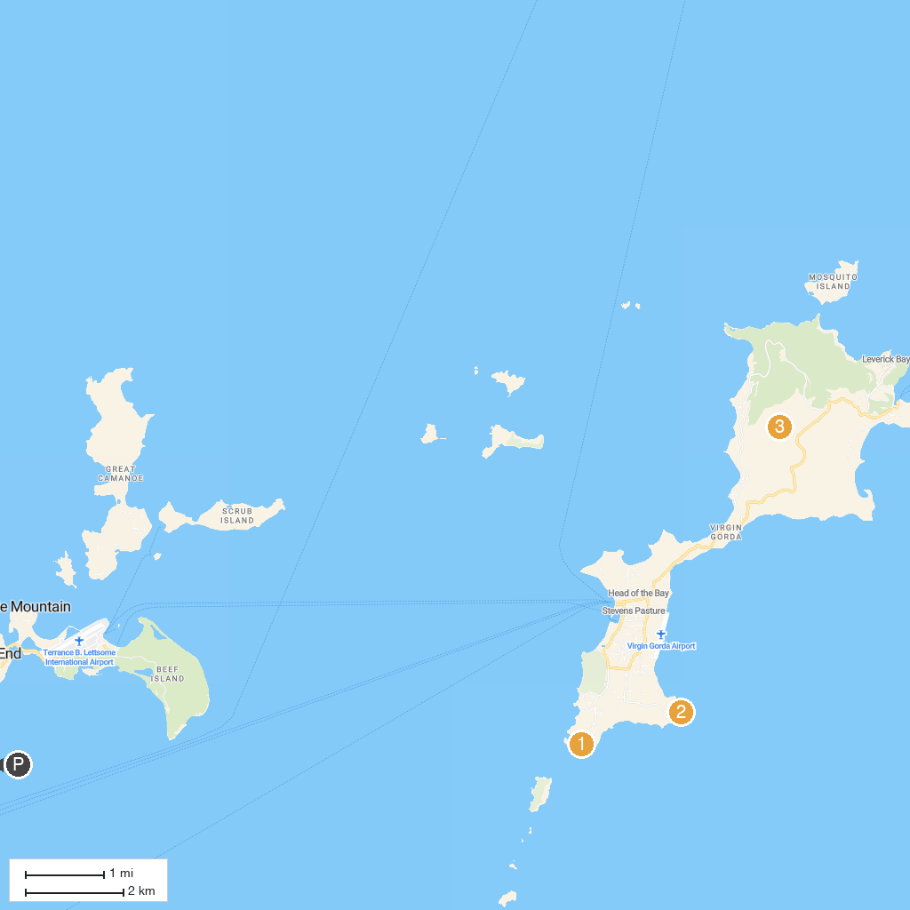
MAP KEY
1. Devil's Bay National Park | 3. Gorda Peak National Park
2. Copper Mine National Park, Virgin Gorda
P. Cruise port / terminal
Map © MapTiler © OpenStreetMap contributors · cruiseports.org

