Vinh Long, Mekong Delta, Vietnam
A living Delta town where coconut-palm canals wind past steaming brick kilns and sampan-filled waterways — the real Mekong, not the postcard version.
⚓ River pier (docked alongside) · 🕒 Typical call: 6–8 hrs · 💵 Vietnamese Dong (VND) — cash only · 🗣️ Vietnamese (very limited English)
✍️ MY DAY IN PORT (FILL IN)
Ship / Date
In port | arrive ______ · all aboard ______
Booked excursion
Notes / meeting point
GETTING ASHORE
- Docking: River cruise ships dock at the Vinh Long waterfront on the Co Chien River; passengers step directly ashore.
- Walk to center: Town market and main street are steps from the pier; An Binh Island requires a short sampan ferry.
- Best For: Canal sampan rides, traditional craft villages, Mang Thit Brick Kilns, tropical fruit gardens.
- Don't Miss: A sampan through the water-coconut canals of An Binh Island — the defining Mekong Delta image.
GETTING AROUND
- 🚕 Taxi: $5–$9 USD — Metered taxis are available from river disembarkation points. From An Binh Island you'll also need a short ferry crossin
- 📱 Rideshare: ✅ Grab
TOP THINGS TO DO
- An Binh Island Sampan & Canal Villages — Cross the Co Chien River and weave through narrow water-coconut canals by wooden sampan, stopping at fruit orchards, traditional…
- Mang Thit Brick Kilns — The Red Kingdom — One of Vietnam's most striking landscapes: hundreds of red-domed kilns still smoking along the canals south of town, surrounded…
- Traditional Craft Workshops — Visit family workshops producing rice paper, rice wine, coconut candy, and pop-rice cakes — all by hand.
- Van Thanh Mieu Temple — A Confucian temple on the Vinh Long waterfront dedicated to Vietnamese scholars and literati, with an attractive garden and…
- Tropical Fruit Garden Lunch — Many An Binh Island homesteads double as eco-tourism stops — sit in a garden of rambutan, longan, pomelo, and mango trees and…
BEST WALKS
- Vinh Long Waterfront Stroll: ~1.5 km · 20 min · Flat — From the pier, walk south along the riverside promenade past local cafés, the town market, and…
- An Binh Island Bicycle Loop: ~8 km · 1.5–2 hrs · Flat — Rent a bicycle on the island and follow the narrow concrete paths through coconut groves, rice…
WEATHER · DAYLIGHT · MONEY
Month | High °F | Low °F | Rainy days
May | 91 | 78 | 26
Jul | 86 | 76 | 29
Sep | 87 | 76 | 28
Daylight: May 5:34AM–6:10PM · Jul 5:42AM–6:21PM · Sep 5:46AM–5:56PM
cruiseports.org/vinh-long · Confirm terminal & all-aboard time with your ship

Vinh Long, Mekong Delta, Vietnam — Port Map
Red = walkable sights · Amber = excursions farther out · P = cruise terminal
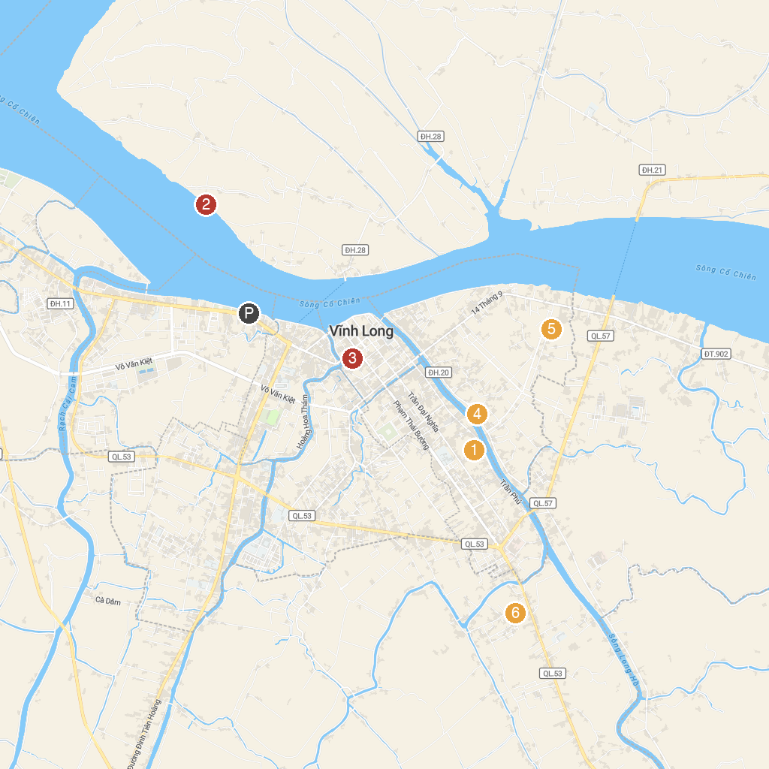
MAP KEY
1. Văn Thánh Miếu | 4. Chùa Long Khánh
2. Khu Du Lịch Vinh Sang | 5. Làng Gốm Tư Buôi
3. Di tích cửa hữu Thành Long Hồ | 6. Pham Hung Temple
P. Cruise port / terminal
Map © MapTiler © OpenStreetMap contributors · cruiseports.org

