Villeneuve-lès-Maguelone, Hérault, France
Wedged between shimmering saltwater lagoons and the Mediterranean, Villeneuve-lès-Maguelone rewards canal barge passengers with a peacock-filled island cathedral, 9 km of untouched beach, and flamingos wading at the water's edge.
⚓ Canal barge (direct mooring) · 🕒 Typical call: 4-6 hrs · 💶 Currency: Euro · 🗣️ Language: French
✍️ MY DAY IN PORT (FILL IN)
Ship / Date
In port | arrive ______ · all aboard ______
Booked excursion
Notes / meeting point
GETTING ASHORE
- Docking: Canal barge mooring along Canal du Rhône à Sète (Passerelle du Pilou)
- Walk to Cathedral: 1.2 km / ~15 min on flat paved path from mooring
- Best For: Medieval history, wild beaches, birdwatching, cycling
- Don't Miss: Cathédrale de Maguelone and the peacocks roaming its pine forest
GETTING AROUND
- 🚕 Taxi: €30–€40 — Taxis connect the port to central Montpellier (~13 km, ~17 min). Street hailing is unreliable; pre-book online or via ho
- 📱 Rideshare: ✅ Uber, Bolt
TOP THINGS TO DO
- Cathédrale de Maguelone — This 12th-century Romanesque fortress-cathedral sits on a wild island once home to a thriving papal city.
- Lagoon Birdwatching Walk — The path to the island crosses the Étang de l'Arnel.
- Plage de Maguelone — Nine kilometers of wild, Blue Flag sandy beach with no hotels, no beach bars, and almost no crowds mid-week.
- Wine Tasting at Domaine du Chapitre — This historic winery sits in the heart of the village, producing organic Languedoc wines on volcanic and sandy soils.
- Montpellier Day Trip — The regional capital is 10 km away — easily reachable by taxi (20 min) or short train from Villeneuve-lès-Maguelone station.
BEST WALKS
- Canal to Cathedral Loop: 2.4 km round trip | Easy | ~30 min walking — Follow the flat, paved path from the Passerelle du Pilou through vineyards and reed-fringed lagoon…
- Cathedral to Beach Stroll: ~600 m from cathedral | Easy | Beach access — From the cathedral, continue south along the path through the pine forest to reach Plage de…
WEATHER · DAYLIGHT · MONEY
Month | High °F | Low °F | Rainy days
May | 71 | 57 | 8
Jul | 85 | 69 | 3
Sep | 77 | 63 | 6
Daylight: May 6:20AM–9:02PM · Jul 6:17AM–9:23PM · Sep 7:24AM–7:54PM
cruiseports.org/villeneuve-les-maguelone · Confirm terminal & all-aboard time with your ship

Villeneuve-lès-Maguelone, Hérault, France — Port Map
Red = walkable sights · Amber = excursions farther out · P = cruise terminal
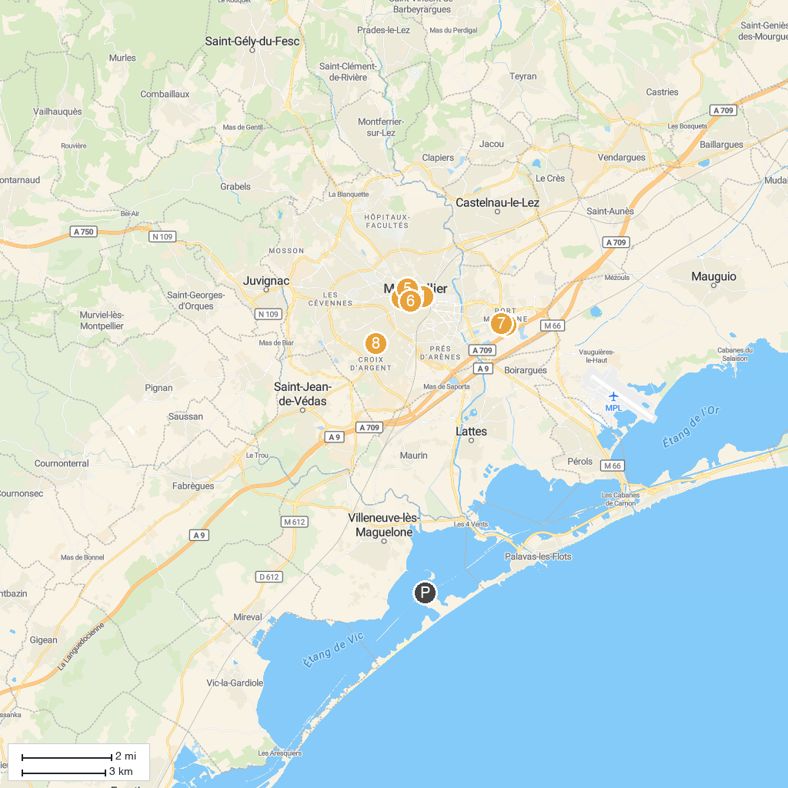
MAP KEY
1. Musée Fabre | 5. Jardin des plantes de Montpellier
2. Planet Ocean Montpellier | 6. Carré Sainte Anne
3. Promenade du Peyrou | 7. Patinoire Vegapolis
4. Cathédrale Saint-Pierre de Montpellier | 8. Parc Montcalm
P. Cruise port / terminal
Map © MapTiler © OpenStreetMap contributors · cruiseports.org

