Villefranche-sur-Saône, Rhône, France
Capital of the Beaujolais wine country, this handsome Saône river town offers a photogenic old town of Renaissance facades, hidden inner courtyards off Rue Nationale, and vineyards stretching to the horizon — all within easy reach of Lyon.
⚓ Docked (river quay) · 🕒 Typical call: 6–8 hrs · 💵 Euro (€) · 🗣️ French · some English in tourist areas
✍️ MY DAY IN PORT (FILL IN)
Ship / Date
In port | arrive ______ · all aboard ______
Booked excursion
Notes / meeting point
GETTING ASHORE
- Docking: Saône river quay, town center
- Walk to center: 5–10 min
- Best For: Wine · Old Town · Beaujolais
- Don't Miss: Rue Nationale & wine villages
GETTING AROUND
- 🚕 Taxi: €20–€37 — Local taxis are available near the port area. Short in-town trips run from around €20; average fare for a taxi journey i
- 📱 Rideshare: ✅ Uber
TOP THINGS TO DO
- Rue Nationale & Old Town Stroll — Wander Villefranche's main pedestrian artery — lined with Renaissance and Gothic facades — and push open the doorways along Rue…
- Beaujolais Wine Village Tour — Head north into the crus of Beaujolais — Fleurie, Moulin-à-Vent, or Morgon — for cellar tastings with local producers amid…
- Collégiale Notre-Dame des Marais — Villefranche's striking Gothic collegiate church, whose ornate flamboyant facade and soaring interior tower over the heart of the…
- Hameau du Vin (Georges Duboeuf) — The celebrated Beaujolais wine museum in Romanèche-Thorins — a themed journey through wine history, viticulture, and the…
- Beaujolais Vineyard Cycling — Bike the gently rolling Beaujolais hills on marked routes through the famous wine villages — a scenic way to absorb the landscape…
BEST WALKS
- Rue Nationale & Hidden Courtyards Loop: ~2 km · 1.5 hrs · easy — From the quay into the old town, down the pedestrian Rue Nationale, into the hidden inner…
- Saône Riverbank Walk: ~1.5 km · 45 min · easy — A peaceful stroll along the Saône quay both north and south of the ship — pleasant views across the…
WEATHER · DAYLIGHT · MONEY
Month | High °F | Low °F | Rainy days
May | 69 | 51 | 12
Jul | 83 | 63 | 9
Sep | 74 | 56 | 7
Daylight: May 6:09AM–9:06PM · Jul 6:05AM–9:28PM · Sep 7:19AM–7:52PM
cruiseports.org/villefranche-sur-saone · Confirm terminal & all-aboard time with your ship

Villefranche-sur-Saône, Rhône, France — Port Map
Red = walkable sights · Amber = excursions farther out · P = cruise terminal
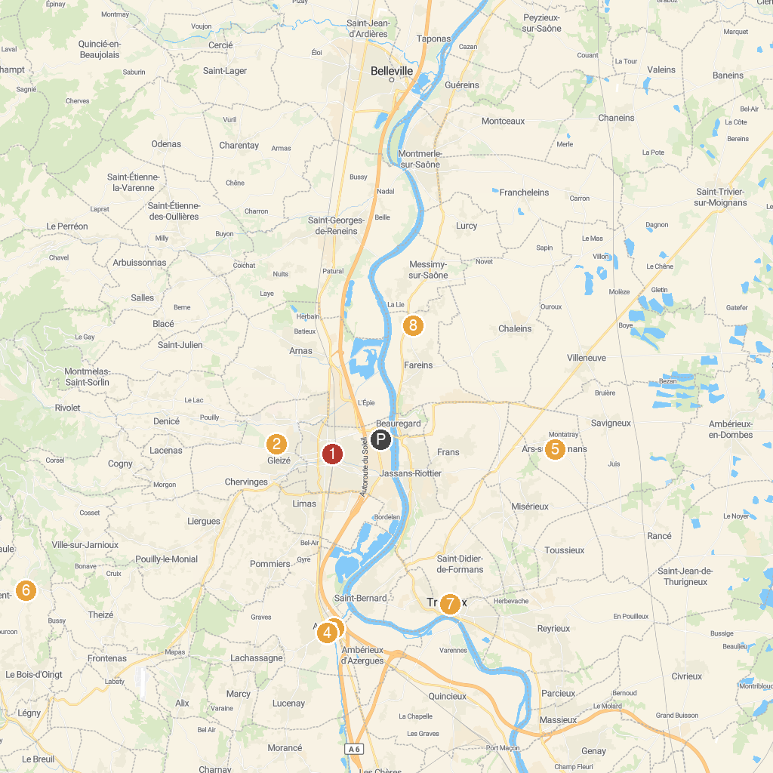
MAP KEY
1. Museum Paul Dini | 5. Sanctuary of Ars (Basilica of Ars)
2. Château de Vaurenard | 6. Tour d'Oingt
3. Anse - Pont (Chemin de Fer Touristique d'Anse) | 7. Château de Trévoux
4. Castle Tours | 8. Château de Fléchères
P. Cruise port / terminal
Map © MapTiler © OpenStreetMap contributors · cruiseports.org

