Vila Real de Santo António, Algarve, Portugal
Built in just five months by the Marquis of Pombal after the 1755 earthquake, Vila Real de Santo António is a perfectly symmetrical neoclassical grid town on the Spanish border — and a quick ferry ride away from Ayamonte, Spain.
⚓ Docked (small ships / river quay) · 🕒 Typical call: 5–8 hrs · 💶 Currency: Euro (€) · 🗣️ Language: Portuguese
✍️ MY DAY IN PORT (FILL IN)
Ship / Date
In port | arrive ______ · all aboard ______
Booked excursion
Notes / meeting point
GETTING ASHORE
- Docking: Small cruise ships and river vessels dock at the Cais da Alfândega riverfront quay. Larger ocean ships are rare; check your itinerary.
- Walk to centre: ~2 min flat walk (150 m) from the quay to Praça Marquês de Pombal
- Best For: Architecture, border-crossing day trip to Spain, beaches, seafood
- Don't Miss: Ferry to Ayamonte (Spain) — €3, 10 minutes, two countries in one day
GETTING AROUND
- 🚕 Taxi: €4–€6 — Local taxis are available at the marina. The city center is 1–2 km away; expect a €4–€6 fare with a €3.30 base charge pl
- 📱 Rideshare: ✅ Uber, Bolt
TOP THINGS TO DO
- Ferry to Ayamonte, Spain — Hop the 10-minute passenger ferry across the Guadiana River to the Spanish town of Ayamonte.
- Castro Marim Castles — A 10-minute taxi ride north to Castro Marim rewards you with a 13th-century hilltop castle and a 17th-century fort, plus sweeping…
- Castro Marim Nature Reserve & Flamingos — The salt pans just north of town are a haven for flamingos, white storks, and avocets.
- Praia de Monte Gordo Beach Day — A 5-minute taxi or bus ride west delivers you to Monte Gordo's wide sandy beach with calm, warm Atlantic water, sunbed hire, and…
- Pombaline Grid Walking Tour — Explore the perfectly symmetrical street grid laid out in 1774 by the Marquis of Pombal — the same system used to rebuild Lisbon…
BEST WALKS
- Promenade & Town Square Stroll: 1.5 km · 20 min · Flat — From the cruise quay, walk south along the palm-lined Avenida da República promenade, then turn…
- Pine Forest Path to Praia de Santo António: 2.5 km one-way · 30 min walk · Flat — Follow the dedicated cycle and walking path from the town edge through the Mata Nacional das Dunas…
WEATHER · DAYLIGHT · MONEY
Month | High °F | Low °F | Rainy days
May | 77 | 60 | 3
Jul | 88 | 68 | 0
Sep | 82 | 65 | 2
Daylight: May 6:21AM–8:31PM · Jul 6:21AM–8:49PM · Sep 7:12AM–7:36PM
cruiseports.org/vila-real-de-santo-antonio · Confirm terminal & all-aboard time with your ship

Vila Real de Santo António, Algarve, Portugal — Port Map
Red = walkable sights · Amber = excursions farther out · P = cruise terminal
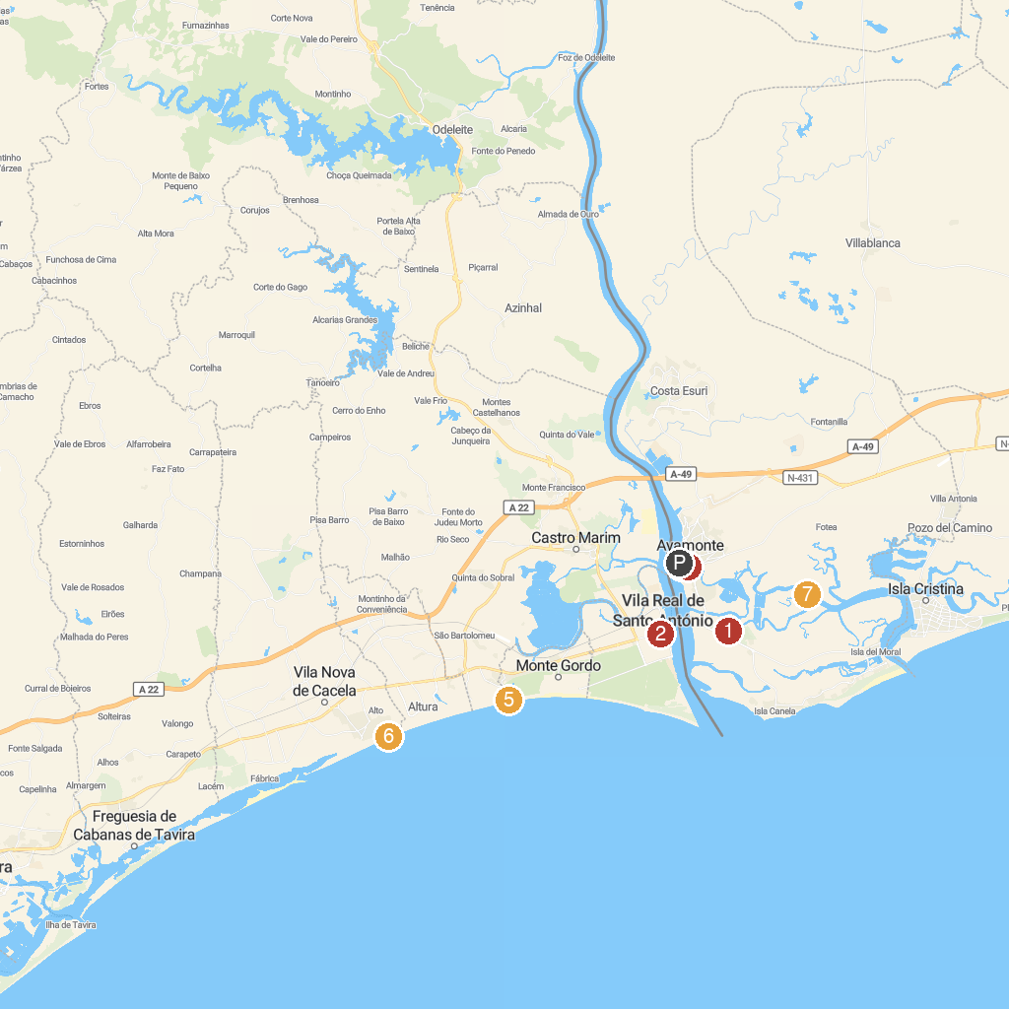
MAP KEY
1. Isla Canela Golf Club | 5. Plaza de la Coronación
2. Church Cacela Velha | 6. Praia Adão e Eva
3. Centro Cultural António Aleixo | 7. Praia da Lota
4. Iglesia de Nuestra Señora de las Angustias | 8. Marismas de Isla Cristina
P. Cruise port / terminal
Map © MapTiler © OpenStreetMap contributors · cruiseports.org

