Vikøyri, Vestland, Norway
Where the Sognefjord meets medieval Norway — Vikøyri pairs two 12th-century churches, a legendary cheese factory, and raspberry orchards stretching up into the mountains.
⚓ Pier (small/mid ships); tender for large vessels · 🕒 Typical call: 6–8 hrs · 💵 NOK (cashless — cards everywhere) · 🗣️ Norwegian (English widely spoken)
✍️ MY DAY IN PORT (FILL IN)
Ship / Date
In port | arrive ______ · all aboard ______
Booked excursion
Notes / meeting point
GETTING ASHORE
- Docking: Small/mid ships dock at village pier; large ships tender to harbor pontoon
- Walk to center: 2–5 min flat walk from pier to village
- Best For: Medieval churches, fjord scenery, local food & cheese
- Don't Miss: Hopperstad Stave Church (c. 1130) — one of Norway's finest
GETTING AROUND
- 🚕 Taxi: NOK 230–280 (~€20–24) for nearby trips — Taxis are extremely limited in Vikøyri and should be pre-booked. Norwegian fares run roughly NOK 16–17/km; short rides w
TOP THINGS TO DO
- Hopperstad Stave Church — Built around 1130, Hopperstad is one of Norway's oldest and best-preserved stave churches.
- Hove Stone Church — Dating to around 1170, Hove is one of the oldest stone buildings in the Sognefjord region — built as a private chapel for a local…
- Silver Ring Cultural Walk — A self-guided loop connecting the harbor, Vikøyri's historic wooden waterfront, Hove Stone Church, and Hopperstad Stave Church…
- TINE Gamalost Cheese Factory — Vikøyri is the only place on Earth where gamalost — a pungent, centuries-old Viking cheese — is still made.
- Sognefjord Boat Excursion — Cruise ships sometimes offer scenic RIB or fjord boat trips into the Arnafjord, Finnafjord, or UNESCO-listed Nærøyfjord…
BEST WALKS
- Silver Ring Walk — Churches & Orchards: 4 km loop · 1.5–2 hrs · Easy-moderate · Free — Start at the pier, stroll through the historic wooden waterfront, then follow the valley road to…
- Vikja River & Village Stroll: 1–2 km · 30–45 min · Easy · Free — A relaxed flat walk along the salmon-rich Vikja River from the fjord into the valley, then looping…
WEATHER · DAYLIGHT · MONEY
Month | High °F | Low °F | Rainy days
May | 56 | 44 | 17
Jul | 67 | 56 | 20
Sep | 60 | 50 | 18
Daylight: May 4:47AM–10:14PM · Jul 4:27AM–10:50PM · Sep 7:01AM–7:55PM
cruiseports.org/vikoyri · Confirm terminal & all-aboard time with your ship

Vikøyri, Vestland, Norway — Port Map
Red = walkable sights · Amber = excursions farther out · P = cruise terminal
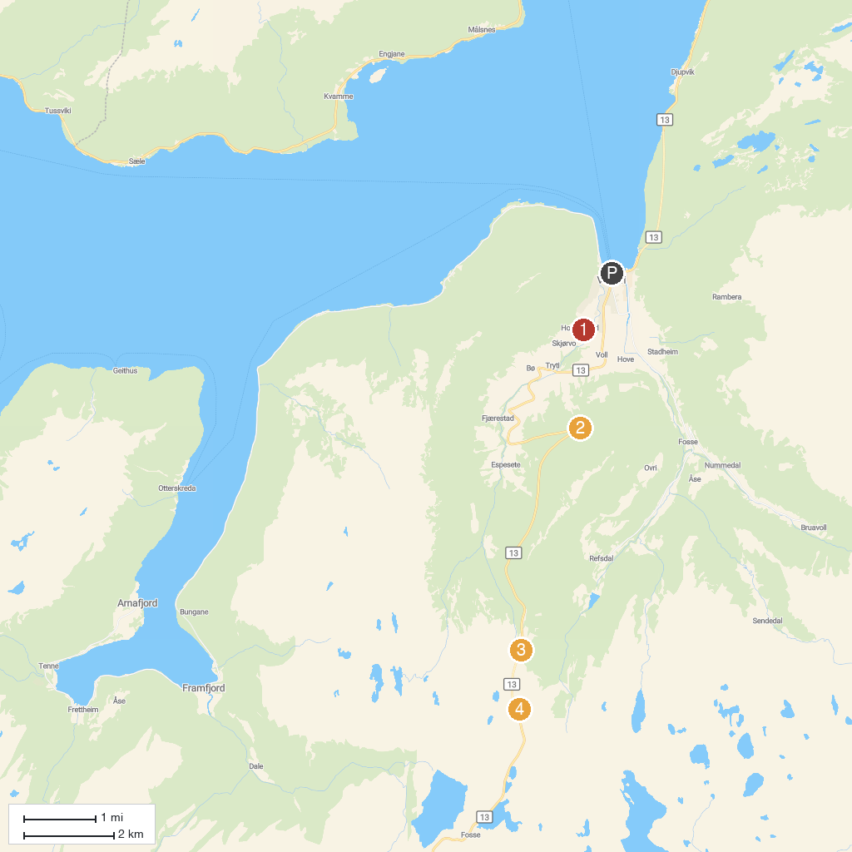
MAP KEY
1. Norwegian Travel Museum | 4. Viewpoint
2. Hopperstad Stave Church | 5. Vikafjell
3. Storesvingen Viewpoint
P. Cruise port / terminal
Map © MapTiler © OpenStreetMap contributors · cruiseports.org

