Vieques Island, Puerto Rico, USA
Eight miles off eastern Puerto Rico, Vieques is what the Caribbean looked like before the resorts arrived — wild horses on empty beaches, a Guinness-record glowing bay, and an ex-Navy wilderness refuge that kept developers out for decades.
⚓ Tender port (no cruise pier) · 🕒 Typical call: 6–8 hrs · 💵 US Dollar · 🗣️ Spanish / English · 🌿 Wildlife refuge & eco beaches
✍️ MY DAY IN PORT (FILL IN)
Ship / Date
In port | arrive ______ · all aboard ______
Booked excursion
Notes / meeting point
GETTING ASHORE
- Docking: Tender only — ships anchor off Esperanza or Isabel Segunda; no cruise pier
- Walk to center: Land directly on Esperanza Malecón (south) or Isabel Segunda ferry pier (north)
- Best For: Pristine beaches, bioluminescent bay tours, wild horse sightings, snorkeling
- Don't Miss: Mosquito Bay bio-bay tour (night only), Sun Bay Beach, Fortin Conde de Mirasol
GETTING AROUND
- 🚕 Taxi: $10–$15 per person — Private taxis available at the ferry terminal. No meters — always agree on the fare before getting in. Round-trip to wil
TOP THINGS TO DO
- Sun Bay Beach (Balneario Sombe) — Crescent bay with calm turquoise water, palm shade, restrooms, and a small cafeteria — the most accessible beach from Esperanza…
- Wild Horse & Wildlife Refuge Drive — Rent a UTV or Jeep and explore the former U.S.
- Mosquito Bioluminescent Bay Tour — Guinness World Record holder for the world's brightest bio-bay.
- Fortín Conde de Mirasol — The last Spanish fort built in the Americas (completed 1855), perched above Isabel Segunda with panoramic ocean views.
- Snorkel at Esperanza Pier — The old fishing pier at Esperanza is a local favorite for snorkeling — corals and fish gather around the pilings steps from the…
BEST WALKS
- Esperanza Malecón to Sun Bay Beach: 2.5 km · ~30 min one-way · Easy — Walk the Malecón boardwalk past restaurants and dive shops, then follow the road east to Sun Bay…
- Isabel Segunda Town Walk: ~1 km loop · 30 min · Easy — From the ferry pier, walk uphill into Isabel Segunda past local bakeries and the plaza to Fortín…
WEATHER · DAYLIGHT · MONEY
Month | High °F | Low °F | Rainy days
May | 81 | 78 | 14
Jul | 83 | 80 | 18
Sep | 84 | 80 | 19
Daylight: May 5:48AM–6:47PM · Jul 5:54AM–7:00PM · Sep 6:10AM–6:23PM
cruiseports.org/vieques-island · Confirm terminal & all-aboard time with your ship

Vieques Island, Puerto Rico, USA — Port Map
Red = walkable sights · Amber = excursions farther out · P = cruise terminal
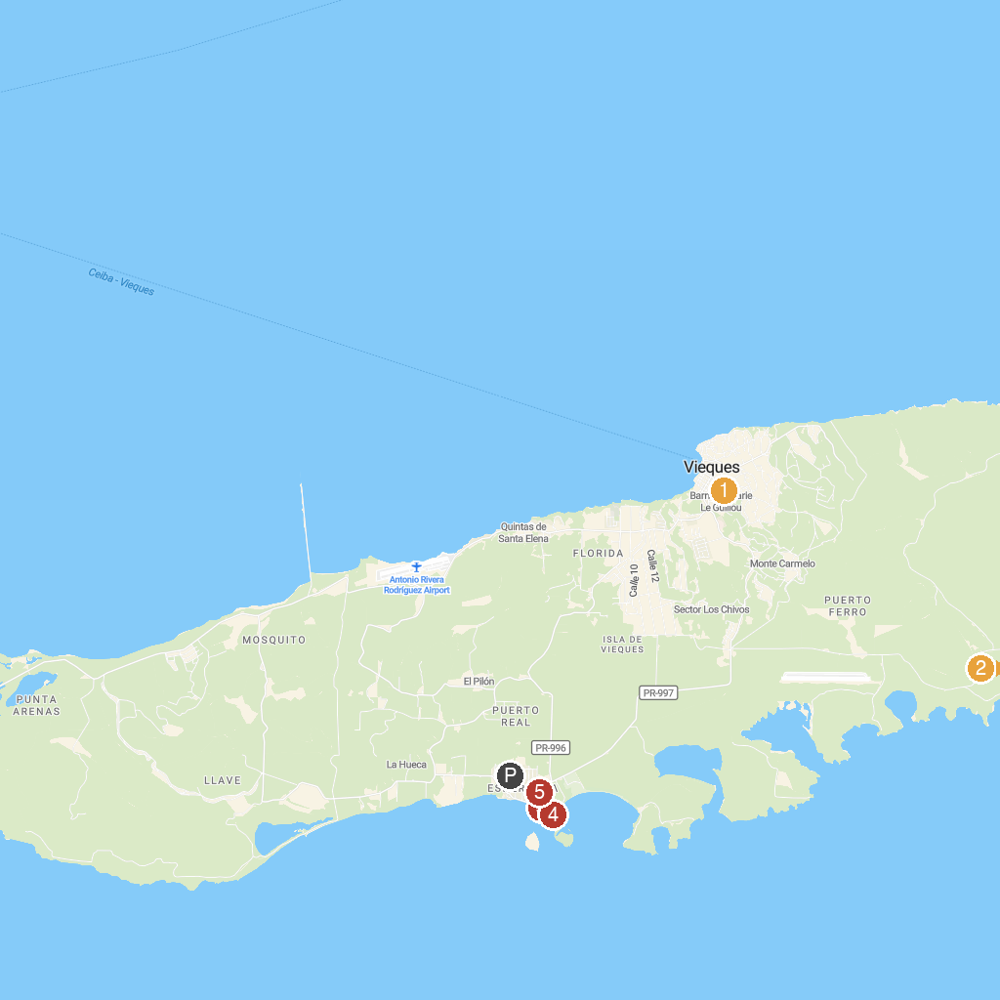
MAP KEY
1. El Fortin de Conde Mirasol Museum | 4. El Cayo Beach
2. Playa La Plata | 5. Mosquito Biobay Tours
3. Esperanza Beach
P. Cruise port / terminal
Map © MapTiler © OpenStreetMap contributors · cruiseports.org

