Vienne, Auvergne-Rhône-Alpes, France
One of the finest intact Roman cities in France, Vienne delivers temples, an ancient theatre, and exceptional gastronomy just steps from your Rhône river mooring.
⚓ Pier (Quai Jean Jaurès) · 🕒 Typical call: 6–10 hrs · 💶 Euro (€) · 🗣️ French
✍️ MY DAY IN PORT (FILL IN)
Ship / Date
In port | arrive ______ · all aboard ______
Booked excursion
Notes / meeting point
GETTING ASHORE
- Docking: Pier alongside Quai Jean Jaurès / Quai Pasteur
- Walk to center: 5–10 min flat walk from ship to Temple d'Auguste
- Best For: Roman history, Rhône wine, French markets
- Don't Miss: Temple of Augustus and Livia + Saturday Grand Market
GETTING AROUND
- 🚕 Taxi: €8–€20 — Local taxis (Taxi Curtil, Allocab and others) are available for trips to outlying sites like the Gallo-Roman Museum of S
- 📱 Rideshare: ✅ Uber Taxi
TOP THINGS TO DO
- Roman Vienne Highlights — Walk the Temple of Augustus and Livia (one of the best-preserved Roman temples in existence), the Ancient Theatre (capacity…
- Saint-Romain-en-Gal Museum & Site — Cross the pedestrian footbridge to the right bank and explore one of France's largest archaeological sites — excavated Roman…
- Côte-Rôtie & Condrieu Wine Tasting — Vienne sits at the northern gateway of the Rhône wine region.
- Saturday Grand Market — One of the largest outdoor markets in France — over 5 km of stalls winding through the city on Saturday mornings.
- Mount Pipet Viewpoint — Climb (or take the tourist train) to the belvedere above the Roman theatre for panoramic views over Vienne's rooftops, the…
BEST WALKS
- Roman Heart of Vienne: 1.5 km · ~30 min · Easy (flat, then optional uphill) — From the riverfront, walk to Place du Palais to admire the Temple of Augustus, then continue to the…
- Cross the Rhône to Saint-Romain-en-Gal: ~1 km each way · 20 min · Easy — Head north along the embankment and cross the Passerelle de Saint-Romain-en-Gal pedestrian…
WEATHER · DAYLIGHT · MONEY
Month | High °F | Low °F | Rainy days
May | 69 | 52 | 12
Jul | 83 | 64 | 8
Sep | 75 | 57 | 7
Daylight: May 6:10AM–9:04PM · Jul 6:06AM–9:25PM · Sep 7:19AM–7:51PM
cruiseports.org/vienne · Confirm terminal & all-aboard time with your ship

Vienne, Auvergne-Rhône-Alpes, France — Port Map
Red = walkable sights · Amber = excursions farther out · P = cruise terminal
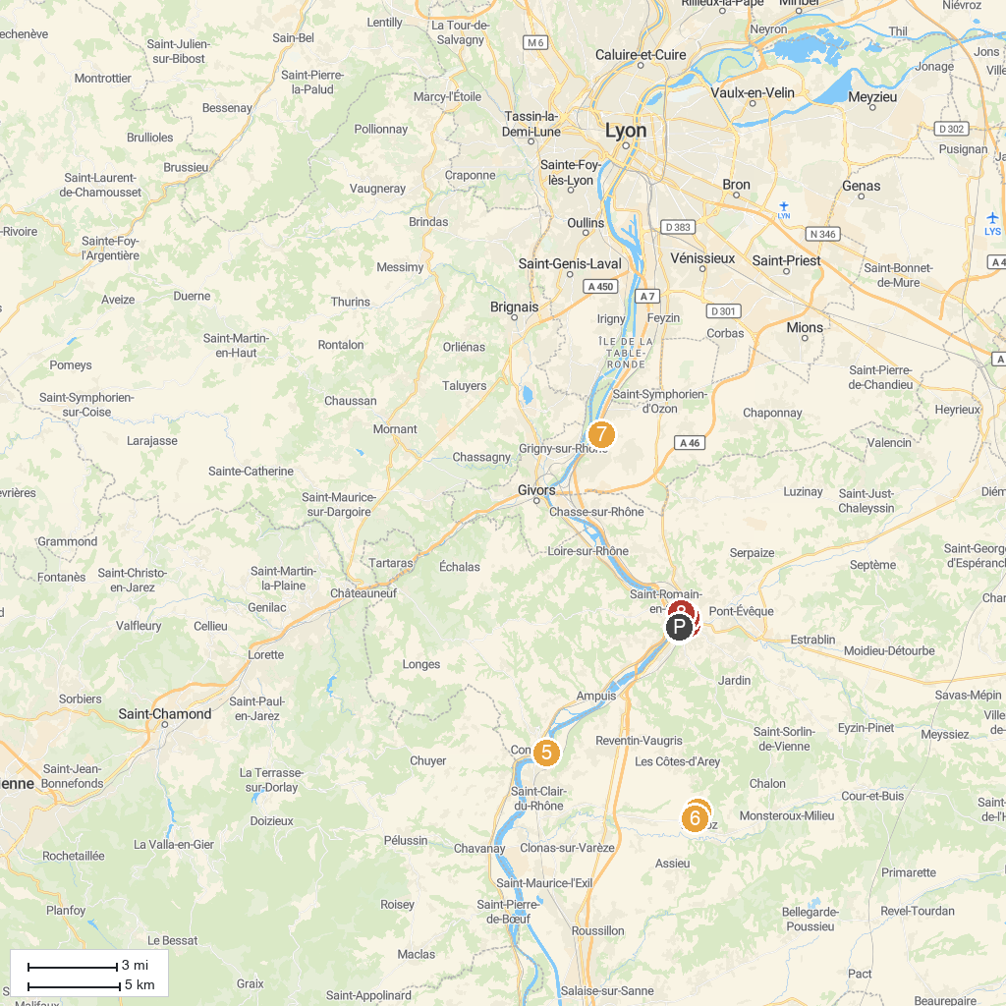
MAP KEY
1. Ville Garden | 5. Intuitive Trace Mobilboard Condrieu
2. Museum of Fine Arts and Archeology of Vienne | 6. LE JARDIN DU BOIS MARQUIS
3. Abbaye de Saint-André-le-Bas de Vienne | 7. Parc du Grand Clos
4. Marquis Woods | 8. Musée et sites archéologiques de Saint-Romain-en-Gal - Département du Rhône
P. Cruise port / terminal
Map © MapTiler © OpenStreetMap contributors · cruiseports.org

