Vienna, Austria
The Habsburg capital of music, coffee, and imperial grandeur. Vienna's Danube piers put one of Europe's most livable — and most magnificent — cities within a metro ride of your ship.
⚓ Docked (river pier) · 🕒 Typical call: full day · 💶 Euro (€) · 🗣️ German (English widely spoken)
✍️ MY DAY IN PORT (FILL IN)
Ship / Date
In port | arrive ______ · all aboard ______
Booked excursion
Notes / meeting point
GETTING ASHORE
- Docking: Pier — Reichsbrücke/Handelskai (main) or Nussdorf; no tendering
- Walk to center: Not walkable — 4 km; metro (U1) to Stephansplatz ~7 min
- Best For: Imperial history, classical music, café culture, museums
- Don't Miss: Schönbrunn Palace, Café Central, and standing-room opera tickets
GETTING AROUND
- 🚕 Taxi: €20–35 — Official metered taxis are plentiful at the port. The ride to central Vienna takes roughly 15–20 minutes; agree on meter
- 📱 Rideshare: ✅ Uber, Bolt
- 🚌 Hop-on hop-off: ✅ Big Bus Vienna
TOP THINGS TO DO
- Schönbrunn Palace & Gardens — The Habsburg summer residence and UNESCO World Heritage site.
- Hofburg Palace & Sisi Museum — The Habsburg winter palace in the heart of Vienna.
- Ringstraße Walking Tour — The 5 km imperial boulevard built by Emperor Franz Joseph rings the Innere Stadt.
- Vienna State Opera Standing Room — Experience the world-famous Staatsoper without paying hundreds of euros.
- Coffee House & Naschmarkt — Vienna's coffee house culture is UNESCO-listed intangible heritage.
BEST WALKS
- Imperial Vienna: Cathedral to Ringstraße: 2 km · 1 hr · Flat · Free — Start at St.
- Stadtpark & Belvedere Art Loop: 2.5 km · 1 hr · Flat · Paid entry at Belvedere — From Stadtpark (home to the golden Strauss statue), walk south along the Ringstraße to the Upper…
WEATHER · DAYLIGHT · MONEY
Month | High °F | Low °F | Rainy days
May | 67 | 51 | 13
Jul | 81 | 63 | 11
Sep | 71 | 55 | 10
Daylight: May 5:15AM–8:27PM · Jul 5:10AM–8:50PM · Sep 6:31AM–7:06PM
cruiseports.org/vienna · Confirm terminal & all-aboard time with your ship

Vienna, Austria — Port Map
Red = walkable sights · Amber = excursions farther out · P = cruise terminal
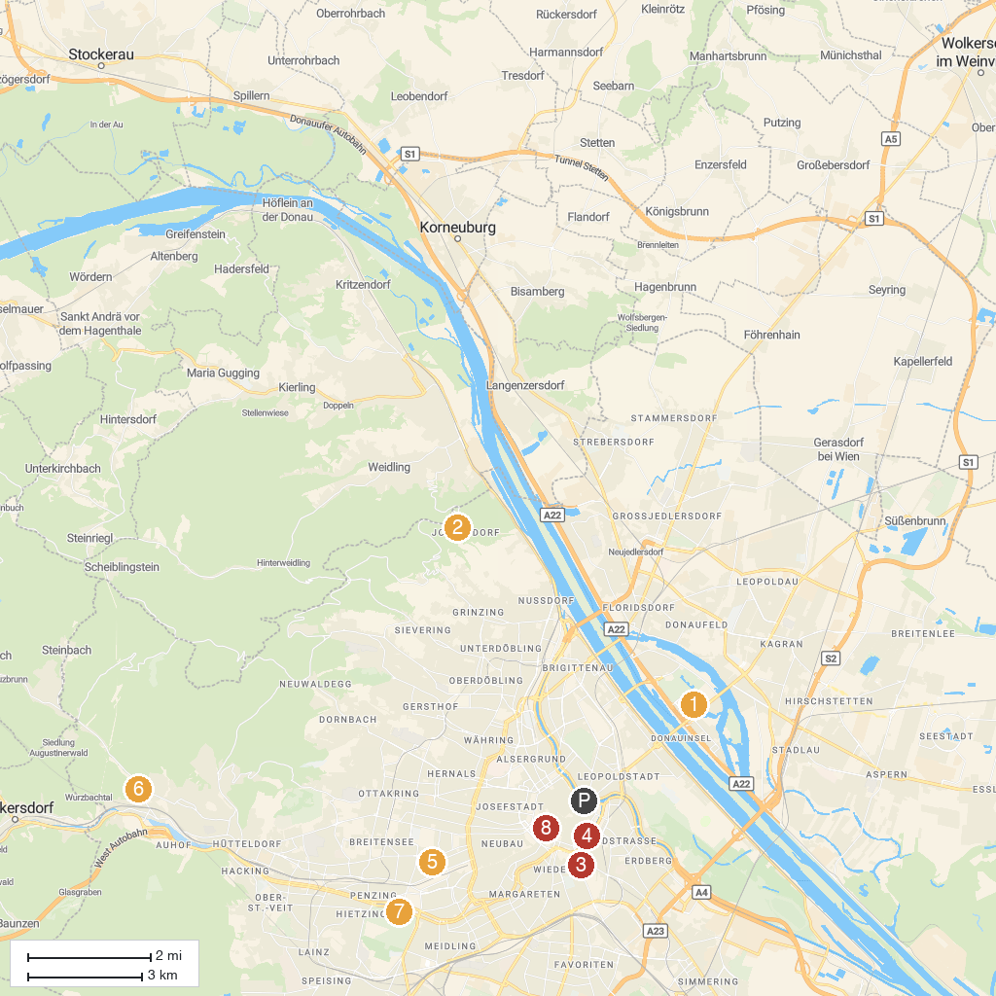
MAP KEY
1. Vienna International Centre (VIC) | 5. Water World
2. Kronprinzessin-Stefanie-Warte | 6. Laudon Palace
3. Palais Schwarzenberg | 7. Schönbrunn Palace
4. Johann Strauss monument | 8. Hofburg
P. Cruise port / terminal
Map © MapTiler © OpenStreetMap contributors · cruiseports.org

