Vidin, Northwest Bulgaria, Bulgaria
One of the oldest towns on the Bulgarian Danube, Vidin packs Roman ruins, a perfectly preserved medieval castle, and Ottoman mosques into a flat, strollable riverfront — all steps from the dock.
⚓ Docked (river pier) · 🕒 Typical call: 6-8 hrs · 💵 Bulgarian Lev (BGN) · 🗣️ Bulgarian (Cyrillic)
✍️ MY DAY IN PORT (FILL IN)
Ship / Date
In port | arrive ______ · all aboard ______
Booked excursion
Notes / meeting point
GETTING ASHORE
- Docking: Direct pier on the Danube — no tender required
- Walk to center: 5–10 min to Bdin Square; 15 min to Baba Vida Fortress
- Best For: Medieval history, Ottoman architecture, local wine
- Don't Miss: Baba Vida Fortress and the heart-topped minaret of the Pazvantoğlu Mosque
GETTING AROUND
- 🚕 Taxi: 3–5 BGN (~€1.50–2.50) — Taxis are available at the port. Base fare is 2 BGN with ~1 BGN/km; short city-center rides are very affordable.
- 📱 Rideshare: ❌ not available
TOP THINGS TO DO
- Baba Vida Fortress — Bulgaria's only fully intact medieval castle, built on Roman foundations in the 10th century.
- Belogradchik Rocks & Fortress — 50 km inland, bizarre red sandstone rock formations tower over an ancient Roman fortress built directly into the cliffs.
- Pazvantoğlu Mosque & the Heart Minaret — This late 18th-century Ottoman mosque is unique in the Islamic world — its minaret is topped with a heart, not a crescent.
- Jules Pascin Cultural Center (Restored Synagogue) — The second-largest synagogue in Bulgaria, beautifully restored in 2023 as a cultural center honoring modernist painter Jules…
- Bulgarian Wine & River Fish Lunch — Vidin sits in Bulgaria's premier Gamza wine region.
BEST WALKS
- Danube Embankment to Baba Vida Loop: 2.5 km · 45–60 min · Easy — From the pier, walk north through Danube Park to Baba Vida Fortress.
WEATHER · DAYLIGHT · MONEY
Month | High °F | Low °F | Rainy days
May | 73 | 56 | 11
Jul | 87 | 68 | 7
Sep | 78 | 60 | 5
Daylight: May 6:02AM–8:47PM · Jul 5:59AM–9:08PM · Sep 7:07AM–7:38PM
cruiseports.org/vidin · Confirm terminal & all-aboard time with your ship

Vidin, Northwest Bulgaria, Bulgaria — Port Map
Red = walkable sights · Amber = excursions farther out · P = cruise terminal
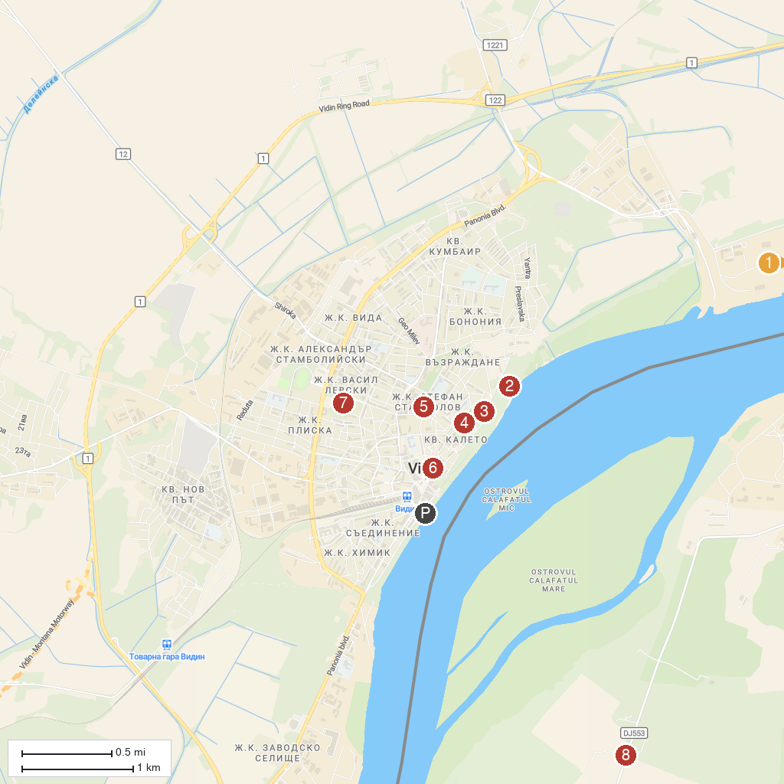
MAP KEY
1. Sunny Beach Bascov | 5. Pazar Kapiya
2. Baba Vida Fortress | 6. Stambol gate
3. The Cultural centrе "Jules Pascin" / Vidin Synagogue | 7. Парк “Владикина Бахча”
4. “The Cross Barracks” Museum | 8. Taverna Pescarilor
P. Cruise port / terminal
Map © MapTiler © OpenStreetMap contributors · cruiseports.org

