Victoria Falls, Matabeleland North, Zimbabwe
The Smoke That Thunders. One of the seven natural wonders of the world, Victoria Falls is not a dockside port — it's a fly-in crown jewel that world cruises access as a land extension from Cape Town or Durban. The payoff: a full day (or more) at one of Africa's most spectacular destinations.
✈️ Fly-in extension (no ship pier) · 🕒 Typical extension: 2–4 nights · 💵 USD widely accepted · 🗣️ English (official) · 🌿 UNESCO World Heritage Site
✍️ MY DAY IN PORT (FILL IN)
Ship / Date
In port | arrive ______ · all aboard ______
Booked excursion
Notes / meeting point
GETTING ASHORE
- Arrival: Fly into Victoria Falls Airport (VFA) or Livingstone (LVI) — no cruise pier exists
- Best For: Waterfall walks, helicopter rides, Zambezi cruises, white-water rafting, safari
- Don't Miss: Devil's Cataract viewpoint and a sunset cruise on the Upper Zambezi
- Entry Fee: USD $58 Zimbabwe side; USD $20 Zambia side (Victoria Falls National Park)
GETTING AROUND
- 🚕 Taxi: USD 5–12 — Taxis are widely available around hotels, tourist areas, and jetty points. Fares are negotiated — always agree on a pric
TOP THINGS TO DO
- Victoria Falls National Park Walk — Sixteen viewpoints along the Zimbabwean rim — from Cataract View to Danger Point — reveal the full 1,708-metre curtain of the…
- Flight of Angels — Helicopter Tour — A 12–25 minute helicopter flight over the falls and Batoka Gorge.
- Zambezi Sunset Cruise — A two-hour float on the Upper Zambezi (upstream from the falls) with hippos wallowing close to the boat, elephants at the banks…
- White-Water Rafting — Batoka Gorge — The Zambezi below the falls is consistently rated one of the top one-day rafting runs in the world, with Grade 5 rapids through a…
- Chobe National Park Day Safari — A 90-minute drive into Botswana reaches Chobe, famous for Africa's densest elephant population.
BEST WALKS
- Victoria Falls Rainforest Trail: 2–3 km | Easy | Wet — bring rain gear — Follow the paved path from the National Park entrance past all 16 viewpoints: Cataract View, Main…
- Victoria Falls Town Stroll: 1–2 km | Easy | Safe during daylight — From most hotels it's a short flat walk down Livingstone Way to the park gate, passing the landmark…
WEATHER · DAYLIGHT · MONEY
Month | High °F | Low °F | Rainy days
May | 80 | 57 | 0
Jul | 76 | 51 | 0
Sep | 91 | 63 | 0
Daylight: May 6:34AM–5:50PM · Jul 6:48AM–5:57PM · Sep 6:12AM–6:11PM
cruiseports.org/victoria-falls · Confirm terminal & all-aboard time with your ship

Victoria Falls, Matabeleland North, Zimbabwe — Port Map
Red = walkable sights · Amber = excursions farther out · P = cruise terminal
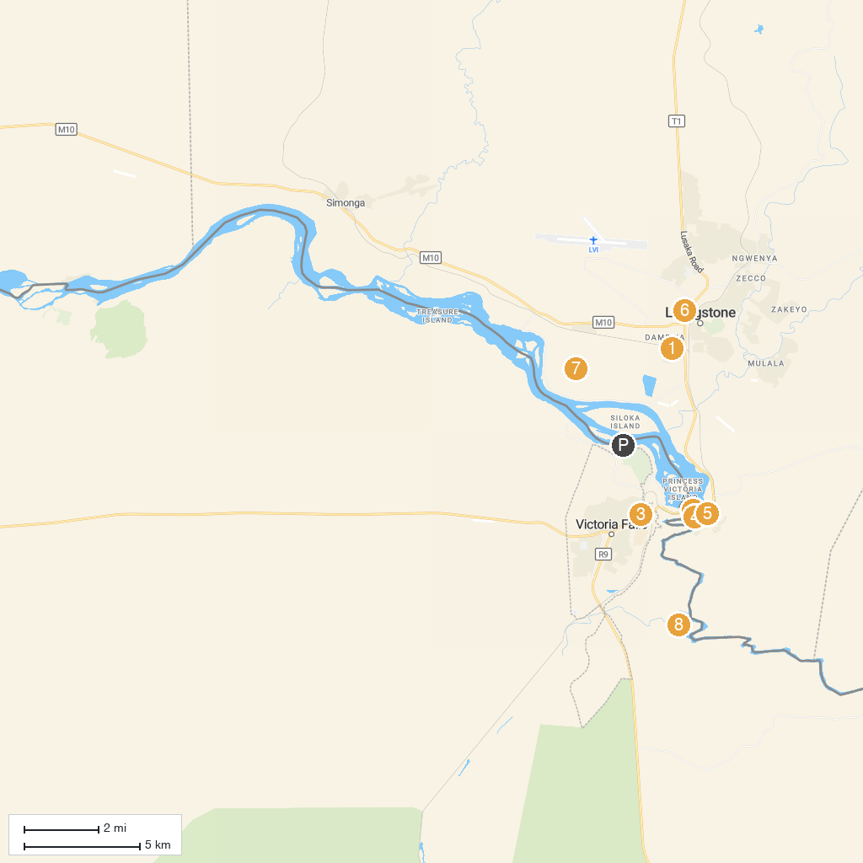
MAP KEY
1. Railway Museum | 5. The Victoria Falls World Heritage Site
2. Victoria Falls | 6. Livingstone Museum
3. Tamuka Travel | 7. Mosi-oa-Tunya National Park
4. The Boiling Pot-Victoria Falls, Zambia | 8. Parco nazionale delle cascate Vittoria
P. Cruise port / terminal
Map © MapTiler © OpenStreetMap contributors · cruiseports.org

