Victoria, British Columbia, Canada
British Columbia's postcard capital sits at the southern tip of Vancouver Island — all flower baskets, double-decker buses, and a harbour so photogenic it barely looks real. Most ships dock overnight or late evening, giving you unusually long time ashore.
⚓ Docked (Ogden Point) · 🕒 Typical call: 8-12 hrs · 💵 CAD (Canadian dollars) · 🗣️ English · 🌸 Gardens & heritage
✍️ MY DAY IN PORT (FILL IN)
Ship / Date
In port | arrive ______ · all aboard ______
Booked excursion
Notes / meeting point
GETTING ASHORE
- Docking: Ogden Point Cruise Terminal — 1.5 km from downtown; shuttle buses run ship to inner harbour
- Walk to center: 20 min on foot along the waterfront pathway, or $5–8 CAD shuttle
- Best For: Butchart Gardens, afternoon tea at the Empress, whale watching, and historic old town
- Don't Miss: Butchart Gardens (30 min from port) and the Inner Harbour at dusk
GETTING AROUND
- 🚕 Taxi: approx. CAD $15–30 / USD $11–22 — Taxis queue at the terminal; Uber is also available in Victoria. Short ride (5–10 min) to downtown or the Inner Harbour.
- 📱 Rideshare: ✅ Uber
- 🚌 Hop-on hop-off: ✅
TOP THINGS TO DO
- Butchart Gardens — Fifty-five acres of immaculate gardens carved into a former limestone quarry on the Saanich Peninsula.
- Whale Watching — Victoria's waters are among the best in Canada for orca sightings.
- Royal BC Museum — One of Canada's finest provincial museums, with deep collections on First Nations cultures, natural history, and BC's colonial…
- Afternoon Tea at the Empress Hotel — The Fairmont Empress has served afternoon tea since 1908.
- Beacon Hill Park & Fisherman's Wharf — Beacon Hill Park is 200 acres of meadows, ponds, and rose gardens — free and beautiful.
BEST WALKS
- Inner Harbour Heritage Loop: 2.5 miles · 1.5 hrs · Easy — From the Inner Harbour, stroll past the BC Parliament Buildings and the Fairmont Empress Hotel…
- Fisherman's Wharf & Beacon Hill Stroll: 3 miles · 1.5 hrs · Easy — Walk the waterfront path south from the Inner Harbour to Fisherman's Wharf for a look at the float…
WEATHER · DAYLIGHT · MONEY
Month | High °F | Low °F | Rainy days
May | 79 | 69 | 11
Jul | 77 | 65 | 10
Sep | 80 | 69 | 10
Daylight: May 6:03AM–5:11PM · Jul 6:17AM–5:17PM · Sep 5:37AM–5:35PM
cruiseports.org/victoria-bc · Confirm terminal & all-aboard time with your ship

Victoria, British Columbia, Canada — Port Map
Red = walkable sights · Amber = excursions farther out · P = cruise terminal
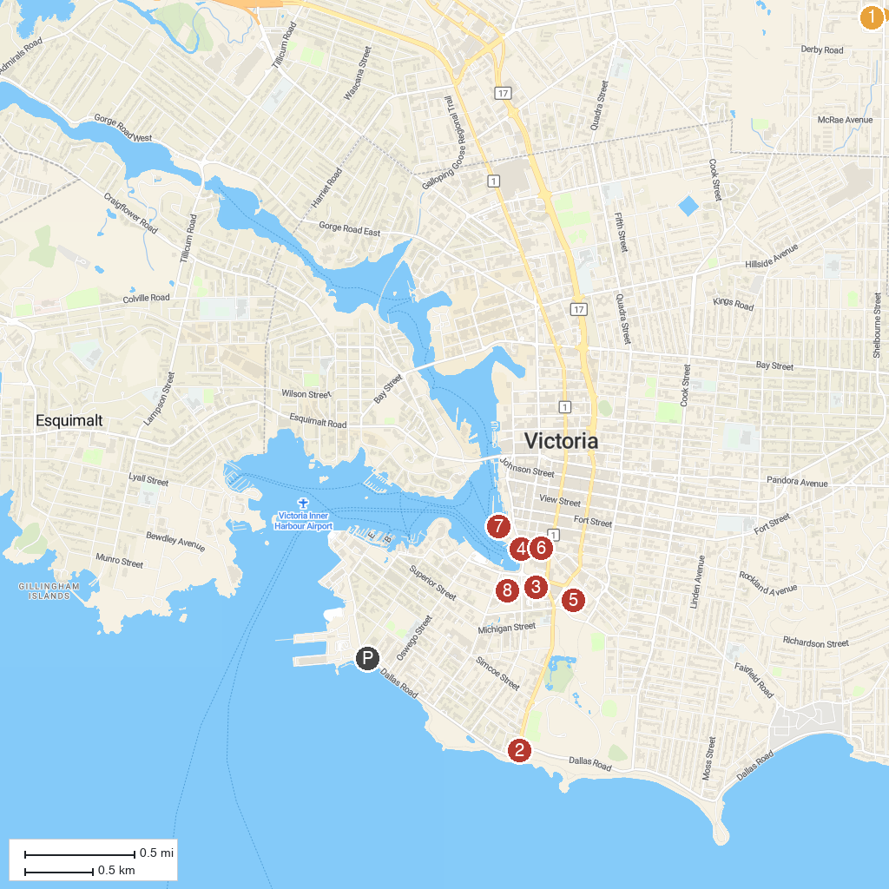
MAP KEY
1. Mystic Vale | 5. St. Ann's Academy and Auditorium National Historic Site
2. Mile Zero Monument | 6. Miniature World
3. Royal BC Museum | 7. Harbour Air - Victoria
4. Victoria Harbour Ferry | 8. Legislative Assembly of British Columbia
P. Cruise port / terminal
Map © MapTiler © OpenStreetMap contributors · cruiseports.org

