Viana do Castelo, Minho, Portugal
Perched where the Lima River meets the Atlantic, Viana do Castelo is an under-the-radar gem — ornate Manueline stonework, a hillside basilica with sweeping views, a historic hospital ship, and beaches reachable by river ferry.
⚓ Docked (pier) · 🕒 Typical call: 7-9 hrs · 💶 Currency: Euro (€) · 🗣️ Language: Portuguese · 🏖️ Beach & Culture
✍️ MY DAY IN PORT (FILL IN)
Ship / Date
In port | arrive ______ · all aboard ______
Booked excursion
Notes / meeting point
GETTING ASHORE
- Docking: Pier — riverfront quay for boutique ships; commercial port (south bank) for larger vessels with shuttle to center
- Walk to center: ~10-15 min (800 m) along the river promenade from riverfront quay
- Best For: History, architecture, viewpoints, fresh seafood, authentic Portuguese culture
- Don't Miss: Funicular up to Santa Luzia Basilica dome + warm Bola de Berlim pastry in town
GETTING AROUND
- 🚕 Taxi: €4–10 — Metered taxis available near the port; day rate starts at €3.25 flag fall plus €1.06/km. Night/weekend rates are ~20% hi
- 📱 Rideshare: ✅ Uber, Bolt
TOP THINGS TO DO
- Santa Luzia Basilica & Dome Views — Ride the funicular (Portugal's longest) up Monte de Santa Luzia to the Neo-Byzantine basilica.
- Gil Eannes Hospital Ship — This 1955 vessel once served as a floating hospital for the Portuguese cod-fishing fleet in the North Atlantic and Greenland.
- Historic Center & Praça da República — Wander Viana's pedestrian old town to the elegant main square — the 16th-century chafariz fountain, the ornate Igreja da…
- Praia do Cabedelo Beach — A crescent of golden Atlantic sand on the far bank of the Lima River.
- Day Trip to Ponte de Lima — Portugal's oldest town is just 25 minutes away — a medieval bridge over the Lima River, weekly market, and quiet riverside walks.
BEST WALKS
- Old Town Highlights Walk: 1.5 km · ~45 min · Easy (flat, cobblestones) — From the riverfront quay, stroll along the promenade past the Gil Eannes ship to the Praça da…
- River Ferry to Cabedelo Beach: Short ferry + 1 km walk · ~30 min one-way · Easy — Walk to the Cais da Passagem ferry terminal in town, hop the 5-minute river crossing, and follow…
WEATHER · DAYLIGHT · MONEY
Month | High °F | Low °F | Rainy days
May | 67 | 55 | 10
Jul | 74 | 62 | 3
Sep | 72 | 60 | 8
Daylight: May 6:15AM–8:48PM · Jul 6:14AM–9:07PM · Sep 7:15AM–7:44PM
cruiseports.org/viana-do-castelo · Confirm terminal & all-aboard time with your ship

Viana do Castelo, Minho, Portugal — Port Map
Red = walkable sights · Amber = excursions farther out · P = cruise terminal
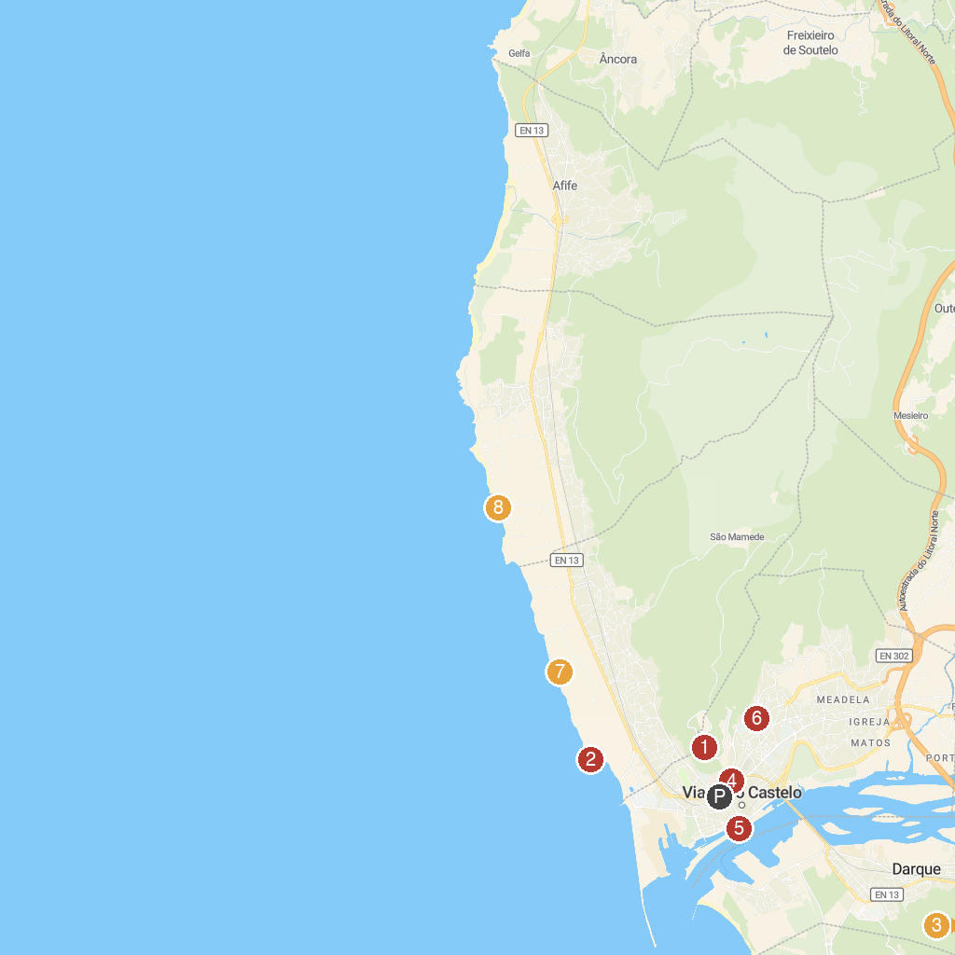
MAP KEY
1. Sanctuary of the Sacred Heart of Jesus | 5. Cultural Center of Viana do Castelo
2. Forte da Areosa | 6. Igreja da Sagrada Família
3. Quinta de Santoinho | 7. Praia do Porto de Vinha
4. Elevador de Santa Luzia | 8. Praia do Canto Marinho
P. Cruise port / terminal
Map © MapTiler © OpenStreetMap contributors · cruiseports.org

