Verona, Veneto, Italy
Romeo, Juliet, and a Roman arena still hosting opera — Verona is the rare city where every corner delivers on the hype. One of Italy's most rewarding shore-day destinations.
🚌 Overland excursion (bus or train from Venice) · 🕒 Typical call: 5-7 hrs in city · 💶 Currency: Euro (€) · 🗣️ Language: Italian · 🏛️ UNESCO World Heritage Site
✍️ MY DAY IN PORT (FILL IN)
Ship / Date
In port | arrive ______ · all aboard ______
Booked excursion
Notes / meeting point
GETTING ASHORE
- Arrival: Bus or train from Venice (~1.5 hrs), Ravenna (~2.5 hrs), or river cruise dock
- Walk to center: Drop-off at Piazza Bra — Arena is right there; all major sites within 20 min on foot
- Best For: History, romance, opera, Roman architecture, Italian food & wine
- Don't Miss: Verona Arena interior, Ponte Pietra view, Castel San Pietro panorama
GETTING AROUND
- 🚕 Taxi: €10–€20 — Official taxis have a base fare of ~€4 and charge ~€1.48/km. Ranks are found at the train station (Porta Nuova) and Piaz
- 📱 Rideshare: ✅ Uber
- 🚌 Hop-on hop-off: ✅
TOP THINGS TO DO
- Verona Arena — One of the world's best-preserved Roman amphitheaters, built in 30 AD and still hosting world-class operas.
- Old City Walking Tour — Cover Piazza Bra, Piazza delle Erbe (the old Roman Forum), Piazza dei Signori, and the Scaligeri tombs.
- Juliet's House & Romeo's House — Enter Juliet's courtyard for free (timed entry in peak season), touch the bronze statue, and view the wall of love letters.
- Castelvecchio & Ponte Scaligero — A 14th-century red-brick castle housing a world-class art museum, and its stunning fortified bridge over the Adige River.
- Lake Garda Day Trip — Italy's largest lake is about 30 km from Verona — vivid blue water backed by mountains.
BEST WALKS
- Arena to Ponte Pietra Loop: 2 km · 45–60 min · Easy · Free — Start at Piazza Bra and the Roman Arena, walk up Via Mazzini to Piazza delle Erbe, duck into Piazza…
- Castelvecchio & Riverside Stroll: 1.5 km · 30 min · Easy · Free — From Piazza Bra head west along the Adige riverbank to Castelvecchio and cross the medieval Ponte…
WEATHER · DAYLIGHT · MONEY
Month | High °F | Low °F | Rainy days
May | 72 | 55 | 15
Jul | 86 | 69 | 12
Sep | 77 | 60 | 9
Daylight: May 5:45AM–8:39PM · Jul 5:42AM–9:01PM · Sep 6:54AM–7:26PM
cruiseports.org/verona · Confirm terminal & all-aboard time with your ship

Verona, Veneto, Italy — Port Map
Red = walkable sights · Amber = excursions farther out · P = cruise terminal
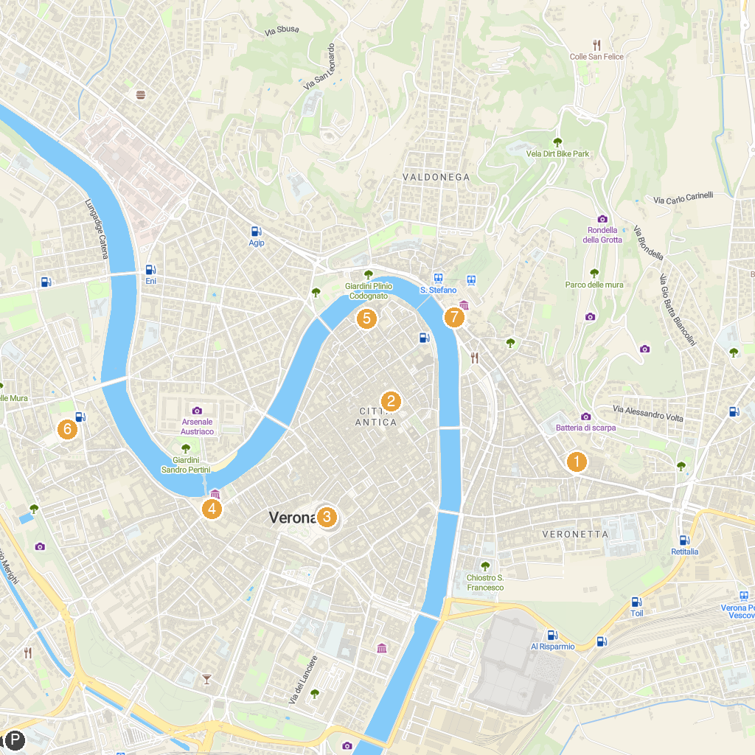
MAP KEY
1. Chiesa dei Santi Nazaro e Celso | 5. Complesso del Duomo di Verona
2. Loggia del Consiglio | 6. Church of Saint Zeno
3. Arena di Verona | 7. Museo Archeologico al Teatro Romano
4. Castelvecchio Museum
P. Cruise port / terminal
Map © MapTiler © OpenStreetMap contributors · cruiseports.org

